Conceptual Model Foundation- in progress

Structural Report

Author: Author

Revision: 0.1

|  |  |
| --- | --- |
|  |  |
|  | Date: February 19, 2015 |

**Table of Contents**

Introduction 1

Purpose 1

Scope 1

Overview 1

Conceptual Modeling and Mapping Library 2

Diagram: Conceptual Risk/Threat Model Diagrams 2

Conceptual Modeling and Mapping Library::Core Concept Library::Foundation 2

Diagram: Upper Foundation Concepts 3

Class Activity 3

Direct Supertypes 4

Associations 4

Inherited Features 4

Class Actor 5

Direct Supertypes 6

Associations 6

Inherited Features 6

Class Anything 7

Associations 8

Association Categorization 9

Association Ends 9

Class Category 9

Direct Supertypes 9

Associations 9

Inherited Features 9

Association Cause and effect 10

Association Ends 10

Class Context 10

Direct Supertypes 10

Associations 10

Inherited Features 11

Class Contextual Dimension 11

Direct Supertypes 11

Associations 11

Inherited Features 11

Association Contextualization 12

Association Ends 12

Class Entity 12

Direct Supertypes 13

Associations 13

Inherited Features 14

Association Generalization 14

Association Ends 14

Class Individual 14

Direct Supertypes 15

Associations 15

Inherited Features 15

Class Occurrence 16

Direct Supertypes 17

Associations 17

Inherited Features 18

Class Role 19

Direct Supertypes 19

Associations 19

Inherited Features 19

Class Situation 20

Direct Supertypes 21

Attributes 21

Associations 21

Inherited Features 21

Class State 22

Direct Supertypes 22

Associations 22

Inherited Features 22

Association Time Order 23

Association Ends 23

Class Type 24

Direct Supertypes 24

Inherited Features 24

Conceptual Modeling and Mapping Library::Core Concept Library::Identifiers 25

Diagram: Identifiers 26

Association Identification 26

Association Ends 26

Class Identifier 26

Direct Supertypes 26

Associations 27

Inherited Features 27

Class Name 27

Direct Supertypes 27

Associations 27

Inherited Features 27

Class Namespace 27

Direct Supertypes 27

Associations 28

Inherited Features 28

Class Textual Name 28

Attributes 28

Class Unique Identifier 28

Direct Supertypes 28

Associations 28

Inherited Features 28

Class URIIdentifier 29

Direct Supertypes 29

Attributes 29

Inherited Features 29

Conceptual Modeling and Mapping Library::Core Concept Library::Process 29

Diagram: Process and plans 30

Class Modus Operandi 30

Direct Supertypes 31

Inherited Features 31

Class Plan 32

Direct Supertypes 32

Associations 32

Inherited Features 32

Class Process 34

Direct Supertypes 34

Associations 34

Inherited Features 34

Class Scenario 36

Direct Supertypes 36

Attributes 36

Associations 36

Inherited Features 36

Conceptual Modeling and Mapping Library::Core Concept Library::Quantities and units 37

Diagram: Quantities and units 38

Class Confidence Metric 38

Direct Supertypes 38

Inherited Features 38

Class Count 39

Direct Supertypes 39

Inherited Features 39

Class Metric 39

Direct Supertypes 39

Inherited Features 39

Class Probability Metric 40

Direct Supertypes 40

Inherited Features 40

Class Quantity 40

Direct Supertypes 40

Attributes 40

Inherited Features 40

Class Time Point 41

Direct Supertypes 41

Inherited Features 41

Class Value 41

Direct Supertypes 41

Inherited Features 41

Conceptual Modeling and Mapping Library::Core Concept Library::Rules 42

Diagram: Rules 42

Association Class Action Rule 42

Direct Supertypes 42

Inherited Features 43

Class Constraint 44

Direct Supertypes 44

Inherited Features 44

Association Class Course Of Action Rule 45

Direct Supertypes 45

Inherited Features 46

Class Expression 47

Class Rule 47

Direct Supertypes 47

Attributes 47

Inherited Features 47

Conceptual Modeling and Mapping Library::Core Concept Library::Templates 49

Diagram: Templating 49

Class Actual Situation 49

Direct Supertypes 49

Associations 49

Inherited Features 50

Class Binding 51

Direct Supertypes 52

Associations 52

Inherited Features 52

Class Template 52

Direct Supertypes 52

Associations 52

Inherited Features 52

Class Template Involvement 53

Direct Supertypes 54

Attributes 54

Associations 54

Inherited Features 54

Enumeration Quantification 54

Conceptual Modeling and Mapping Library::Core Concept Library::Timeframe 55

Diagram: Timeframe 56

Class Current Situation 56

Direct Supertypes 56

Inherited Features 56

Class Past Situation 57

Direct Supertypes 57

Inherited Features 58

Class Potential Situation 59

Direct Supertypes 59

Attributes 59

Associations 59

Inherited Features 59

Conceptual Modeling and Mapping Library::Core Concept Library::Universal 60

Diagram: Universal 61

Class Potential Association 61

Direct Supertypes 61

Inherited Features 61

Class Relationship 63

Direct Supertypes 63

Inherited Features 63

Conceptual Modeling and Mapping Library::Generic Concepts::Actor Associations 64

Diagram: Actor Associations 64

Association Class Actor Association 65

Direct Supertypes 65

Inherited Features 65

Association Class Membership 66

Direct Supertypes 66

Inherited Features 66

Class Organization 67

Direct Supertypes 68

Inherited Features 68

Conceptual Modeling and Mapping Library::Generic Concepts::Authority 68

Diagram: Authority 69

Class Authority 69

Direct Supertypes 69

Associations 69

Inherited Features 69

Association Subject to Authority 70

Association Ends 70

Conceptual Modeling and Mapping Library::Generic Concepts::Capability 70

Diagram: Capability 71

Class Alter Capability 71

Direct Supertypes 71

Associations 71

Inherited Features 72

Class Alter Capability Act 73

Direct Supertypes 73

Associations 73

Inherited Features 73

Association Class Capability 74

Direct Supertypes 75

Associations 75

Inherited Features 75

Class Credential 76

Direct Supertypes 76

Associations 76

Inherited Features 76

Class Diminish Capability 77

Direct Supertypes 77

Inherited Features 77

Class Enhance Capability 79

Direct Supertypes 79

Inherited Features 79

Class Facilitator 80

Direct Supertypes 80

Associations 80

Inherited Features 80

Conceptual Modeling and Mapping Library::Generic Concepts::Contact Information 81

Diagram: Contact Information 81

Class Contact Information 82

Associations 82

Class Electronic Contact 82

Direct Supertypes 82

Inherited Features 82

Class Postal Contact 82

Direct Supertypes 82

Inherited Features 82

Class Voice Contact 82

Direct Supertypes 82

Inherited Features 83

Conceptual Modeling and Mapping Library::Generic Concepts::Custody 83

Diagram: Custody 84

Class Custodian 84

Direct Supertypes 84

Inherited Features 85

Association Class Custody 85

Direct Supertypes 85

Attributes 86

Associations 86

Inherited Features 86

Class Managed Entity 87

Direct Supertypes 87

Associations 87

Inherited Features 87

Class Transfer Custody 88

Direct Supertypes 88

Associations 88

Inherited Features 88

Conceptual Modeling and Mapping Library::Generic Concepts::Entity kinds 90

Diagram: Entity kinds 90

Class Automaton 90

Direct Supertypes 90

Inherited Features 90

Class Computer System 91

Direct Supertypes 91

Inherited Features 91

Class Item 92

Direct Supertypes 92

Inherited Features 92

Class Physical Entity 93

Direct Supertypes 93

Associations 93

Inherited Features 93

Diagram: Role Hierarchy 95

Known other classes 95

Conceptual Modeling and Mapping Library::Generic Concepts::Information 95

Diagram: Information foundation 96

Class Collection 96

Direct Supertypes 96

Associations 97

Inherited Features 97

Class Description 97

Direct Supertypes 97

Associations 98

Inherited Features 98

Class Information Action 98

Direct Supertypes 98

Associations 99

Inherited Features 99

Class Information Object 100

Direct Supertypes 100

Associations 100

Inherited Features 100

Class Information Store 101

Direct Supertypes 101

Inherited Features 101

Class Information Transfer 102

Direct Supertypes 102

Inherited Features 102

Class Package 103

Direct Supertypes 103

Inherited Features 103

Class Query 104

Direct Supertypes 104

Inherited Features 104

Class Software 106

Direct Supertypes 106

Inherited Features 106

Class Source 107

Associations 107

Class Structured Information Object 107

Direct Supertypes 107

Associations 107

Inherited Features 107

Conceptual Modeling and Mapping Library::Generic Concepts::Intent 108

Diagram: Intent 108

Class Asset Objective 109

Direct Supertypes 109

Associations 109

Inherited Features 109

Class Benefit 109

Direct Supertypes 109

Inherited Features 109

Class Consequence 110

Direct Supertypes 111

Attributes 111

Associations 111

Inherited Features 112

Class Harm 113

Direct Supertypes 113

Inherited Features 113

Class Intent 114

Attributes 114

Associations 114

Class Objective 114

Direct Supertypes 114

Associations 114

Inherited Features 115

Class Opportunity 115

Direct Supertypes 115

Inherited Features 115

Class Stakeholder 117

Direct Supertypes 117

Associations 117

Inherited Features 117

Association Class Stakeholder Desirability 118

Attributes 118

Associations 118

Conceptual Modeling and Mapping Library::Generic Concepts::Location 118

Diagram: Location 119

Class Coordinate 119

Direct Supertypes 119

Associations 119

Inherited Features 119

Class Coordinate System 120

Direct Supertypes 120

Associations 120

Inherited Features 120

Class Facility 121

Direct Supertypes 121

Inherited Features 121

Class GPS Coordinate 122

Direct Supertypes 122

Inherited Features 122

Class Location Identifier 123

Direct Supertypes 123

Associations 123

Inherited Features 123

Class Physical Location 123

Direct Supertypes 123

Associations 123

Inherited Features 124

Class Place 124

Direct Supertypes 124

Inherited Features 125

Class Point On Earth 126

Direct Supertypes 126

Inherited Features 126

Class Postal Address 126

Direct Supertypes 126

Associations 126

Inherited Features 126

Class Residence 127

Direct Supertypes 127

Associations 127

Inherited Features 127

Conceptual Modeling and Mapping Library::Generic Concepts::Observation 128

Diagram: Observation 129

Class Measurement 129

Direct Supertypes 129

Inherited Features 129

Class Observation 131

Direct Supertypes 131

Associations 131

Inherited Features 131

Conceptual Modeling and Mapping Library::Generic Concepts::Person 132

Diagram: Person 133

Class Full Person Name 133

Direct Supertypes 133

Attributes 133

Inherited Features 133

Class Partial Person Name 134

Direct Supertypes 134

Inherited Features 134

Class Person 134

Direct Supertypes 134

Attributes 134

Associations 135

Inherited Features 135

Class Person Name 135

Direct Supertypes 136

Associations 136

Inherited Features 136

Class Salutation Name 136

Direct Supertypes 136

Inherited Features 136

Class Title Name 137

Direct Supertypes 137

Inherited Features 137

Conceptual Modeling and Mapping Library::Generic Concepts::Requirements 137

Diagram: Requirements 137

Class Requirement 138

Direct Supertypes 138

Inherited Features 138

Association Class Satisfaction of requirement 138

Direct Supertypes 138

Attributes 138

Inherited Features 138

Conceptual Modeling and Mapping Library::Generic Concepts::Resources 139

Diagram: Resource 140

Class Primary Asset 140

Direct Supertypes 140

Associations 140

Inherited Features 140

Class Resource 141

Direct Supertypes 141

Associations 141

Inherited Features 142

Class Tool 143

Direct Supertypes 143

Inherited Features 143

Class Unwitting Participant 144

Direct Supertypes 144

Inherited Features 144

Conceptual Modeling and Mapping Library::Mapping Profile 145

Diagram: Mapping profile 145

Conceptual Modeling and Mapping Library::Risk and Threat Concepts 145

Diagram: Threat and risk overview 146

Conceptual Modeling and Mapping Library::Risk and Threat Concepts::Danger 146

Diagram: Danger 147

Class Danger 147

Direct Supertypes 148

Attributes 148

Associations 148

Inherited Features 149

Association Danger Impact 150

Association Ends 150

Class Danger Source 150

Direct Supertypes 150

Associations 150

Inherited Features 150

Class Dangerous Activity 151

Direct Supertypes 151

Associations 151

Inherited Features 151

Class Dangerous Condition 152

Direct Supertypes 152

Inherited Features 153

Class Dangerous Event 154

Direct Supertypes 154

Inherited Features 154

Class Threat Actor 155

Direct Supertypes 155

Associations 156

Inherited Features 156

Conceptual Modeling and Mapping Library::Risk and Threat Concepts::Incident 156

Diagram: Incident 157

Class Accident 157

Direct Supertypes 157

Inherited Features 157

Class Attack 159

Direct Supertypes 159

Inherited Features 159

Class Disaster 161

Direct Supertypes 161

Inherited Features 161

Class Incident 162

Direct Supertypes 163

Associations 163

Inherited Features 163

Class Victim 164

Direct Supertypes 164

Inherited Features 164

Conceptual Modeling and Mapping Library::Risk and Threat Concepts::Indicator 166

Diagram: Indicator 166

Association Class Indication 167

Attributes 167

Class Indicator 167

Direct Supertypes 168

Associations 168

Inherited Features 168

Class Indicator And Group 169

Direct Supertypes 169

Inherited Features 169

Class Indicator Group 170

Direct Supertypes 170

Associations 170

Inherited Features 170

Class Indicator Or Group 171

Direct Supertypes 171

Inherited Features 171

Class Indicator Pattern 172

Direct Supertypes 172

Inherited Features 172

Class Indicator Watchlist 173

Direct Supertypes 173

Associations 173

Inherited Features 174

Class Sighting 174

Direct Supertypes 175

Associations 175

Inherited Features 175

Conceptual Modeling and Mapping Library::Risk and Threat Concepts::Risk 177

Diagram: Risk 178

Class Avoid Danger 178

Direct Supertypes 178

Inherited Features 178

Class Hazard 178

Direct Supertypes 178

Inherited Features 179

Class Mitication Plan 180

Direct Supertypes 180

Inherited Features 180

Class Mitigation 182

Attributes 183

Associations 183

Class Mitigation Activity 183

Direct Supertypes 183

Associations 183

Inherited Features 183

Class Mitigation Actor 184

Direct Supertypes 185

Associations 185

Inherited Features 185

Class Risk 186

Direct Supertypes 186

Attributes 187

Associations 187

Inherited Features 187

Class Risk requirement 188

Direct Supertypes 188

Inherited Features 189

Association Class Risk Requirement Satisfaction 189

Direct Supertypes 189

Inherited Features 189

Class Risk Treatment Option 190

Direct Supertypes 190

Attributes 190

Associations 190

Inherited Features 190

Class Threat 192

Direct Supertypes 192

Inherited Features 192

Conceptual Modeling and Mapping Library::Risk and Threat Concepts::Vulnerability 194

Diagram: Vulnerability Detail 194

Class Exploit 194

Direct Supertypes 194

Associations 195

Inherited Features 195

Class Vulnerability 196

Direct Supertypes 196

Associations 196

Inherited Features 196

Class Weakness 198

Direct Supertypes 198

Associations 198

Inherited Features 198

Appendix A: Data Type 200

Number 200

ordered 200

Appendix B: Tree 201

Class Hierarchy 201

Enumeration Hierarchy 202

**Table of Figures**

Figure 1. Conceptual Risk/Threat Model Diagrams 2

Figure 2. Upper Foundation Concepts 3

Figure 1. Activity Detail 4

Figure 2. Actor Detail 6

Figure 3. Anything Detail 8

Figure 4. Entity Detail 13

Figure 5. Individual Detail 15

Figure 6. Occurrence Detail 17

Figure 7. Situation Detail 20

Figure 8. Type Detail 24

Figure 9. Identifiers 26

Figure 10. Process and plans 30

Figure 11. Quantities and units 38

Figure 12. Rules 42

Figure 13. Templating 49

Figure 14. Binding Detail 51

Figure 15. Templating 55

Figure 16. Timeframe 56

Figure 17. Universal 60

Figure 18. Actor Associations 64

Figure 19. Authority 68

Figure 20. Capability 71

Figure 21. Contact Information 81

Figure 22. Custody 83

Figure 23. Entity kinds 89

Figure 24. Role Hierarchy 94

Figure 25. Information foundation 95

Figure 26. Intent 107

Figure 27. Consequence 110

Figure 28. Opportunity 114

Figure 29. Location 118

Figure 30. Observation 127

Figure 31. Person 131

Figure 32. Requirements 136

Figure 33. Resource 138

Figure 34. Mapping profile 143

Figure 35. Threat and risk overview 144

Figure 36. Danger 145

Figure 37. Danger Detail 146

Figure 38. Incident 155

Figure 39. Indicator 164

Figure 40. Indicator Detail 165

Figure 41. Sighting Detail 173

Figure 42. Risk 176

Figure 43. Mitigation Detail 180

Figure 44. Risk Detail 184

Figure 45. Vulnerability Detail 192

# Introduction

## Purpose

<This document provides an overview of structural view>

## Scope

<Provide a short description of the system being specified and its purpose, including relevant benefits, objectives, and goals>

## Overview

<Describe what the document contains and explain how document is organized>

## Conceptual Modeling and Mapping Library

### Diagram: Conceptual Risk/Threat Model Diagrams

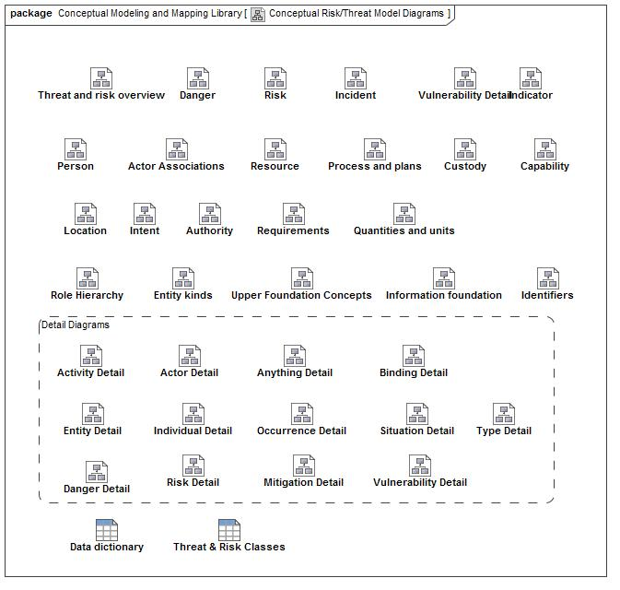

1. Conceptual Risk/Threat Model Diagrams

## Conceptual Modeling and Mapping Library::Core Concept Library::Foundation

The foundation library provides fundamental concepts that apply to any domain or area of concern. These fundamental concepts are specialized and related for more specific concerns, such as risk management.

Such fundamental concepts provide for links between domains, systems, organizations, cultures and stakeholders.

Unless stated otherwise, these concepts are intended to be mixed together to fully describe something in the "real world" - something may be classified by any number of types (e.g. a transfer of custody that is an actual situation that happened in the past).

### Diagram: Upper Foundation Concepts

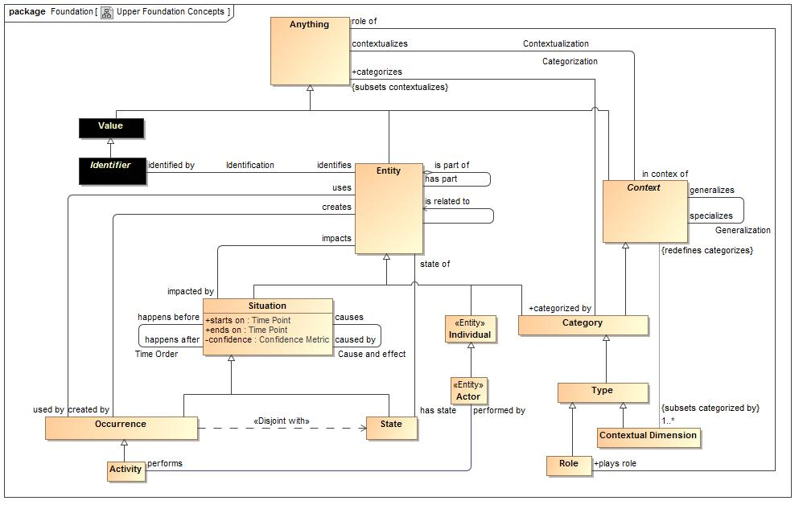

1. Upper Foundation Concepts

### Class Activity

An occurrence of a unit of work performed by an actor.

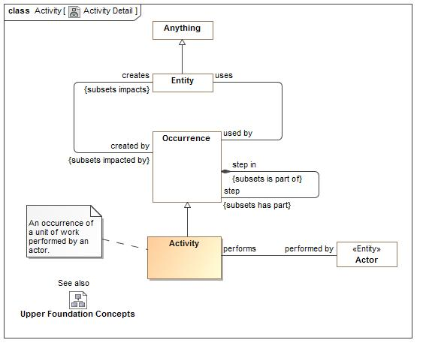

1. Activity Detail

#### Direct Supertypes

Occurrence

**package** Conceptual Modeling and Mapping Library::Core Concept Library::Foundation

**extends** Occurrence

#### Associations

-1826097578.jpg performed by:Actor

The performer of an activity.

#### Inherited Features

***From*** Occurrence:

‘uses’:Entity

‘creates’:Entity

‘step in’:Occurrence

‘step’:Occurrence

‘when’:Situation

***From*** Situation:

‘starts on’:Time Point

‘ends on’:Time Point

‘has binding’:Binding

‘has consequence’:Consequence

‘impacts’:Entity

‘matches’:Template

‘confidence’:Confidence Metric

‘happens before’:Situation

‘happens after’:Situation

‘selects’:Indicator

‘do’:Occurrence

‘course of action’:Process

***From*** Entity:

‘used by’:Occurrence

‘is part of’:Entity

‘has part’:Entity

‘has state’:State

‘created by’:Occurrence

‘is related to’:Entity

‘impacted by’:Situation

‘identified by’:Identifier

‘has name’:Name

‘prefered identifier’:Identifier

‘watched by’:Indicator Watchlist

‘observed by’:Observation

‘made available by’:Alter Capability

***From*** Anything:

‘categorized by’:Category

‘plays role’:Role

‘bound by’:Binding

‘in contex of’:Context

‘described by’:Description

‘stated by’:Source

***From*** Context:

‘generalizes’:Context

‘specializes’:Context

‘contextualizes’:Anything

### Class Actor

An entity capable of performing acts/actions.

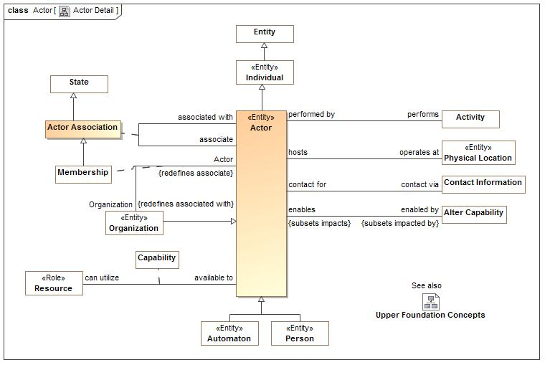

1. Actor Detail

#### Direct Supertypes

Individual

**package** Conceptual Modeling and Mapping Library::Core Concept Library::Foundation

**extends** Individual

#### Associations

-1826097578.jpg performs:Activity

The activity an actor performs.

1382130166.jpg operates at:Physical Location

Locations where actors perform acts

1468165938.jpg contact via:Contact Information

A way to contact an actor.

1521677897.jpg enabled by:Alter Capability *Subsets*: impacted by:Situation

An occurrence that enables an actor's capability.

#### Inherited Features

***From*** Individual:

‘has observation’:Observation

***From*** Entity:

‘used by’:Occurrence

‘is part of’:Entity

‘has part’:Entity

‘has state’:State

‘created by’:Occurrence

‘is related to’:Entity

‘impacted by’:Situation

‘identified by’:Identifier

‘has name’:Name

‘prefered identifier’:Identifier

‘watched by’:Indicator Watchlist

‘observed by’:Observation

‘made available by’:Alter Capability

***From*** Anything:

‘categorized by’:Category

‘plays role’:Role

‘bound by’:Binding

‘in contex of’:Context

‘described by’:Description

‘stated by’:Source

### Class Anything

Any thing or value that does or may exist in any possible world. ***Anything* is the supertype of all conceptual model types** and may therefor participate in unbounded relations.

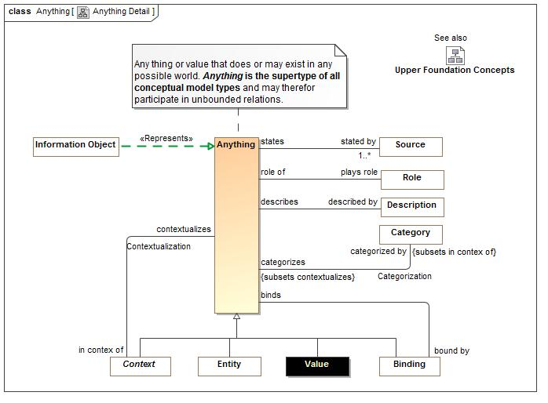

1. Anything Detail

**package** Conceptual Modeling and Mapping Library::Core Concept Library::Foundation

#### Associations

-1928028217.jpg categorized by:Category *Subsets*: in contex of:Context

The category(s) that categorize something. Categories include types.

1208242139.jpg plays role:Role

The role played by a bound individual in a situation.

-697779601.jpg bound by:Binding

A binding something participates in.

1151110039.jpg in contex of:Context

Context that contextualize anything.

885772868.jpg described by:Description

A description for some concept.

1401719257.jpg stated by:Source [1..*]

Sources of a statement

### Association Categorization

Categorization states that something is categorized by the category. . Categorization also represents the "instance" of a type.

**package** Conceptual Modeling and Mapping Library::Core Concept Library::Foundation

#### Association Ends

-1928028217.jpg categorizes : Anything

The set of "instances" categorized by a category or type. The extent of the category.

-1928028217.jpg categorized by : Category

The category(s) that categorize something. Categories include types.

### Class Category

An arbitrary grouping of anything. A category is an asserted context - one defined by some authority or actor.

#### Direct Supertypes

Context, Entity

**package** Conceptual Modeling and Mapping Library::Core Concept Library::Foundation

**extends** Entity, Context

#### Associations

-1928028217.jpg categorizes:Anything *Subsets*: contextualizes:Anything

The set of "instances" categorized by a category or type. The extent of the category.

#### Inherited Features

***From*** Entity:

‘used by’:Occurrence

‘is part of’:Entity

‘has part’:Entity

‘has state’:State

‘created by’:Occurrence

‘is related to’:Entity

‘impacted by’:Situation

‘identified by’:Identifier

‘has name’:Name

‘prefered identifier’:Identifier

‘watched by’:Indicator Watchlist

‘observed by’:Observation

‘made available by’:Alter Capability

***From*** Anything:

‘categorized by’:Category

‘plays role’:Role

‘bound by’:Binding

‘in contex of’:Context

‘described by’:Description

‘stated by’:Source

***From*** Context:

‘generalizes’:Context

‘specializes’:Context

‘contextualizes’:Anything

### Association Cause and effect

The causality relation

**package** Conceptual Modeling and Mapping Library::Core Concept Library::Foundation

#### Association Ends

1506739120.jpg causes : Situation *Subsets*: contextualizes:Anything

A situation caused by another

1506739120.jpg caused by : Situation *Subsets*: contextualizes:Anything

One of situations that causes another situation

1506739120.jpg likelihood : Probability Metric *Subsets*: contextualizes:Anything

Likelihood that the cause will result in the effect

### Class Context

A grouping of concepts contextualized in some way and with some common attributes facts and/or relations. Rules defined for a context are true for anything contextualized by that context. Note that anything may play the role of a context.

#### Direct Supertypes

Anything

**package** Conceptual Modeling and Mapping Library::Core Concept Library::Foundation

**extends** Anything

#### Associations

-1988560015.jpg generalizes:Anything *Subsets*: contextualizes:Anything

The more general role of a generalization.

-1988560015.jpg specializes:Anything *Subsets*: contextualizes:Anything

The more specific role of a generalization.

1151110039.jpg contextualizes:Anything

Anything a context contextualizes.

-1436309573.jpg :Contextual Dimension [1..*] *Subsets*: categorized by:Category

#### Inherited Features

***From*** Anything:

‘categorized by’:Category

‘plays role’:Role

‘bound by’:Binding

‘in contex of’:Context

‘described by’:Description

‘stated by’:Source

### Class Contextual Dimension

A way to group related categories, context or types. A category of categories - related to concept "power type" or "power set". E.g. "Locale" could be a contextual dimension for a set of locations that define certain rules or geopolitical rules.

#### Direct Supertypes

Type

**package** Conceptual Modeling and Mapping Library::Core Concept Library::Foundation

**extends** Type

#### Associations

-1436309573.jpg :Context *Redefines*: categorizes:Anything

#### Inherited Features

***From*** Category:

‘categorizes’:Anything

***From*** Entity:

‘used by’:Occurrence

‘is part of’:Entity

‘has part’:Entity

‘has state’:State

‘created by’:Occurrence

‘is related to’:Entity

‘impacted by’:Situation

‘identified by’:Identifier

‘has name’:Name

‘prefered identifier’:Identifier

‘watched by’:Indicator Watchlist

‘observed by’:Observation

‘made available by’:Alter Capability

***From*** Anything:

‘categorized by’:Category

‘plays role’:Role

‘bound by’:Binding

‘in contex of’:Context

‘described by’:Description

‘stated by’:Source

***From*** Context:

‘generalizes’:Context

‘specializes’:Context

‘contextualizes’:Anything

### Association Contextualization

Contextualization says that the thing contextualized is subject to the facts about the context it is in context of.

**package** Conceptual Modeling and Mapping Library::Core Concept Library::Foundation

#### Association Ends

1151110039.jpg contextualizes : Anything *Redefines*: categorizes:Anything

Anything a context contextualizes.

1151110039.jpg in contex of : Context *Redefines*: categorizes:Anything

Context that contextualize anything.

### Class Entity

Anything identifiable that may change over time (or the extent may change over time), not a pure value. This includes: person, place, thing, agreement, situation, context category and type.

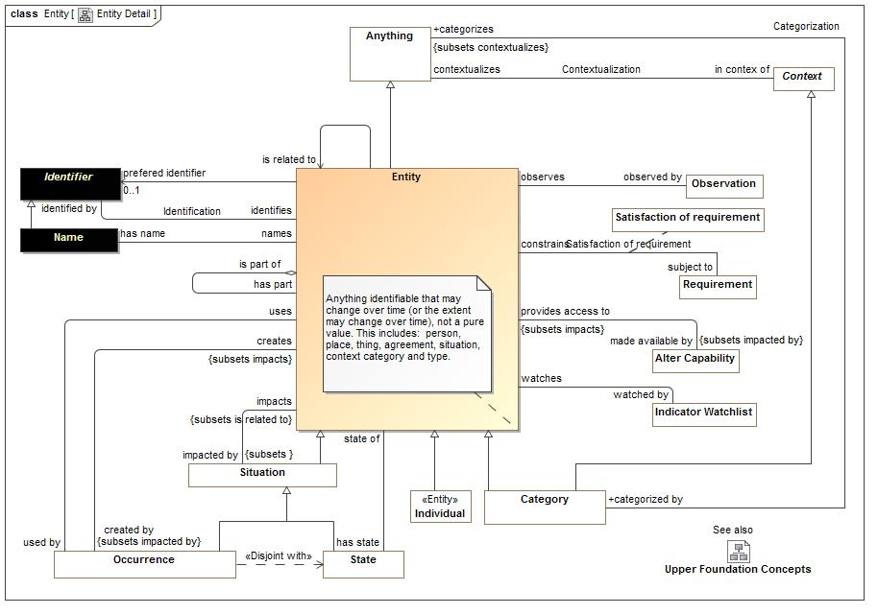

1. Entity Detail

#### Direct Supertypes

Anything

**package** Conceptual Modeling and Mapping Library::Core Concept Library::Foundation

**extends** Anything

#### Associations

1403811134.jpg used by:Occurrence

Occurrences used by an occurrence.

-467416936.jpg is part of:Occurrence

Composite entity of which this entity is a part.

-467416936.jpg has part:Occurrence

A part of something. This a general concept of part and does not assume exclusivity of partness or total part inclusion.

823471263.jpg has state:State

States (or snapshots) of an entity over its lifetime.

-2027135241.jpg created by:Occurrence *Subsets*: impacted by:Situation

Occurrence that created the entity.

-933117107.jpg is related to:Occurrence *Subsets*: impacted by:Situation

A generic relation to capture arbitrary relations that do not have more specific meaning.

1064614199.jpg impacted by:Situation *Subsets*: :Entity

Situations that impact an entity.

1704181353.jpg identified by:Identifier

Identifiers for a concept - note that a concept may have multiple identifiers and they may be context specific.

369499764.jpg has name:Name

Name of anything

-972702961.jpg prefered identifier:Identifier [0..1]

Identifier that should be reported for an entity.

-324390161.jpg watched by:Indicator Watchlist

Watch lists an entity is in.

-1813298664.jpg observed by:Observation

Observations of an entity.

2121882416.jpg made available by:Alter Capability *Subsets*: impacted by:Situation

An act that makes an entity available to an actor as a resource.

#### Inherited Features

***From*** Anything:

‘categorized by’:Category

‘plays role’:Role

‘bound by’:Binding

‘in contex of’:Context

‘described by’:Description

‘stated by’:Source

### Association Generalization

The set of instances contextualized by the specialized context is a subset of the set of instances contextualized by the generalized context.

**package** Conceptual Modeling and Mapping Library::Core Concept Library::Foundation

#### Association Ends

-1988560015.jpg generalizes : Context *Subsets*: impacted by:Situation

The more general role of a generalization.

-1988560015.jpg specializes : Context *Subsets*: impacted by:Situation

The more specific role of a generalization.

### Class Individual

An individual is a person or a specific object, process, agreement, etc. Individuals do not have to be physical but do not include types, categories or values. Individuality (or selfhood) is the state or quality of being an individual; particularly of being a separate from other individuals and possessing identity. Individuals typically have a lifetime and may change over that lifetime. Individuals may have parts and processes that together help define the individual but may change over time. Also known as "Endurant".

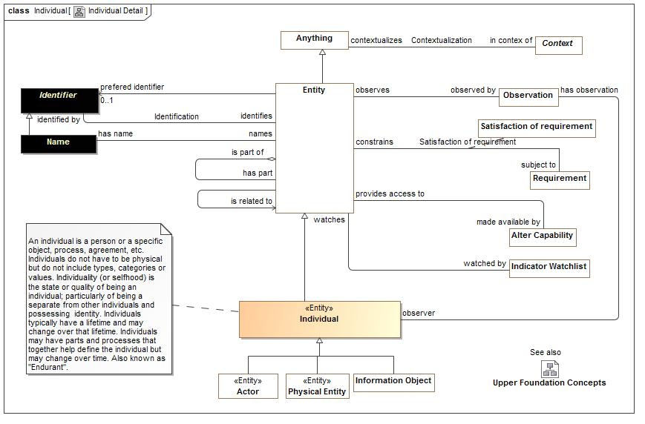

1. Individual Detail

#### Direct Supertypes

Entity

**package** Conceptual Modeling and Mapping Library::Core Concept Library::Foundation

**extends** Entity

#### Associations

-1321993893.jpg has observation:Observation

Observations of something

#### Inherited Features

***From*** Entity:

‘used by’:Occurrence

‘is part of’:Entity

‘has part’:Entity

‘has state’:State

‘created by’:Occurrence

‘is related to’:Entity

‘impacted by’:Situation

‘identified by’:Identifier

‘has name’:Name

‘prefered identifier’:Identifier

‘watched by’:Indicator Watchlist

‘observed by’:Observation

‘made available by’:Alter Capability

***From*** Anything:

‘categorized by’:Category

‘plays role’:Role

‘bound by’:Binding

‘in contex of’:Context

‘described by’:Description

‘stated by’:Source

### Class Occurrence

Anything that happens. A dynamic situation (past, present or future) of a set of things changing over a period of time {Perdurant}. E.g. a rock falling.

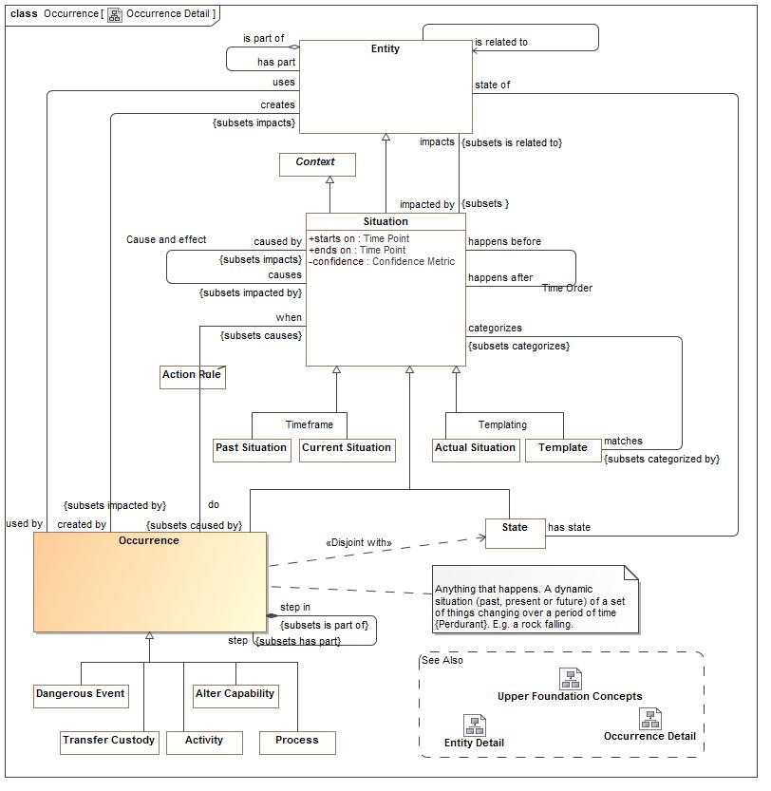

1. Occurrence Detail

#### Direct Supertypes

Situation

**package** Conceptual Modeling and Mapping Library::Core Concept Library::Foundation

**extends** Situation

#### Associations

1403811134.jpg uses:Entity

Occurrences that use an entity.

-2027135241.jpg creates:Entity *Subsets*: impacts:Entity

Anything created by an occurrence.

-826165577.jpg step in:Entity *Subsets*: impacts:Entity

A more granular occurrence of which this is a part.

-826165577.jpg step:Entity *Subsets*: impacts:Entity

A part of an occurence, one step in its execution.

1114599170.jpg when:Situation *Subsets*: causes:Situation

When a situation occurs

#### Inherited Features

***From*** Situation:

‘starts on’:Time Point

‘ends on’:Time Point

‘has binding’:Binding

‘has consequence’:Consequence

‘impacts’:Entity

‘matches’:Template

‘confidence’:Confidence Metric

‘happens before’:Situation

‘happens after’:Situation

‘selects’:Indicator

‘do’:Occurrence

‘course of action’:Process

***From*** Entity:

‘used by’:Occurrence

‘is part of’:Entity

‘has part’:Entity

‘has state’:State

‘created by’:Occurrence

‘is related to’:Entity

‘impacted by’:Situation

‘identified by’:Identifier

‘has name’:Name

‘prefered identifier’:Identifier

‘watched by’:Indicator Watchlist

‘observed by’:Observation

‘made available by’:Alter Capability

***From*** Anything:

‘categorized by’:Category

‘plays role’:Role

‘bound by’:Binding

‘in contex of’:Context

‘described by’:Description

‘stated by’:Source

***From*** Context:

‘generalizes’:Context

‘specializes’:Context

‘contextualizes’:Anything

### Class Role

A realized or potential behavior of an entity with respect to some situation, e.g. Joe is teaching class A123. Entities may have multiple roles that change over time.

#### Direct Supertypes

Type

**package** Conceptual Modeling and Mapping Library::Core Concept Library::Foundation

**extends** Type

#### Associations

1208242139.jpg role of:Anything

Entity that is playing a role. Note: This is the same as the role in a binding but represented at a different "meta level".

1813855882.jpg :Binding

#### Inherited Features

***From*** Category:

‘categorizes’:Anything

***From*** Entity:

‘used by’:Occurrence

‘is part of’:Entity

‘has part’:Entity

‘has state’:State

‘created by’:Occurrence

‘is related to’:Entity

‘impacted by’:Situation

‘identified by’:Identifier

‘has name’:Name

‘prefered identifier’:Identifier

‘watched by’:Indicator Watchlist

‘observed by’:Observation

‘made available by’:Alter Capability

***From*** Anything:

‘categorized by’:Category

‘plays role’:Role

‘bound by’:Binding

‘in contex of’:Context

‘described by’:Description

‘stated by’:Source

***From*** Context:

‘generalizes’:Context

‘specializes’:Context

‘contextualizes’:Anything

### Class Situation

A situation is a particular configuration of things and their relations including spacial, temporal and logical connections between those things valid over a period of time. Situations include property values and instances of associations.  
Situations may be static (the things on a desk) or dynamic (eating lunch), these are called occurrences and states, respectively.  
Situations may be in the past, present or future and include both possible and actual situations.  
Situations is a fundamental concept that spans and connects different domains and concerns.

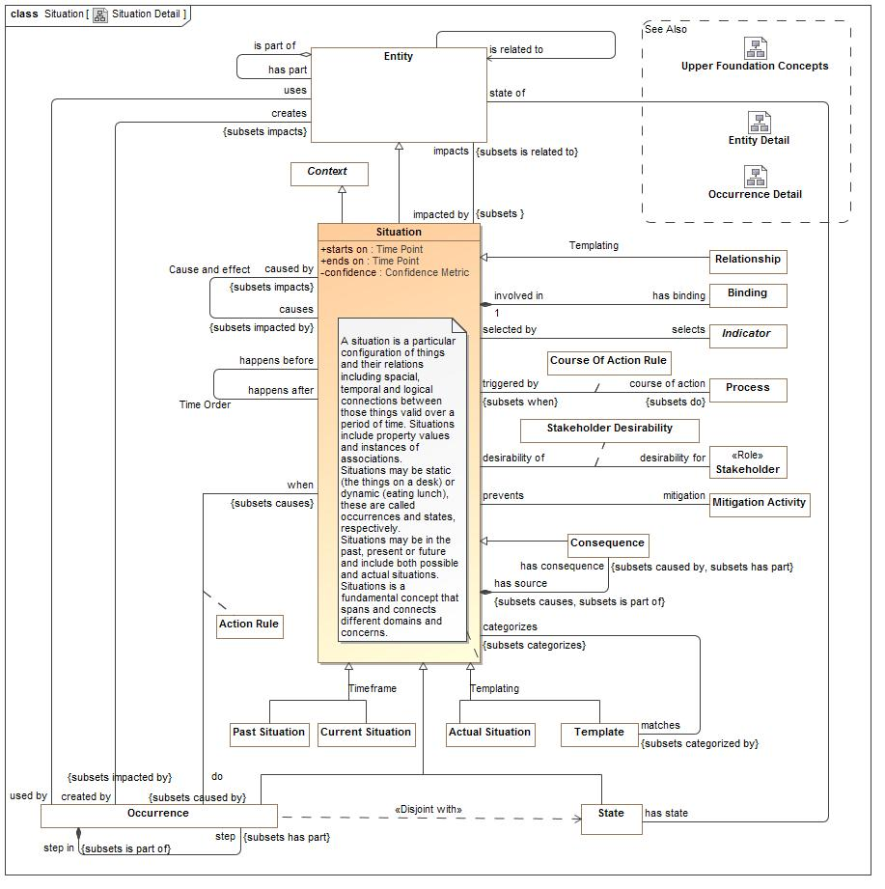

1. Situation Detail

#### Direct Supertypes

Context, Entity

**package** Conceptual Modeling and Mapping Library::Core Concept Library::Foundation

**extends** Entity, Context

#### Attributes

187681857.jpg starts on : Time Point

Time the situation started

241013451.jpg ends on : Time Point

Time the situation ended or will end.

-975232220.jpg confidence : Confidence Metric

Confidence that the situation did or will happen as specified.

#### Associations

2848227.jpg has binding:Binding

The individual playing a role in a situation.

-1829751593.jpg has consequence:Consequence *Subsets*: caused by:Situation has part:Entity

A consequence of a situation that impacts the objectives of a stakeholder.

1064614199.jpg impacts:Entity *Subsets*: is related to:Entity

Entities a situation may affect.

-1457603567.jpg matches:Template *Subsets*: categorized by:Category

Situations that match a template situation.

-80444652.jpg happens before:Template *Subsets*: categorized by:Category

Situations that end before the subject situation starts.

-80444652.jpg happens after:Template *Subsets*: categorized by:Category

Situations that start after the subject situation ends.

414591249.jpg selects:Indicator

Indicator which is in the context of (valid within) the situation.

1114599170.jpg do:Occurrence *Subsets*: caused by:Situation

What to do when a rule is fired.

333654349.jpg course of action:Process *Subsets*: do:Occurrence

The process initiated when triggered by a course of action rule.

#### Inherited Features

***From*** Entity:

‘used by’:Occurrence

‘is part of’:Entity

‘has part’:Entity

‘has state’:State

‘created by’:Occurrence

‘is related to’:Entity

‘impacted by’:Situation

‘identified by’:Identifier

‘has name’:Name

‘prefered identifier’:Identifier

‘watched by’:Indicator Watchlist

‘observed by’:Observation

‘made available by’:Alter Capability

***From*** Anything:

‘categorized by’:Category

‘plays role’:Role

‘bound by’:Binding

‘in contex of’:Context

‘described by’:Description

‘stated by’:Source

***From*** Context:

‘generalizes’:Context

‘specializes’:Context

‘contextualizes’:Anything

### Class State

A static situation - A particular configuration of entities that is static for a time period, including spatial and logical connections between those things {Snapshot of a Perdurant}

#### Direct Supertypes

Situation

**package** Conceptual Modeling and Mapping Library::Core Concept Library::Foundation

**extends** Situation

#### Associations

823471263.jpg state of:Entity

The endurant entity for which the state is a snapshot of.

#### Inherited Features

***From*** Situation:

‘starts on’:Time Point

‘ends on’:Time Point

‘has binding’:Binding

‘has consequence’:Consequence

‘impacts’:Entity

‘matches’:Template

‘confidence’:Confidence Metric

‘happens before’:Situation

‘happens after’:Situation

‘selects’:Indicator

‘do’:Occurrence

‘course of action’:Process

***From*** Entity:

‘used by’:Occurrence

‘is part of’:Entity

‘has part’:Entity

‘has state’:State

‘created by’:Occurrence

‘is related to’:Entity

‘impacted by’:Situation

‘identified by’:Identifier

‘has name’:Name

‘prefered identifier’:Identifier

‘watched by’:Indicator Watchlist

‘observed by’:Observation

‘made available by’:Alter Capability

***From*** Anything:

‘categorized by’:Category

‘plays role’:Role

‘bound by’:Binding

‘in contex of’:Context

‘described by’:Description

‘stated by’:Source

***From*** Context:

‘generalizes’:Context

‘specializes’:Context

‘contextualizes’:Anything

### Association Time Order

**package** Conceptual Modeling and Mapping Library::Core Concept Library::Foundation

#### Association Ends

-80444652.jpg happens after : Situation

Situations that start after the subject situation ends.

-80444652.jpg happens before : Situation

Situations that end before the subject situation starts.

### Class Type

A categorization of concepts about individuals or types based on specific criteria. Related concept "Class".

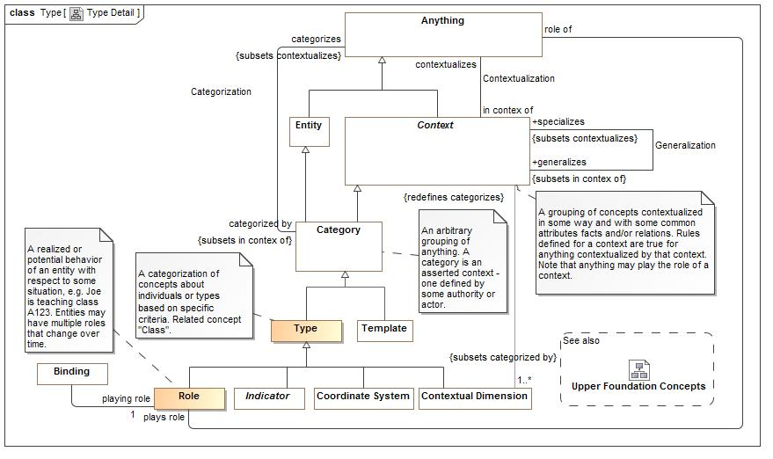

1. Type Detail

#### Direct Supertypes

Category

**package** Conceptual Modeling and Mapping Library::Core Concept Library::Foundation

**extends** Category

#### Inherited Features

***From*** Category:

‘categorizes’:Anything

***From*** Entity:

‘used by’:Occurrence

‘is part of’:Entity

‘has part’:Entity

‘has state’:State

‘created by’:Occurrence

‘is related to’:Entity

‘impacted by’:Situation

‘identified by’:Identifier

‘has name’:Name

‘prefered identifier’:Identifier

‘watched by’:Indicator Watchlist

‘observed by’:Observation

‘made available by’:Alter Capability

***From*** Anything:

‘categorized by’:Category

‘plays role’:Role

‘bound by’:Binding

‘in contex of’:Context

‘described by’:Description

‘stated by’:Source

***From*** Context:

‘generalizes’:Context

‘specializes’:Context

‘contextualizes’:Anything

## Conceptual Modeling and Mapping Library::Core Concept Library::Identifiers

Identification connects *identifiers* with the entity they identify. Identifiers are all assumed to be values, that is they are immutable. If course an entity may be assigned different identifiers over time.

The base Identifier class identifies a set of entities and is not assumed to be unique or to identify only one entity. For example, a name is an identifier but many people could have the same name and a person could have multiple names. Identifiers or the relation to an entity may be contextual.

The class of *Unique Identifiers* is more typical of I.T. systems and managed identifiers, such as drivers license numbers. A unique identifier is assumed unique within exactly one *Namespace*.

Subtypes of Identifier may be specific to identifying particular kinds of entities. For example, a Location Identifier (such as an address or GPS coordinate) is specific to identifying locations.

Note that as with all concepts, identifiers are independent of representation. Since names are so often textual, we also define a representation of names - "Textual Name".

### Diagram: Identifiers

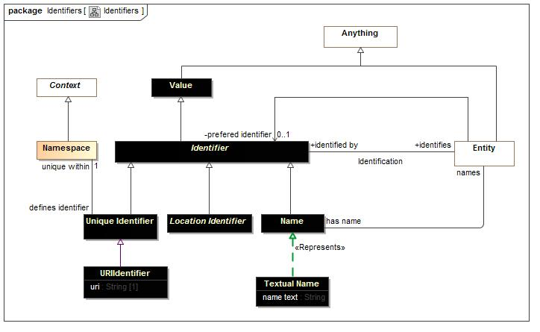

1. Identifiers

### Association Identification

Identification connects an identifier with an entity it identifies. At the top level identification is not necessarily unique, but certain identifiers are unique within a namespace.

**package** Conceptual Modeling and Mapping Library::Core Concept Library::Identifiers

#### Association Ends

1704181353.jpg identifies : Entity

Entity identified by an identifier.

1704181353.jpg identified by : Identifier

Identifiers for a concept - note that a concept may have multiple identifiers and they may be context specific.

### Class Identifier

Anything that is used to identify a concept

#### Direct Supertypes

Value

**package** Conceptual Modeling and Mapping Library::Core Concept Library::Identifiers

**extends** Value

#### Associations

1704181353.jpg identifies:Entity

Entity identified by an identifier.

#### Inherited Features

***From*** Anything:

‘categorized by’:Category

‘plays role’:Role

‘bound by’:Binding

‘in contex of’:Context

‘described by’:Description

‘stated by’:Source

### Class Name

A word or set of words by which a person, animal, place, or thing is known, addressed, or referred to. Names are not nessisaraly unique.

#### Direct Supertypes

Identifier

**package** Conceptual Modeling and Mapping Library::Core Concept Library::Identifiers

**extends** Identifier

#### Associations

369499764.jpg names:Entity

The named entity.

#### Inherited Features

***From*** Identifier:

‘identifies’:Entity

***From*** Anything:

‘categorized by’:Category

‘plays role’:Role

‘bound by’:Binding

‘in contex of’:Context

‘described by’:Description

‘stated by’:Source

### Class Namespace

A context that provides a way to make identifiers unique and identify exactly one entity. For example, the Virginia drivers license division provides unique drivers license numbers.

#### Direct Supertypes

Context

**package** Conceptual Modeling and Mapping Library::Core Concept Library::Identifiers

**extends** Context

#### Associations

-1304768006.jpg defines identifier:Unique Identifier

#### Inherited Features

***From*** Context:

‘generalizes’:Context

‘specializes’:Context

‘contextualizes’:Anything

***From*** Anything:

‘categorized by’:Category

‘plays role’:Role

‘bound by’:Binding

‘in contex of’:Context

‘described by’:Description

‘stated by’:Source

### Class Textual Name

A name represented as text.

**package** Conceptual Modeling and Mapping Library::Core Concept Library::Identifiers

#### Attributes

1827955880.jpg name text : String

A textual representation of a name.

### Class Unique Identifier

An identifier unique within some context

#### Direct Supertypes

Identifier

**package** Conceptual Modeling and Mapping Library::Core Concept Library::Identifiers

**extends** Identifier

#### Associations

-1304768006.jpg unique within:Namespace [1]

Namespace in which an identifier is unique

#### Inherited Features

***From*** Identifier:

‘identifies’:Entity

***From*** Anything:

‘categorized by’:Category

‘plays role’:Role

‘bound by’:Binding

‘in contex of’:Context

‘described by’:Description

‘stated by’:Source

### Class URIIdentifier

A URI Identifier for a concept unique within the W3C URI system.

#### Direct Supertypes

Unique Identifier

**package** Conceptual Modeling and Mapping Library::Core Concept Library::Identifiers

**extends** Unique Identifier

#### Attributes

-612402647.jpg uri : String [1]

A Universal resource identifier text.

#### Inherited Features

***From*** Unique Identifier:

‘unique within’:Namespace

***From*** Identifier:

‘identifies’:Entity

***From*** Anything:

‘categorized by’:Category

‘plays role’:Role

‘bound by’:Binding

‘in contex of’:Context

‘described by’:Description

‘stated by’:Source

## Conceptual Modeling and Mapping Library::Core Concept Library::Process

Processes are templates for (descriptions of) a series of occurrences (activities, events, etc.). Processes may be natural, organizational or carried out by an actor. Processes carried out by an actor are plans.

Processes may require resources - noting that resource can be a role of any entity.

Scenarios are typically less formal processes and describe how a series of occurrences may play out.

### Diagram: Process and plans

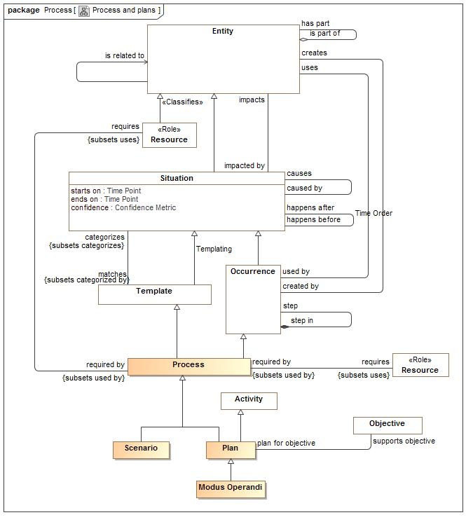

1. Process and plans

### Class Modus Operandi

A particular way or method fro an actor to do something, especially one that is characteristic or well-established.  
In threat terms, a particular tactic, technique or procedure for achieving a result.  
Open question: Can Modus Operandi or "TTP" be distinguished from plan?

#### Direct Supertypes

Plan

**package** Conceptual Modeling and Mapping Library::Core Concept Library::Process

**extends** Plan

#### Inherited Features

***From*** Plan:

‘supports objective’:Objective

***From*** Process:

‘requires’:Resource

‘triggered by’:Situation

***From*** Occurrence:

‘uses’:Entity

‘creates’:Entity

‘step in’:Occurrence

‘step’:Occurrence

‘when’:Situation

***From*** Situation:

‘starts on’:Time Point

‘ends on’:Time Point

‘has binding’:Binding

‘has consequence’:Consequence

‘impacts’:Entity

‘matches’:Template

‘confidence’:Confidence Metric

‘happens before’:Situation

‘happens after’:Situation

‘selects’:Indicator

‘do’:Occurrence

‘course of action’:Process

***From*** Entity:

‘used by’:Occurrence

‘is part of’:Entity

‘has part’:Entity

‘has state’:State

‘created by’:Occurrence

‘is related to’:Entity

‘impacted by’:Situation

‘identified by’:Identifier

‘has name’:Name

‘prefered identifier’:Identifier

‘watched by’:Indicator Watchlist

‘observed by’:Observation

‘made available by’:Alter Capability

***From*** Anything:

‘categorized by’:Category

‘plays role’:Role

‘bound by’:Binding

‘in contex of’:Context

‘described by’:Description

‘stated by’:Source

***From*** Context:

‘generalizes’:Context

‘specializes’:Context

‘contextualizes’:Anything

***From*** Template:

‘categorizes’:Situation

***From*** Category:

‘categorizes’:Anything

***From*** Activity:

‘performed by’:Actor

### Class Plan

A plan is a process definition that supports a stakeholders objective. As a process definition a plan is a template for a series of activities.

#### Direct Supertypes

Activity, Process

**package** Conceptual Modeling and Mapping Library::Core Concept Library::Process

**extends** Process, Activity

#### Associations

508196693.jpg supports objective:Objective

Objectives supported by a plan.

#### Inherited Features

***From*** Process:

‘requires’:Resource

‘triggered by’:Situation

***From*** Occurrence:

‘uses’:Entity

‘creates’:Entity

‘step in’:Occurrence

‘step’:Occurrence

‘when’:Situation

***From*** Situation:

‘starts on’:Time Point

‘ends on’:Time Point

‘has binding’:Binding

‘has consequence’:Consequence

‘impacts’:Entity

‘matches’:Template

‘confidence’:Confidence Metric

‘happens before’:Situation

‘happens after’:Situation

‘selects’:Indicator

‘do’:Occurrence

‘course of action’:Process

***From*** Entity:

‘used by’:Occurrence

‘is part of’:Entity

‘has part’:Entity

‘has state’:State

‘created by’:Occurrence

‘is related to’:Entity

‘impacted by’:Situation

‘identified by’:Identifier

‘has name’:Name

‘prefered identifier’:Identifier

‘watched by’:Indicator Watchlist

‘observed by’:Observation

‘made available by’:Alter Capability

***From*** Anything:

‘categorized by’:Category

‘plays role’:Role

‘bound by’:Binding

‘in contex of’:Context

‘described by’:Description

‘stated by’:Source

***From*** Context:

‘generalizes’:Context

‘specializes’:Context

‘contextualizes’:Anything

***From*** Template:

‘categorizes’:Situation

***From*** Category:

‘categorizes’:Anything

***From*** Activity:

‘performed by’:Actor

### Class Process

A template and definition for a family occurrences (i.e. actions, events) that results in a situation. A plan may be natural or caused by the activities of actors, in which case it is a plan.  
  
Relations of occurrences and situations are utilized by process definitions.

#### Direct Supertypes

Occurrence, Template

**package** Conceptual Modeling and Mapping Library::Core Concept Library::Process

**extends** Occurrence, Template

#### Associations

-139049095.jpg requires:Resource *Subsets*: uses:Entity

A resource required for a process to take place.

333654349.jpg triggered by:Situation *Subsets*: when:Situation

The situation that triggers a course of action

#### Inherited Features

***From*** Occurrence:

‘uses’:Entity

‘creates’:Entity

‘step in’:Occurrence

‘step’:Occurrence

‘when’:Situation

***From*** Situation:

‘starts on’:Time Point

‘ends on’:Time Point

‘has binding’:Binding

‘has consequence’:Consequence

‘impacts’:Entity

‘matches’:Template

‘confidence’:Confidence Metric

‘happens before’:Situation

‘happens after’:Situation

‘selects’:Indicator

‘do’:Occurrence

‘course of action’:Process

***From*** Entity:

‘used by’:Occurrence

‘is part of’:Entity

‘has part’:Entity

‘has state’:State

‘created by’:Occurrence

‘is related to’:Entity

‘impacted by’:Situation

‘identified by’:Identifier

‘has name’:Name

‘prefered identifier’:Identifier

‘watched by’:Indicator Watchlist

‘observed by’:Observation

‘made available by’:Alter Capability

***From*** Anything:

‘categorized by’:Category

‘plays role’:Role

‘bound by’:Binding

‘in contex of’:Context

‘described by’:Description

‘stated by’:Source

***From*** Context:

‘generalizes’:Context

‘specializes’:Context

‘contextualizes’:Anything

***From*** Template:

‘categorizes’:Situation

***From*** Category:

‘categorizes’:Anything

### Class Scenario

A template for a set of occurrences (may be but are not always activities) and resource that formally or informally define how things may happen.

#### Direct Supertypes

Process

**package** Conceptual Modeling and Mapping Library::Core Concept Library::Process

**extends** Process

#### Attributes

-188064948.jpg likelihood : Probability Metric

Possibility that the containing element represents reality.

#### Associations

312529784.jpg results in:Danger *Redefines*: matches:Template

Danger that is a result of a scenario playing out.

#### Inherited Features

***From*** Process:

‘requires’:Resource

‘triggered by’:Situation

***From*** Occurrence:

‘uses’:Entity

‘creates’:Entity

‘step in’:Occurrence

‘step’:Occurrence

‘when’:Situation

***From*** Situation:

‘starts on’:Time Point

‘ends on’:Time Point

‘has binding’:Binding

‘has consequence’:Consequence

‘impacts’:Entity

‘matches’:Template

‘confidence’:Confidence Metric

‘happens before’:Situation

‘happens after’:Situation

‘selects’:Indicator

‘do’:Occurrence

‘course of action’:Process

***From*** Entity:

‘used by’:Occurrence

‘is part of’:Entity

‘has part’:Entity

‘has state’:State

‘created by’:Occurrence

‘is related to’:Entity

‘impacted by’:Situation

‘identified by’:Identifier

‘has name’:Name

‘prefered identifier’:Identifier

‘watched by’:Indicator Watchlist

‘observed by’:Observation

‘made available by’:Alter Capability

***From*** Anything:

‘categorized by’:Category

‘plays role’:Role

‘bound by’:Binding

‘in contex of’:Context

‘described by’:Description

‘stated by’:Source

***From*** Context:

‘generalizes’:Context

‘specializes’:Context

‘contextualizes’:Anything

***From*** Template:

‘categorizes’:Situation

***From*** Category:

‘categorizes’:Anything

## Conceptual Modeling and Mapping Library::Core Concept Library::Quantities and units

Qualities of things are represented with respect to what that thing means, not how it is represented. This introduces multiple "quantity kinds" which derive from *Value* and *Quantity*. Quantiles are stereotyped as "Quantity Kind".

A full system of units based on international standards will be defined as quantity kinds, but only those needed for threat-risk are defined here.

The representation of a value or quantity will typically use the "primitive types" that are fond in I.T. system such as "Integer", "Real" and "String".

### Diagram: Quantities and units

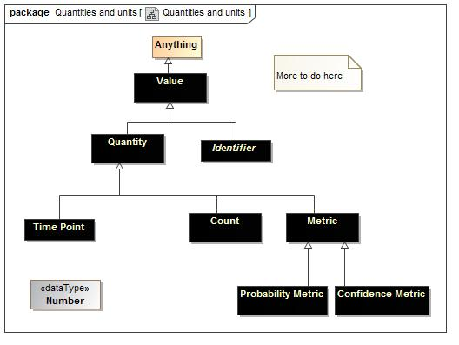

1. Quantities and units

### Class Confidence Metric

Any metric of confidence.

#### Direct Supertypes

Metric

**package** Conceptual Modeling and Mapping Library::Core Concept Library::Quantities and units

**extends** Metric

#### Inherited Features

***From*** Quantity:

‘value’:Number

***From*** Anything:

‘categorized by’:Category

‘plays role’:Role

‘bound by’:Binding

‘in contex of’:Context

‘described by’:Description

‘stated by’:Source

### Class Count

The number of something, e.g. 5 fish.

#### Direct Supertypes

Quantity

**package** Conceptual Modeling and Mapping Library::Core Concept Library::Quantities and units

**extends** Quantity

#### Inherited Features

***From*** Quantity:

‘value’:Number

***From*** Anything:

‘categorized by’:Category

‘plays role’:Role

‘bound by’:Binding

‘in contex of’:Context

‘described by’:Description

‘stated by’:Source

### Class Metric

A standard for measuring or evaluating something, especially one that uses figures or statistics: [Dictionary.com]  
Typical representations of a metric may be a fraction from zero to 1 or a rating such as "high, medium, low".

#### Direct Supertypes

Quantity

**package** Conceptual Modeling and Mapping Library::Core Concept Library::Quantities and units

**extends** Quantity

#### Inherited Features

***From*** Quantity:

‘value’:Number

***From*** Anything:

‘categorized by’:Category

‘plays role’:Role

‘bound by’:Binding

‘in contex of’:Context

‘described by’:Description

‘stated by’:Source

### Class Probability Metric

A metric that represents the possibility that something uncertain will happen.

#### Direct Supertypes

Metric

**package** Conceptual Modeling and Mapping Library::Core Concept Library::Quantities and units

**extends** Metric

#### Inherited Features

***From*** Quantity:

‘value’:Number

***From*** Anything:

‘categorized by’:Category

‘plays role’:Role

‘bound by’:Binding

‘in contex of’:Context

‘described by’:Description

‘stated by’:Source

### Class Quantity

A real scalar quantity, defined and adopted by convention, with which any other quantity of the same quantity kind can be compared to express the ratio of the two quantities as a number. e.g. Degrees Centigrade, Miles. [JCGM 200:2008-Measurement Unit]

#### Direct Supertypes

Value

**package** Conceptual Modeling and Mapping Library::Core Concept Library::Quantities and units

**extends** Value

#### Attributes

1029417053.jpg value : Number

The numeric value of a quantity that is the multiple of the Unit.

#### Inherited Features

***From*** Anything:

‘categorized by’:Category

‘plays role’:Role

‘bound by’:Binding

‘in contex of’:Context

‘described by’:Description

‘stated by’:Source

### Class Time Point

A particular point in time, recognizing that any such point is a duration at a finer level of granularity.

#### Direct Supertypes

Quantity

**package** Conceptual Modeling and Mapping Library::Core Concept Library::Quantities and units

**extends** Quantity

#### Inherited Features

***From*** Quantity:

‘value’:Number

***From*** Anything:

‘categorized by’:Category

‘plays role’:Role

‘bound by’:Binding

‘in contex of’:Context

‘described by’:Description

‘stated by’:Source

### Class Value

A value is an atomic piece of information without a specific lifetime or identity independent of the value. Values include numbers, strings and other atomic "primitive" data.

#### Direct Supertypes

Anything

**package** Conceptual Modeling and Mapping Library::Core Concept Library::Quantities and units

**extends** Anything

#### Inherited Features

***From*** Anything:

‘categorized by’:Category

‘plays role’:Role

‘bound by’:Binding

‘in contex of’:Context

‘described by’:Description

‘stated by’:Source

## Conceptual Modeling and Mapping Library::Core Concept Library::Rules

Rules define conditional behavior that have some condition and some result. The result may be an action (An action rule) or simple to say what must be true (a constraint).

### Diagram: Rules

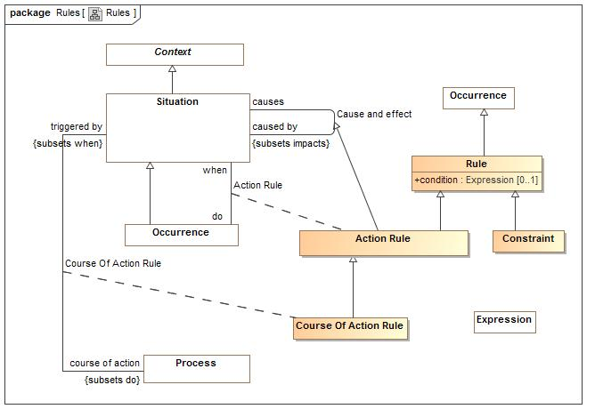

1. Rules

### Association Class Action Rule

A rule triggers a "do" effect when the "when" situation is matched under conditions(s) of the context - a proactive cause and effect.

#### Direct Supertypes

Cause and effect, Rule

**package** Conceptual Modeling and Mapping Library::Core Concept Library::Rules

**extends** Cause and effect, Rule

##### Association Ends

1114599170.jpg when : Situation *Redefines*: matches:Template

When a situation occurs

1114599170.jpg do : Occurrence *Redefines*: matches:Template

What to do when a rule is fired.

#### Inherited Features

***From*** Cause and effect:

‘likelihood’:Probability Metric

‘caused by’:Situation

‘causes’:Situation

***From*** Rule:

‘condition’:Expression

***From*** Occurrence:

‘uses’:Entity

‘creates’:Entity

‘step in’:Occurrence

‘step’:Occurrence

‘when’:Situation

***From*** Situation:

‘starts on’:Time Point

‘ends on’:Time Point

‘has binding’:Binding

‘has consequence’:Consequence

‘impacts’:Entity

‘matches’:Template

‘confidence’:Confidence Metric

‘happens before’:Situation

‘happens after’:Situation

‘selects’:Indicator

‘do’:Occurrence

‘course of action’:Process

***From*** Entity:

‘used by’:Occurrence

‘is part of’:Entity

‘has part’:Entity

‘has state’:State

‘created by’:Occurrence

‘is related to’:Entity

‘impacted by’:Situation

‘identified by’:Identifier

‘has name’:Name

‘prefered identifier’:Identifier

‘watched by’:Indicator Watchlist

‘observed by’:Observation

‘made available by’:Alter Capability

***From*** Anything:

‘categorized by’:Category

‘plays role’:Role

‘bound by’:Binding

‘in contex of’:Context

‘described by’:Description

‘stated by’:Source

***From*** Context:

‘generalizes’:Context

‘specializes’:Context

‘contextualizes’:Anything

### Class Constraint

#### Direct Supertypes

Rule

**package** Conceptual Modeling and Mapping Library::Core Concept Library::Rules

**extends** Rule

#### Inherited Features

***From*** Rule:

‘condition’:Expression

***From*** Occurrence:

‘uses’:Entity

‘creates’:Entity

‘step in’:Occurrence

‘step’:Occurrence

‘when’:Situation

***From*** Situation:

‘starts on’:Time Point

‘ends on’:Time Point

‘has binding’:Binding

‘has consequence’:Consequence

‘impacts’:Entity

‘matches’:Template

‘confidence’:Confidence Metric

‘happens before’:Situation

‘happens after’:Situation

‘selects’:Indicator

‘do’:Occurrence

‘course of action’:Process

***From*** Entity:

‘used by’:Occurrence

‘is part of’:Entity

‘has part’:Entity

‘has state’:State

‘created by’:Occurrence

‘is related to’:Entity

‘impacted by’:Situation

‘identified by’:Identifier

‘has name’:Name

‘prefered identifier’:Identifier

‘watched by’:Indicator Watchlist

‘observed by’:Observation

‘made available by’:Alter Capability

***From*** Anything:

‘categorized by’:Category

‘plays role’:Role

‘bound by’:Binding

‘in contex of’:Context

‘described by’:Description

‘stated by’:Source

***From*** Context:

‘generalizes’:Context

‘specializes’:Context

‘contextualizes’:Anything

### Association Class Course Of Action Rule

A rule to initiate a process as a course of action triggered by a situation.  
A course of action rule is an action that initiates a process. to be performed by some actor or actors.

#### Direct Supertypes

Action Rule

**package** Conceptual Modeling and Mapping Library::Core Concept Library::Rules

**extends** Action Rule

##### Association Ends

333654349.jpg course of action : Process *Redefines*: matches:Template

The process initiated when triggered by a course of action rule.

333654349.jpg triggered by : Situation *Redefines*: matches:Template

The situation that triggers a course of action

#### Inherited Features

***From*** Cause and effect:

‘likelihood’:Probability Metric

‘caused by’:Situation

‘causes’:Situation

***From*** Rule:

‘condition’:Expression

***From*** Occurrence:

‘uses’:Entity

‘creates’:Entity

‘step in’:Occurrence

‘step’:Occurrence

‘when’:Situation

***From*** Situation:

‘starts on’:Time Point

‘ends on’:Time Point

‘has binding’:Binding

‘has consequence’:Consequence

‘impacts’:Entity

‘matches’:Template

‘confidence’:Confidence Metric

‘happens before’:Situation

‘happens after’:Situation

‘selects’:Indicator

‘do’:Occurrence

‘course of action’:Process

***From*** Entity:

‘used by’:Occurrence

‘is part of’:Entity

‘has part’:Entity

‘has state’:State

‘created by’:Occurrence

‘is related to’:Entity

‘impacted by’:Situation

‘identified by’:Identifier

‘has name’:Name

‘prefered identifier’:Identifier

‘watched by’:Indicator Watchlist

‘observed by’:Observation

‘made available by’:Alter Capability

***From*** Anything:

‘categorized by’:Category

‘plays role’:Role

‘bound by’:Binding

‘in contex of’:Context

‘described by’:Description

‘stated by’:Source

***From*** Context:

‘generalizes’:Context

‘specializes’:Context

‘contextualizes’:Anything

### Class Expression

Expressions return a value based on a calculation - todo, more specific.

**package** Conceptual Modeling and Mapping Library::Core Concept Library::Rules

### Class Rule

A statement that defines or constrains some aspect of behavior of an entity (type of entity) or state of a situation (or type of situation).

#### Direct Supertypes

Occurrence

**package** Conceptual Modeling and Mapping Library::Core Concept Library::Rules

**extends** Occurrence

#### Attributes

1542035866.jpg condition : Expression [0..1]

An expression that must be true for a rule to "fire"

#### Inherited Features

***From*** Occurrence:

‘uses’:Entity

‘creates’:Entity

‘step in’:Occurrence

‘step’:Occurrence

‘when’:Situation

***From*** Situation:

‘starts on’:Time Point

‘ends on’:Time Point

‘has binding’:Binding

‘has consequence’:Consequence

‘impacts’:Entity

‘matches’:Template

‘confidence’:Confidence Metric

‘happens before’:Situation

‘happens after’:Situation

‘selects’:Indicator

‘do’:Occurrence

‘course of action’:Process

***From*** Entity:

‘used by’:Occurrence

‘is part of’:Entity

‘has part’:Entity

‘has state’:State

‘created by’:Occurrence

‘is related to’:Entity

‘impacted by’:Situation

‘identified by’:Identifier

‘has name’:Name

‘prefered identifier’:Identifier

‘watched by’:Indicator Watchlist

‘observed by’:Observation

‘made available by’:Alter Capability

***From*** Anything:

‘categorized by’:Category

‘plays role’:Role

‘bound by’:Binding

‘in contex of’:Context

‘described by’:Description

‘stated by’:Source

***From*** Context:

‘generalizes’:Context

‘specializes’:Context

‘contextualizes’:Anything

## Conceptual Modeling and Mapping Library::Core Concept Library::Templates

Templates define patterns and how patterns match actual situations or other patterns. A pattern is a set of bindings that define values or sets of values that together define the template pattern. Actual situations represent individual actual situations that happened, are happening or will happen.

A binding may include Template Involvements which are capable of stating general facts by referencing a Quantification of the possible individuals playing a role.

### Diagram: Templating

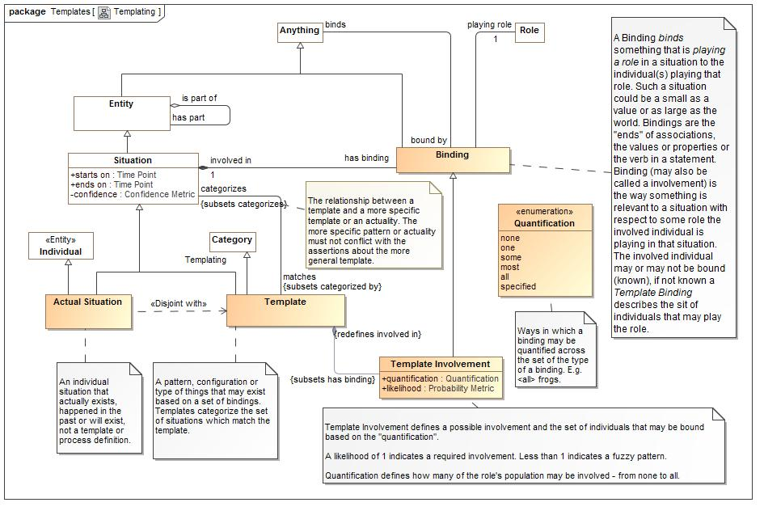

1. Templating

### Class Actual Situation

An individual situation that actually exists, happened in the past or will exist, not a template or process definition.

#### Direct Supertypes

Individual, Situation

**package** Conceptual Modeling and Mapping Library::Core Concept Library::Templates

**extends** Situation, Individual

#### Associations

1842775683.jpg has sighting:Sighting

Sightings that have sighted an actual situation.

-107506044.jpg has observation:Observation

Observations of an actual situation

#### Inherited Features

***From*** Situation:

‘starts on’:Time Point

‘ends on’:Time Point

‘has binding’:Binding

‘has consequence’:Consequence

‘impacts’:Entity

‘matches’:Template

‘confidence’:Confidence Metric

‘happens before’:Situation

‘happens after’:Situation

‘selects’:Indicator

‘do’:Occurrence

‘course of action’:Process

***From*** Entity:

‘used by’:Occurrence

‘is part of’:Entity

‘has part’:Entity

‘has state’:State

‘created by’:Occurrence

‘is related to’:Entity

‘impacted by’:Situation

‘identified by’:Identifier

‘has name’:Name

‘prefered identifier’:Identifier

‘watched by’:Indicator Watchlist

‘observed by’:Observation

‘made available by’:Alter Capability

***From*** Anything:

‘categorized by’:Category

‘plays role’:Role

‘bound by’:Binding

‘in contex of’:Context

‘described by’:Description

‘stated by’:Source

***From*** Context:

‘generalizes’:Context

‘specializes’:Context

‘contextualizes’:Anything

***From*** Individual:

‘has observation’:Observation

### Class Binding

A Binding *binds* something that is *playing a role* in a situation to the individual(s) playing that role. Such a situation could be a small as a value or as large as the world. Bindings are the "ends" of associations, the values or properties or the verb in a statement.

Binding (may also be called a involvement) is the way something is relevant to a situation with respect to some role the involved individual is playing in that situation. The involved individual may or may not be bound (known), if not known a *Template Binding* describes the sit of individuals that may play the role.

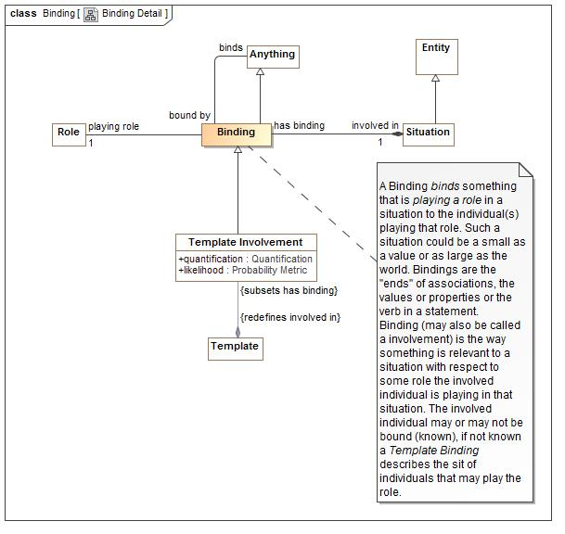

1. Binding Detail

#### Direct Supertypes

Anything

**package** Conceptual Modeling and Mapping Library::Core Concept Library::Templates

**extends** Anything

#### Associations

-697779601.jpg binds:Anything

The entities that are playing roles in a situation.

1813855882.jpg playing role:Role [1]

The individual playing a role in a situation.

2848227.jpg involved in:Situation [1]

The situation a bound entity is playing a role in.

#### Inherited Features

***From*** Anything:

‘categorized by’:Category

‘plays role’:Role

‘bound by’:Binding

‘in contex of’:Context

‘described by’:Description

‘stated by’:Source

### Class Template

A pattern, configuration or type of things that may exist based on a set of bindings. Templates categorize the set of situations which match the template.

#### Direct Supertypes

Category, Situation

**package** Conceptual Modeling and Mapping Library::Core Concept Library::Templates

**extends** Situation, Category

#### Associations

-1457603567.jpg categorizes:Situation *Subsets*: categorizes:Anything

The set of instances matching the template.

-1133628536.jpg :Template Involvement *Subsets*: has binding:Binding

#### Inherited Features

***From*** Situation:

‘starts on’:Time Point

‘ends on’:Time Point

‘has binding’:Binding

‘has consequence’:Consequence

‘impacts’:Entity

‘matches’:Template

‘confidence’:Confidence Metric

‘happens before’:Situation

‘happens after’:Situation

‘selects’:Indicator

‘do’:Occurrence

‘course of action’:Process

***From*** Entity:

‘used by’:Occurrence

‘is part of’:Entity

‘has part’:Entity

‘has state’:State

‘created by’:Occurrence

‘is related to’:Entity

‘impacted by’:Situation

‘identified by’:Identifier

‘has name’:Name

‘prefered identifier’:Identifier

‘watched by’:Indicator Watchlist

‘observed by’:Observation

‘made available by’:Alter Capability

***From*** Anything:

‘categorized by’:Category

‘plays role’:Role

‘bound by’:Binding

‘in contex of’:Context

‘described by’:Description

‘stated by’:Source

***From*** Context:

‘generalizes’:Context

‘specializes’:Context

‘contextualizes’:Anything

***From*** Category:

‘categorizes’:Anything

### Class Template Involvement

Template Involvement defines a possible involvement and the set of individuals that may be bound based on the "quantification".  
  
A likelihood of 1 indicates a required involvement. Less than 1 indicates a fuzzy pattern.  
  
Quantification defines how many of the role's population may be involved - from none to all.

#### Direct Supertypes

Binding

**package** Conceptual Modeling and Mapping Library::Core Concept Library::Templates

**extends** Binding

#### Attributes

-2087144313.jpg quantification : Quantification

The range of individuals covered by a rule or generic statement

936156309.jpg likelihood : Probability Metric

Possibility that the containing element represents reality.

#### Associations

-1133628536.jpg :Template *Redefines*: involved in:Situation

#### Inherited Features

***From*** Binding:

‘binds’:Anything

‘playing role’:Role

‘involved in’:Situation

***From*** Anything:

‘categorized by’:Category

‘plays role’:Role

‘bound by’:Binding

‘in contex of’:Context

‘described by’:Description

‘stated by’:Source

#### Enumeration Quantification

Ways in which a binding may be quantified across the set of the type of a binding. E.g. <all> frogs.

package Conceptual Modeling and Mapping Library::Core Concept Library::Templates

public enum Quantification

{none, one, some, most, all, specified}

##### Literals

-853611586.jpg none

No entities may play this role in this situation

-256680183.jpg one

One entity

233440380.jpg some

Some entities that may play the role

2051576742.jpg most

Most entities that may play the role

-568523439.jpg all

All entities that may play the role

-29973966.jpg specified

Specific (specified) involved entities



1. Templating

## Conceptual Modeling and Mapping Library::Core Concept Library::Timeframe

*Timeframe* segregates situations into those that are in the past, are current and those that are potential. Past and Current situations are *actual situations*. Potential situations are a kind of template for what may happen and have a likelihood.

### Diagram: Timeframe

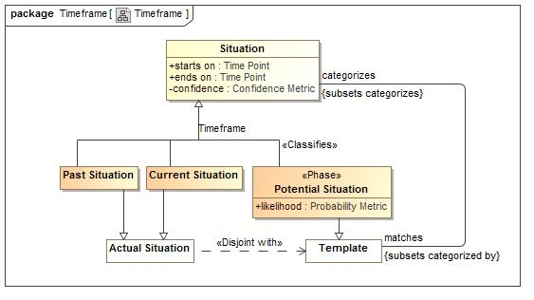

1. Timeframe

### Class Current Situation

A situation that is actully occuring at the moment.

#### Direct Supertypes

Actual Situation, Situation

**package** Conceptual Modeling and Mapping Library::Core Concept Library::Timeframe

**extends** Situation, Actual Situation

#### Inherited Features

***From*** Situation:

‘starts on’:Time Point

‘ends on’:Time Point

‘has binding’:Binding

‘has consequence’:Consequence

‘impacts’:Entity

‘matches’:Template

‘confidence’:Confidence Metric

‘happens before’:Situation

‘happens after’:Situation

‘selects’:Indicator

‘do’:Occurrence

‘course of action’:Process

***From*** Entity:

‘used by’:Occurrence

‘is part of’:Entity

‘has part’:Entity

‘has state’:State

‘created by’:Occurrence

‘is related to’:Entity

‘impacted by’:Situation

‘identified by’:Identifier

‘has name’:Name

‘prefered identifier’:Identifier

‘watched by’:Indicator Watchlist

‘observed by’:Observation

‘made available by’:Alter Capability

***From*** Anything:

‘categorized by’:Category

‘plays role’:Role

‘bound by’:Binding

‘in contex of’:Context

‘described by’:Description

‘stated by’:Source

***From*** Context:

‘generalizes’:Context

‘specializes’:Context

‘contextualizes’:Anything

***From*** Actual Situation:

‘has sighting’:Sighting

‘has observation’:Observation

***From*** Individual:

‘has observation’:Observation

### Class Past Situation

A situation that has actually occurred in the past (recognizing that all such statements are subject to confidence).

#### Direct Supertypes

Actual Situation, Situation

**package** Conceptual Modeling and Mapping Library::Core Concept Library::Timeframe

**extends** Situation, Actual Situation

#### Inherited Features

***From*** Situation:

‘starts on’:Time Point

‘ends on’:Time Point

‘has binding’:Binding

‘has consequence’:Consequence

‘impacts’:Entity

‘matches’:Template

‘confidence’:Confidence Metric

‘happens before’:Situation

‘happens after’:Situation

‘selects’:Indicator

‘do’:Occurrence

‘course of action’:Process

***From*** Entity:

‘used by’:Occurrence

‘is part of’:Entity

‘has part’:Entity

‘has state’:State

‘created by’:Occurrence

‘is related to’:Entity

‘impacted by’:Situation

‘identified by’:Identifier

‘has name’:Name

‘prefered identifier’:Identifier

‘watched by’:Indicator Watchlist

‘observed by’:Observation

‘made available by’:Alter Capability

***From*** Anything:

‘categorized by’:Category

‘plays role’:Role

‘bound by’:Binding

‘in contex of’:Context

‘described by’:Description

‘stated by’:Source

***From*** Context:

‘generalizes’:Context

‘specializes’:Context

‘contextualizes’:Anything

***From*** Actual Situation:

‘has sighting’:Sighting

‘has observation’:Observation

***From*** Individual:

‘has observation’:Observation

### Class Potential Situation

A situation that has not yet started

#### Direct Supertypes

Situation, Template

**package** Conceptual Modeling and Mapping Library::Core Concept Library::Timeframe

**extends** Situation, Template

#### Attributes

-916885931.jpg likelihood : Probability Metric

Possibility that the containing element represents reality.

#### Associations

2057692105.jpg indicated by:Indicator

Indicators of a situation

#### Inherited Features

***From*** Situation:

‘starts on’:Time Point

‘ends on’:Time Point

‘has binding’:Binding

‘has consequence’:Consequence

‘impacts’:Entity

‘matches’:Template

‘confidence’:Confidence Metric

‘happens before’:Situation

‘happens after’:Situation

‘selects’:Indicator

‘do’:Occurrence

‘course of action’:Process

***From*** Entity:

‘used by’:Occurrence

‘is part of’:Entity

‘has part’:Entity

‘has state’:State

‘created by’:Occurrence

‘is related to’:Entity

‘impacted by’:Situation

‘identified by’:Identifier

‘has name’:Name

‘prefered identifier’:Identifier

‘watched by’:Indicator Watchlist

‘observed by’:Observation

‘made available by’:Alter Capability

***From*** Anything:

‘categorized by’:Category

‘plays role’:Role

‘bound by’:Binding

‘in contex of’:Context

‘described by’:Description

‘stated by’:Source

***From*** Context:

‘generalizes’:Context

‘specializes’:Context

‘contextualizes’:Anything

***From*** Template:

‘categorizes’:Situation

***From*** Category:

‘categorizes’:Anything

## Conceptual Modeling and Mapping Library::Core Concept Library::Universal

All associations in the risk/threat model may have "likelihood" and "confidence" measures. Everything can have source metadata which delineates the source artifact and date/time it was referenced. There is no easy way to represent this in UML - we show that all UML associations represent the Situation concept.

### Diagram: Universal

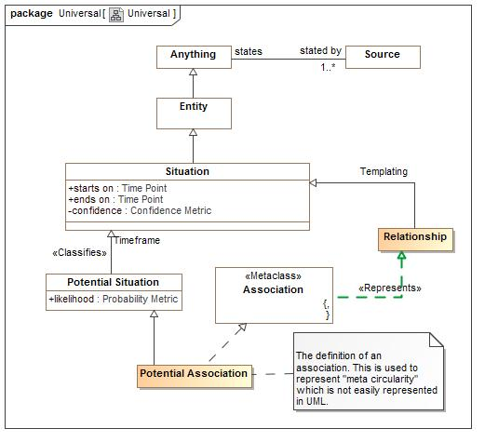

1. Universal

### Class Potential Association

The definition of an association. This is used to represent "meta circularity" which is not easily represented in UML.

#### Direct Supertypes

Potential Situation

**package** Conceptual Modeling and Mapping Library::Core Concept Library::Universal

**extends** Potential Situation

#### Inherited Features

***From*** Potential Situation:

‘likelihood’:Probability Metric

‘indicated by’:Indicator

***From*** Situation:

‘starts on’:Time Point

‘ends on’:Time Point

‘has binding’:Binding

‘has consequence’:Consequence

‘impacts’:Entity

‘matches’:Template

‘confidence’:Confidence Metric

‘happens before’:Situation

‘happens after’:Situation

‘selects’:Indicator

‘do’:Occurrence

‘course of action’:Process

***From*** Entity:

‘used by’:Occurrence

‘is part of’:Entity

‘has part’:Entity

‘has state’:State

‘created by’:Occurrence

‘is related to’:Entity

‘impacted by’:Situation

‘identified by’:Identifier

‘has name’:Name

‘prefered identifier’:Identifier

‘watched by’:Indicator Watchlist

‘observed by’:Observation

‘made available by’:Alter Capability

***From*** Anything:

‘categorized by’:Category

‘plays role’:Role

‘bound by’:Binding

‘in contex of’:Context

‘described by’:Description

‘stated by’:Source

***From*** Context:

‘generalizes’:Context

‘specializes’:Context

‘contextualizes’:Anything

***From*** Template:

‘categorizes’:Situation

***From*** Category:

‘categorizes’:Anything

### Class Relationship

A logical connection between other entities, an instance of the associations in the conceptual model.

#### Direct Supertypes

Situation

**package** Conceptual Modeling and Mapping Library::Core Concept Library::Universal

**extends** Situation

#### Inherited Features

***From*** Situation:

‘starts on’:Time Point

‘ends on’:Time Point

‘has binding’:Binding

‘has consequence’:Consequence

‘impacts’:Entity

‘matches’:Template

‘confidence’:Confidence Metric

‘happens before’:Situation

‘happens after’:Situation

‘selects’:Indicator

‘do’:Occurrence

‘course of action’:Process

***From*** Entity:

‘used by’:Occurrence

‘is part of’:Entity

‘has part’:Entity

‘has state’:State

‘created by’:Occurrence

‘is related to’:Entity

‘impacted by’:Situation

‘identified by’:Identifier

‘has name’:Name

‘prefered identifier’:Identifier

‘watched by’:Indicator Watchlist

‘observed by’:Observation

‘made available by’:Alter Capability

***From*** Anything:

‘categorized by’:Category

‘plays role’:Role

‘bound by’:Binding

‘in contex of’:Context

‘described by’:Description

‘stated by’:Source

***From*** Context:

‘generalizes’:Context

‘specializes’:Context

‘contextualizes’:Anything

## Conceptual Modeling and Mapping Library::Generic Concepts::Actor Associations

Actor associations define the concept of an organization as well as a general concept of associations between actors, including organization membership.

### Diagram: Actor Associations

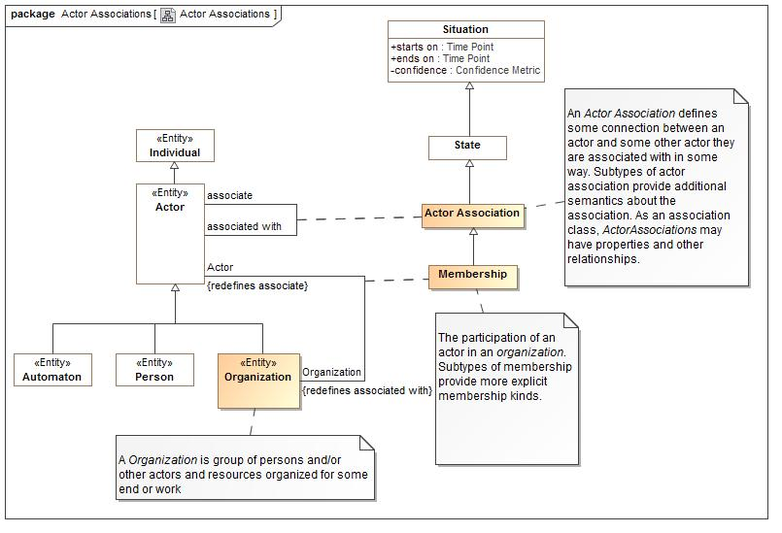

1. Actor Associations

Actor associations define the concept of an organization and provide a general framework for associations between actors with the use of an Actor Association.

### Association Class Actor Association

An *Actor Association* defines some connection between an actor and some other actor they are associated with in some way. Subtypes of actor association provide additional semantics about the association. As an association class, *ActorAssociations* may have properties and other relationships.

#### Direct Supertypes

State

**package** Conceptual Modeling and Mapping Library::Generic Concepts::Actor Associations

**extends** State

##### Association Ends

1763653155.jpg associate : Actor

The actor associated with another.

1763653155.jpg associated with : Actor

Another actor the actor is associated with

#### Inherited Features

***From*** State:

‘state of’:Entity

***From*** Situation:

‘starts on’:Time Point

‘ends on’:Time Point

‘has binding’:Binding

‘has consequence’:Consequence

‘impacts’:Entity

‘matches’:Template

‘confidence’:Confidence Metric

‘happens before’:Situation

‘happens after’:Situation

‘selects’:Indicator

‘do’:Occurrence

‘course of action’:Process

***From*** Entity:

‘used by’:Occurrence

‘is part of’:Entity

‘has part’:Entity

‘has state’:State

‘created by’:Occurrence

‘is related to’:Entity

‘impacted by’:Situation

‘identified by’:Identifier

‘has name’:Name

‘prefered identifier’:Identifier

‘watched by’:Indicator Watchlist

‘observed by’:Observation

‘made available by’:Alter Capability

***From*** Anything:

‘categorized by’:Category

‘plays role’:Role

‘bound by’:Binding

‘in contex of’:Context

‘described by’:Description

‘stated by’:Source

***From*** Context:

‘generalizes’:Context

‘specializes’:Context

‘contextualizes’:Anything

### Association Class Membership

The participation of an actor in an *organization*. Subtypes of membership provide more explicit membership kinds.

#### Direct Supertypes

Actor Association

**package** Conceptual Modeling and Mapping Library::Generic Concepts::Actor Associations

**extends** Actor Association

##### Association Ends

-851364695.jpg Actor : Actor

A Documented Component

-851364695.jpg Organization : Organization

A Documented Component

#### Inherited Features

***From*** Actor Association:

‘associate’:Actor

‘associated with’:Actor

***From*** State:

‘state of’:Entity

***From*** Situation:

‘starts on’:Time Point

‘ends on’:Time Point

‘has binding’:Binding

‘has consequence’:Consequence

‘impacts’:Entity

‘matches’:Template

‘confidence’:Confidence Metric

‘happens before’:Situation

‘happens after’:Situation

‘selects’:Indicator

‘do’:Occurrence

‘course of action’:Process

***From*** Entity:

‘used by’:Occurrence

‘is part of’:Entity

‘has part’:Entity

‘has state’:State

‘created by’:Occurrence

‘is related to’:Entity

‘impacted by’:Situation

‘identified by’:Identifier

‘has name’:Name

‘prefered identifier’:Identifier

‘watched by’:Indicator Watchlist

‘observed by’:Observation

‘made available by’:Alter Capability

***From*** Anything:

‘categorized by’:Category

‘plays role’:Role

‘bound by’:Binding

‘in contex of’:Context

‘described by’:Description

‘stated by’:Source

***From*** Context:

‘generalizes’:Context

‘specializes’:Context

‘contextualizes’:Anything

### Class Organization

A *Organization* is group of persons and/or other actors and resources organized for some end or work

#### Direct Supertypes

Actor

**package** Conceptual Modeling and Mapping Library::Generic Concepts::Actor Associations

**extends** Actor

#### Inherited Features

***From*** Actor:

‘performs’:Activity

‘operates at’:Physical Location

‘contact via’:Contact Information

‘enabled by’:Alter Capability

***From*** Individual:

‘has observation’:Observation

***From*** Entity:

‘used by’:Occurrence

‘is part of’:Entity

‘has part’:Entity

‘has state’:State

‘created by’:Occurrence

‘is related to’:Entity

‘impacted by’:Situation

‘identified by’:Identifier

‘has name’:Name

‘prefered identifier’:Identifier

‘watched by’:Indicator Watchlist

‘observed by’:Observation

‘made available by’:Alter Capability

***From*** Anything:

‘categorized by’:Category

‘plays role’:Role

‘bound by’:Binding

‘in contex of’:Context

‘described by’:Description

‘stated by’:Source

## Conceptual Modeling and Mapping Library::Generic Concepts::Authority

Authority defines a role of an actor that has authoritative influence over a resource. Since resources can be roles of any entity, that resource may be another actor, a thing, a process, etc.

### Diagram: Authority

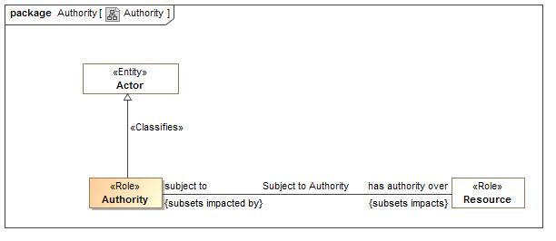

1. Authority

### Class Authority

An actor with authority over resources.

#### Direct Supertypes

Actor

**package** Conceptual Modeling and Mapping Library::Generic Concepts::Authority

**extends** Actor

#### Associations

467609802.jpg has authority over:Resource *Subsets*: impacts:Entity

Resoruces an authority has authority over.

#### Inherited Features

***From*** Actor:

‘performs’:Activity

‘operates at’:Physical Location

‘contact via’:Contact Information

‘enabled by’:Alter Capability

***From*** Individual:

‘has observation’:Observation

***From*** Entity:

‘used by’:Occurrence

‘is part of’:Entity

‘has part’:Entity

‘has state’:State

‘created by’:Occurrence

‘is related to’:Entity

‘impacted by’:Situation

‘identified by’:Identifier

‘has name’:Name

‘prefered identifier’:Identifier

‘watched by’:Indicator Watchlist

‘observed by’:Observation

‘made available by’:Alter Capability

***From*** Anything:

‘categorized by’:Category

‘plays role’:Role

‘bound by’:Binding

‘in contex of’:Context

‘described by’:Description

‘stated by’:Source

### Association Subject to Authority

The relationship between an authority and what it has authority over.

**package** Conceptual Modeling and Mapping Library::Generic Concepts::Authority

#### Association Ends

467609802.jpg has authority over : Resource *Subsets*: impacts:Entity

Resoruces an authority has authority over.

467609802.jpg subject to : Authority *Subsets*: impacts:Entity

The authority that has some control over a resource.

## Conceptual Modeling and Mapping Library::Generic Concepts::Capability

The capability module defines the basic concept of a *capability* as the availability of a resource to an actor. The resource may be specific, such as $5000.00, or general, such as the ability to teach math. Each capability is a state indicating that it has a lifetime and can participate in all the state/situation and entity relations. *Credentials* may be physical or virtual and attest to the capability.

Capabilities are created, enhanced, diminished or eliminated with an *Alter Capability* occurrence. When an actor alters a capability (of themselves or others) they are playing the role of a *Facilitator* who performs an *Alter Capability Act*.

### Diagram: Capability

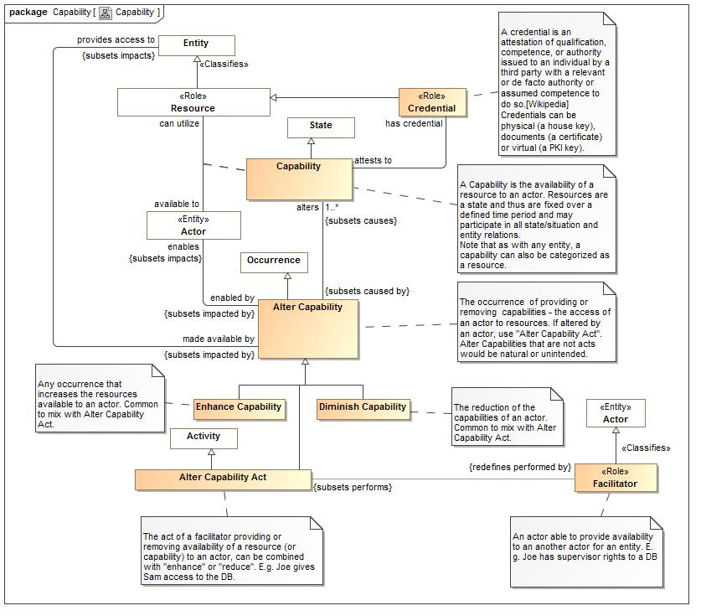

1. Capability

### Class Alter Capability

The occurrence of providing or removing capabilities - the access of an actor to resources. If altered by an actor, use "Alter Capability Act". Alter Capabilities that are not acts would be natural or unintended.

#### Direct Supertypes

Occurrence

**package** Conceptual Modeling and Mapping Library::Generic Concepts::Capability

**extends** Occurrence

#### Associations

-1837839652.jpg alters:Capability [1..*] *Subsets*: causes:Situation

A capability which is enhanced/created or reduced/removed.

2121882416.jpg provides access to:Entity *Subsets*: impacts:Entity

The entity that will be used as the capability of an actor.

1521677897.jpg enables:Actor *Subsets*: impacts:Entity

A resource made available to an actor by an occurrence of the Alter Capability.

#### Inherited Features

***From*** Occurrence:

‘uses’:Entity

‘creates’:Entity

‘step in’:Occurrence

‘step’:Occurrence

‘when’:Situation

***From*** Situation:

‘starts on’:Time Point

‘ends on’:Time Point

‘has binding’:Binding

‘has consequence’:Consequence

‘impacts’:Entity

‘matches’:Template

‘confidence’:Confidence Metric

‘happens before’:Situation

‘happens after’:Situation

‘selects’:Indicator

‘do’:Occurrence

‘course of action’:Process

***From*** Entity:

‘used by’:Occurrence

‘is part of’:Entity

‘has part’:Entity

‘has state’:State

‘created by’:Occurrence

‘is related to’:Entity

‘impacted by’:Situation

‘identified by’:Identifier

‘has name’:Name

‘prefered identifier’:Identifier

‘watched by’:Indicator Watchlist

‘observed by’:Observation

‘made available by’:Alter Capability

***From*** Anything:

‘categorized by’:Category

‘plays role’:Role

‘bound by’:Binding

‘in contex of’:Context

‘described by’:Description

‘stated by’:Source

***From*** Context:

‘generalizes’:Context

‘specializes’:Context

‘contextualizes’:Anything

### Class Alter Capability Act

The act of a facilitator providing or removing availability of a resource (or capability) to an actor, can be combined with "enhance" or "reduce". E.g. Joe gives Sam access to the DB.

#### Direct Supertypes

Activity, Alter Capability

**package** Conceptual Modeling and Mapping Library::Generic Concepts::Capability

**extends** Alter Capability, Activity

#### Associations

-1431170874.jpg :Facilitator *Redefines*: performed by:Actor

#### Inherited Features

***From*** Alter Capability:

‘alters’:Capability

‘provides access to’:Entity

‘enables’:Actor

***From*** Occurrence:

‘uses’:Entity

‘creates’:Entity

‘step in’:Occurrence

‘step’:Occurrence

‘when’:Situation

***From*** Situation:

‘starts on’:Time Point

‘ends on’:Time Point

‘has binding’:Binding

‘has consequence’:Consequence

‘impacts’:Entity

‘matches’:Template

‘confidence’:Confidence Metric

‘happens before’:Situation

‘happens after’:Situation

‘selects’:Indicator

‘do’:Occurrence

‘course of action’:Process

***From*** Entity:

‘used by’:Occurrence

‘is part of’:Entity

‘has part’:Entity

‘has state’:State

‘created by’:Occurrence

‘is related to’:Entity

‘impacted by’:Situation

‘identified by’:Identifier

‘has name’:Name

‘prefered identifier’:Identifier

‘watched by’:Indicator Watchlist

‘observed by’:Observation

‘made available by’:Alter Capability

***From*** Anything:

‘categorized by’:Category

‘plays role’:Role

‘bound by’:Binding

‘in contex of’:Context

‘described by’:Description

‘stated by’:Source

***From*** Context:

‘generalizes’:Context

‘specializes’:Context

‘contextualizes’:Anything

***From*** Activity:

‘performed by’:Actor

### Association Class Capability

A Capability is the availability of a resource to an actor. Resources are a state and thus are fixed over a defined time period and may participate in all state/situation and entity relations.  
Note that as with any entity, a capability can also be categorized as a resource.

#### Direct Supertypes

State

**package** Conceptual Modeling and Mapping Library::Generic Concepts::Capability

**extends** State

##### Association Ends

-65986590.jpg available to : Actor *Redefines*: performed by:Actor

A resource made available to an actor as a part of a capability.

-65986590.jpg can utilize : Resource *Redefines*: performed by:Actor

The resource an actor can utilize as part of a capability.

#### Associations

-1837839652.jpg :Alter Capability *Subsets*: caused by:Situation

-212173931.jpg has credential:Credential

Provides proof of a capability.

#### Inherited Features

***From*** State:

‘state of’:Entity

***From*** Situation:

‘starts on’:Time Point

‘ends on’:Time Point

‘has binding’:Binding

‘has consequence’:Consequence

‘impacts’:Entity

‘matches’:Template

‘confidence’:Confidence Metric

‘happens before’:Situation

‘happens after’:Situation

‘selects’:Indicator

‘do’:Occurrence

‘course of action’:Process

***From*** Entity:

‘used by’:Occurrence

‘is part of’:Entity

‘has part’:Entity

‘has state’:State

‘created by’:Occurrence

‘is related to’:Entity

‘impacted by’:Situation

‘identified by’:Identifier

‘has name’:Name

‘prefered identifier’:Identifier

‘watched by’:Indicator Watchlist

‘observed by’:Observation

‘made available by’:Alter Capability

***From*** Anything:

‘categorized by’:Category

‘plays role’:Role

‘bound by’:Binding

‘in contex of’:Context

‘described by’:Description

‘stated by’:Source

***From*** Context:

‘generalizes’:Context

‘specializes’:Context

‘contextualizes’:Anything

### Class Credential

A credential is an attestation of qualification, competence, or authority issued to an individual by a third party with a relevant or de facto authority or assumed competence to do so.[Wikipedia] Credentials can be physical (a house key), documents (a certificate) or virtual (a PKI key).

#### Direct Supertypes

Resource

**package** Conceptual Modeling and Mapping Library::Generic Concepts::Capability

**extends** Resource

#### Associations

-212173931.jpg attests to:Capability

Cridentialed capability

#### Inherited Features

***From*** Resource:

‘has weakness’:Weakness

‘responsibility of’:Stakeholder

‘supports’:Resource

‘impacted by’:Consequence

‘required by’:Process

‘has vunerability’:Vulnerability

‘depends on’:Resource

‘subject to’:Authority

***From*** Entity:

‘used by’:Occurrence

‘is part of’:Entity

‘has part’:Entity

‘has state’:State

‘created by’:Occurrence

‘is related to’:Entity

‘impacted by’:Situation

‘identified by’:Identifier

‘has name’:Name

‘prefered identifier’:Identifier

‘watched by’:Indicator Watchlist

‘observed by’:Observation

‘made available by’:Alter Capability

***From*** Anything:

‘categorized by’:Category

‘plays role’:Role

‘bound by’:Binding

‘in contex of’:Context

‘described by’:Description

‘stated by’:Source

### Class Diminish Capability

The reduction of the capabilities of an actor. Common to mix with Alter Capability Act.

#### Direct Supertypes

Alter Capability

**package** Conceptual Modeling and Mapping Library::Generic Concepts::Capability

**extends** Alter Capability

#### Inherited Features

***From*** Alter Capability:

‘alters’:Capability

‘provides access to’:Entity

‘enables’:Actor

***From*** Occurrence:

‘uses’:Entity

‘creates’:Entity

‘step in’:Occurrence

‘step’:Occurrence

‘when’:Situation

***From*** Situation:

‘starts on’:Time Point

‘ends on’:Time Point

‘has binding’:Binding

‘has consequence’:Consequence

‘impacts’:Entity

‘matches’:Template

‘confidence’:Confidence Metric

‘happens before’:Situation

‘happens after’:Situation

‘selects’:Indicator

‘do’:Occurrence

‘course of action’:Process

***From*** Entity:

‘used by’:Occurrence

‘is part of’:Entity

‘has part’:Entity

‘has state’:State

‘created by’:Occurrence

‘is related to’:Entity

‘impacted by’:Situation

‘identified by’:Identifier

‘has name’:Name

‘prefered identifier’:Identifier

‘watched by’:Indicator Watchlist

‘observed by’:Observation

‘made available by’:Alter Capability

***From*** Anything:

‘categorized by’:Category

‘plays role’:Role

‘bound by’:Binding

‘in contex of’:Context

‘described by’:Description

‘stated by’:Source

***From*** Context:

‘generalizes’:Context

‘specializes’:Context

‘contextualizes’:Anything

### Class Enhance Capability

Any occurrence that increases the resources available to an actor. Common to mix with Alter Capability Act.

#### Direct Supertypes

Alter Capability

**package** Conceptual Modeling and Mapping Library::Generic Concepts::Capability

**extends** Alter Capability

#### Inherited Features

***From*** Alter Capability:

‘alters’:Capability

‘provides access to’:Entity

‘enables’:Actor

***From*** Occurrence:

‘uses’:Entity

‘creates’:Entity

‘step in’:Occurrence

‘step’:Occurrence

‘when’:Situation

***From*** Situation:

‘starts on’:Time Point

‘ends on’:Time Point

‘has binding’:Binding

‘has consequence’:Consequence

‘impacts’:Entity

‘matches’:Template

‘confidence’:Confidence Metric

‘happens before’:Situation

‘happens after’:Situation

‘selects’:Indicator

‘do’:Occurrence

‘course of action’:Process

***From*** Entity:

‘used by’:Occurrence

‘is part of’:Entity

‘has part’:Entity

‘has state’:State

‘created by’:Occurrence

‘is related to’:Entity

‘impacted by’:Situation

‘identified by’:Identifier

‘has name’:Name

‘prefered identifier’:Identifier

‘watched by’:Indicator Watchlist

‘observed by’:Observation

‘made available by’:Alter Capability

***From*** Anything:

‘categorized by’:Category

‘plays role’:Role

‘bound by’:Binding

‘in contex of’:Context

‘described by’:Description

‘stated by’:Source

***From*** Context:

‘generalizes’:Context

‘specializes’:Context

‘contextualizes’:Anything

### Class Facilitator

An actor able to provide availability to an another actor for an entity. E.g. Joe has supervisor rights to a DB

#### Direct Supertypes

Actor

**package** Conceptual Modeling and Mapping Library::Generic Concepts::Capability

**extends** Actor

#### Associations

-1431170874.jpg :Alter Capability Act *Subsets*: performs:Activity

#### Inherited Features

***From*** Actor:

‘performs’:Activity

‘operates at’:Physical Location

‘contact via’:Contact Information

‘enabled by’:Alter Capability

***From*** Individual:

‘has observation’:Observation

***From*** Entity:

‘used by’:Occurrence

‘is part of’:Entity

‘has part’:Entity

‘has state’:State

‘created by’:Occurrence

‘is related to’:Entity

‘impacted by’:Situation

‘identified by’:Identifier

‘has name’:Name

‘prefered identifier’:Identifier

‘watched by’:Indicator Watchlist

‘observed by’:Observation

‘made available by’:Alter Capability

***From*** Anything:

‘categorized by’:Category

‘plays role’:Role

‘bound by’:Binding

‘in contex of’:Context

‘described by’:Description

‘stated by’:Source

## Conceptual Modeling and Mapping Library::Generic Concepts::Contact Information

The definition of various ways to contact any entity. Subtypes of contact information supply specific formats.

### Diagram: Contact Information

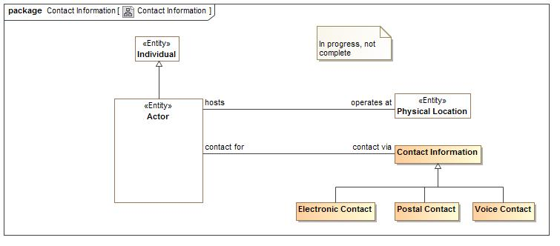

1. Contact Information

### Class Contact Information

Anything that may be used to contact an actor.

**package** Conceptual Modeling and Mapping Library::Generic Concepts::Contact Information

#### Associations

1468165938.jpg contact for:Actor

An actor for which the contact information may be used to context.

### Class Electronic Contact

A means of contact that provides for the electronic transmission of information.

#### Direct Supertypes

Contact Information

**package** Conceptual Modeling and Mapping Library::Generic Concepts::Contact Information

**extends** Contact Information

#### Inherited Features

***From*** Contact Information:

‘contact for’:Actor

### Class Postal Contact

An abstraction for anything that identifies a place to deliver mail. Noting that mail addresses are used for other purposes.

#### Direct Supertypes

Contact Information

**package** Conceptual Modeling and Mapping Library::Generic Concepts::Contact Information

**extends** Contact Information

#### Inherited Features

***From*** Contact Information:

‘contact for’:Actor

### Class Voice Contact

Contact information that enables real-time voice communication. Most likely telephone or VOIP.

#### Direct Supertypes

Contact Information

**package** Conceptual Modeling and Mapping Library::Generic Concepts::Contact Information

**extends** Contact Information

#### Inherited Features

***From*** Contact Information:

‘contact for’:Actor

## Conceptual Modeling and Mapping Library::Generic Concepts::Custody

*Custody* provides a general framework for tracking the control and life cycle of items and information such that the history, trust and provenance may be ascertained. Custody provides for secure supply chains in that the life-cycle or items, information and their parts may be traced.

*Custody* is the relation between a *Custodian* and a *Managed Entity* (Something for which the provenance is interesting).

Trust in a managed entity may also be influenced by the actors that have a capability to impact the resource.

### Diagram: Custody

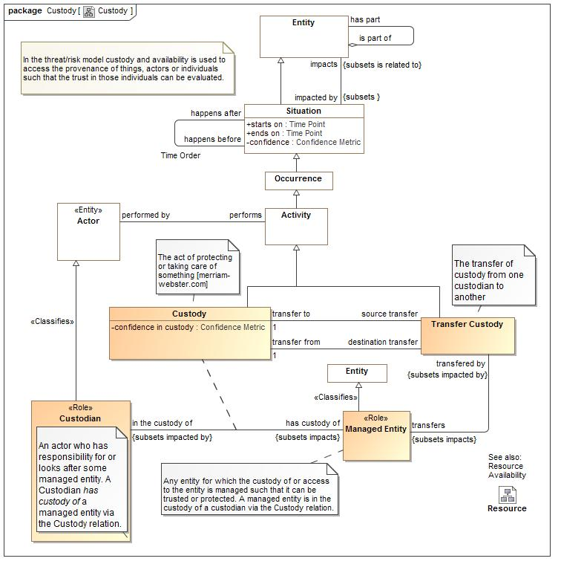

1. Custody

### Class Custodian

An actor who has responsibility for or looks after some managed entity. A Custodian *has custody of* a managed entity via the Custody relation.

#### Direct Supertypes

Actor

**package** Conceptual Modeling and Mapping Library::Generic Concepts::Custody

**extends** Actor

#### Inherited Features

***From*** Actor:

‘performs’:Activity

‘operates at’:Physical Location

‘contact via’:Contact Information

‘enabled by’:Alter Capability

***From*** Individual:

‘has observation’:Observation

***From*** Entity:

‘used by’:Occurrence

‘is part of’:Entity

‘has part’:Entity

‘has state’:State

‘created by’:Occurrence

‘is related to’:Entity

‘impacted by’:Situation

‘identified by’:Identifier

‘has name’:Name

‘prefered identifier’:Identifier

‘watched by’:Indicator Watchlist

‘observed by’:Observation

‘made available by’:Alter Capability

***From*** Anything:

‘categorized by’:Category

‘plays role’:Role

‘bound by’:Binding

‘in contex of’:Context

‘described by’:Description

‘stated by’:Source

### Association Class Custody

The act of protecting or taking care of something [merriam-webster.com]

#### Direct Supertypes

Activity

**package** Conceptual Modeling and Mapping Library::Generic Concepts::Custody

**extends** Activity

##### Association Ends

2109022149.jpg has custody of : Managed Entity

.The entity a custodian has custody of

2109022149.jpg in the custody of : Custodian

The custodian of an entity

#### Attributes

-456290179.jpg confidence in custody : Confidence Metric

Confidence that the custody is trustworthy.

#### Associations

-1490875369.jpg source transfer:Transfer Custody

The transfer providing the custody

-617579961.jpg destination transfer:Transfer Custody

The transfer, transferring custody away.

#### Inherited Features

***From*** Activity:

‘performed by’:Actor

***From*** Occurrence:

‘uses’:Entity

‘creates’:Entity

‘step in’:Occurrence

‘step’:Occurrence

‘when’:Situation

***From*** Situation:

‘starts on’:Time Point

‘ends on’:Time Point

‘has binding’:Binding

‘has consequence’:Consequence

‘impacts’:Entity

‘matches’:Template

‘confidence’:Confidence Metric

‘happens before’:Situation

‘happens after’:Situation

‘selects’:Indicator

‘do’:Occurrence

‘course of action’:Process

***From*** Entity:

‘used by’:Occurrence

‘is part of’:Entity

‘has part’:Entity

‘has state’:State

‘created by’:Occurrence

‘is related to’:Entity

‘impacted by’:Situation

‘identified by’:Identifier

‘has name’:Name

‘prefered identifier’:Identifier

‘watched by’:Indicator Watchlist

‘observed by’:Observation

‘made available by’:Alter Capability

***From*** Anything:

‘categorized by’:Category

‘plays role’:Role

‘bound by’:Binding

‘in contex of’:Context

‘described by’:Description

‘stated by’:Source

***From*** Context:

‘generalizes’:Context

‘specializes’:Context

‘contextualizes’:Anything

### Class Managed Entity

Any entity for which the custody of or access to the entity is managed such that it can be trusted or protected. A managed entity is in the custody of a custodian via the Custody relation.

#### Direct Supertypes

Entity

**package** Conceptual Modeling and Mapping Library::Generic Concepts::Custody

**extends** Entity

#### Associations

-812430666.jpg transfered by:Transfer Custody *Subsets*: impacted by:Situation

A transfer of custody for the entity

#### Inherited Features

***From*** Entity:

‘used by’:Occurrence

‘is part of’:Entity

‘has part’:Entity

‘has state’:State

‘created by’:Occurrence

‘is related to’:Entity

‘impacted by’:Situation

‘identified by’:Identifier

‘has name’:Name

‘prefered identifier’:Identifier

‘watched by’:Indicator Watchlist

‘observed by’:Observation

‘made available by’:Alter Capability

***From*** Anything:

‘categorized by’:Category

‘plays role’:Role

‘bound by’:Binding

‘in contex of’:Context

‘described by’:Description

‘stated by’:Source

### Class Transfer Custody

The transfer of custody from one custodian to another

#### Direct Supertypes

Activity, Occurrence

**package** Conceptual Modeling and Mapping Library::Generic Concepts::Custody

**extends** Occurrence, Activity

#### Associations

-617579961.jpg transfer from:Custody [1]

the custody a transfer, transfers from.

-1490875369.jpg transfer to:Custody [1]

the custody a transfer, transfers to.

-812430666.jpg transfers:Managed Entity *Subsets*: impacts:Entity

The transfered entity

#### Inherited Features

***From*** Occurrence:

‘uses’:Entity

‘creates’:Entity

‘step in’:Occurrence

‘step’:Occurrence

‘when’:Situation

***From*** Situation:

‘starts on’:Time Point

‘ends on’:Time Point

‘has binding’:Binding

‘has consequence’:Consequence

‘impacts’:Entity

‘matches’:Template

‘confidence’:Confidence Metric

‘happens before’:Situation

‘happens after’:Situation

‘selects’:Indicator

‘do’:Occurrence

‘course of action’:Process

***From*** Entity:

‘used by’:Occurrence

‘is part of’:Entity

‘has part’:Entity

‘has state’:State

‘created by’:Occurrence

‘is related to’:Entity

‘impacted by’:Situation

‘identified by’:Identifier

‘has name’:Name

‘prefered identifier’:Identifier

‘watched by’:Indicator Watchlist

‘observed by’:Observation

‘made available by’:Alter Capability

***From*** Anything:

‘categorized by’:Category

‘plays role’:Role

‘bound by’:Binding

‘in contex of’:Context

‘described by’:Description

‘stated by’:Source

***From*** Context:

‘generalizes’:Context

‘specializes’:Context

‘contextualizes’:Anything

***From*** Activity:

‘performed by’:Actor

## Conceptual Modeling and Mapping Library::Generic Concepts::Entity kinds

### Diagram: Entity kinds

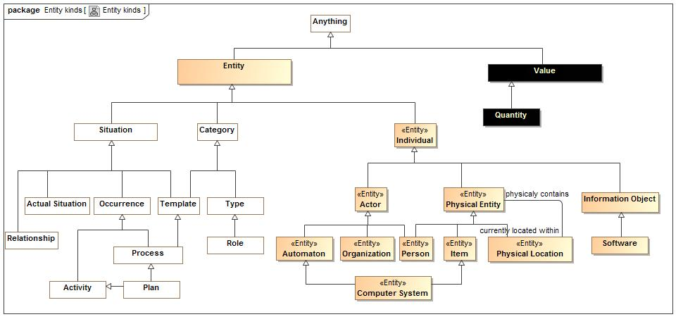

1. Entity kinds

Any thing or value that does or may exist

### Class Automaton

A machine or group of machines (most often a computer system, robot or computerized swarm combined with software) that can perform actions in accordance with a process without another actor directing each step of the process.  
  
Distinguished from simple tools which facilitate an actor performing a process but have no innate capacity to follow such a process.  
  
Also distinguished from "legal entities" and "stakeholders", roles of some actors which indicates the capacity to enter into legally binding agreements or have objectives (at this time no Automatons are legal entities or stakeholders but the model does not preclude the possibility).

#### Direct Supertypes

Actor

**package** Conceptual Modeling and Mapping Library::Generic Concepts::Entity kinds

**extends** Actor

#### Inherited Features

***From*** Actor:

‘performs’:Activity

‘operates at’:Physical Location

‘contact via’:Contact Information

‘enabled by’:Alter Capability

***From*** Individual:

‘has observation’:Observation

***From*** Entity:

‘used by’:Occurrence

‘is part of’:Entity

‘has part’:Entity

‘has state’:State

‘created by’:Occurrence

‘is related to’:Entity

‘impacted by’:Situation

‘identified by’:Identifier

‘has name’:Name

‘prefered identifier’:Identifier

‘watched by’:Indicator Watchlist

‘observed by’:Observation

‘made available by’:Alter Capability

***From*** Anything:

‘categorized by’:Category

‘plays role’:Role

‘bound by’:Binding

‘in contex of’:Context

‘described by’:Description

‘stated by’:Source

### Class Computer System

An identifiable and physical computer system that acts as an automaton agent performing processes.  
  
A programmable electronic device designed to accept data, perform prescribed mathematical and logical operations at high speed, and display the results of these operations. Mainframes, desktop and laptop computers, tablets, and smartphones are some of the different types of computers. [dictionary.com]

#### Direct Supertypes

Automaton, Item

**package** Conceptual Modeling and Mapping Library::Generic Concepts::Entity kinds

**extends** Item, Automaton

#### Inherited Features

***From*** Physical Entity:

‘currently located within’:Physical Location

***From*** Individual:

‘has observation’:Observation

***From*** Entity:

‘used by’:Occurrence

‘is part of’:Entity

‘has part’:Entity

‘has state’:State

‘created by’:Occurrence

‘is related to’:Entity

‘impacted by’:Situation

‘identified by’:Identifier

‘has name’:Name

‘prefered identifier’:Identifier

‘watched by’:Indicator Watchlist

‘observed by’:Observation

‘made available by’:Alter Capability

***From*** Anything:

‘categorized by’:Category

‘plays role’:Role

‘bound by’:Binding

‘in contex of’:Context

‘described by’:Description

‘stated by’:Source

***From*** Actor:

‘performs’:Activity

‘operates at’:Physical Location

‘contact via’:Contact Information

‘enabled by’:Alter Capability

### Class Item

An inanimate material object as distinct from a living sentient being.

#### Direct Supertypes

Physical Entity

**package** Conceptual Modeling and Mapping Library::Generic Concepts::Entity kinds

**extends** Physical Entity

#### Inherited Features

***From*** Physical Entity:

‘currently located within’:Physical Location

***From*** Individual:

‘has observation’:Observation

***From*** Entity:

‘used by’:Occurrence

‘is part of’:Entity

‘has part’:Entity

‘has state’:State

‘created by’:Occurrence

‘is related to’:Entity

‘impacted by’:Situation

‘identified by’:Identifier

‘has name’:Name

‘prefered identifier’:Identifier

‘watched by’:Indicator Watchlist

‘observed by’:Observation

‘made available by’:Alter Capability

***From*** Anything:

‘categorized by’:Category

‘plays role’:Role

‘bound by’:Binding

‘in contex of’:Context

‘described by’:Description

‘stated by’:Source

### Class Physical Entity

A thing that has mass and takes up space including people, places and things.

#### Direct Supertypes

Individual

**package** Conceptual Modeling and Mapping Library::Generic Concepts::Entity kinds

**extends** Individual

#### Associations

1834571903.jpg currently located within:Physical Location

Where something is located.

#### Inherited Features

***From*** Individual:

‘has observation’:Observation

***From*** Entity:

‘used by’:Occurrence

‘is part of’:Entity

‘has part’:Entity

‘has state’:State

‘created by’:Occurrence

‘is related to’:Entity

‘impacted by’:Situation

‘identified by’:Identifier

‘has name’:Name

‘prefered identifier’:Identifier

‘watched by’:Indicator Watchlist

‘observed by’:Observation

‘made available by’:Alter Capability

***From*** Anything:

‘categorized by’:Category

‘plays role’:Role

‘bound by’:Binding

‘in contex of’:Context

‘described by’:Description

‘stated by’:Source

### Diagram: Role Hierarchy

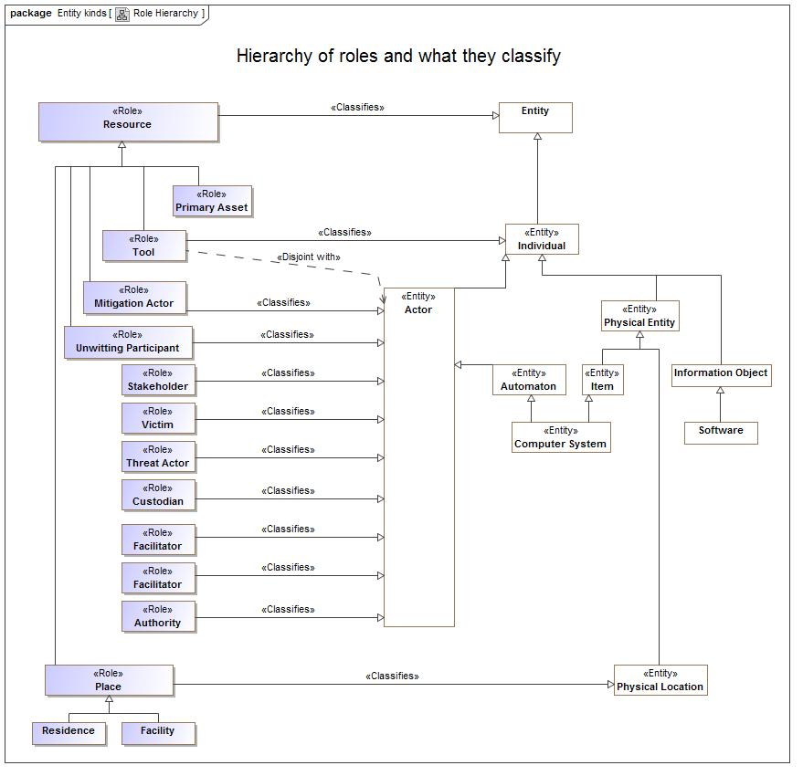

1. Role Hierarchy

#### Known other classes

Class Automaton, Class Computer System, Class Item, Class Physical Entity

## Conceptual Modeling and Mapping Library::Generic Concepts::Information

Concepts relating to information (including data) about entities.

### Diagram: Information foundation

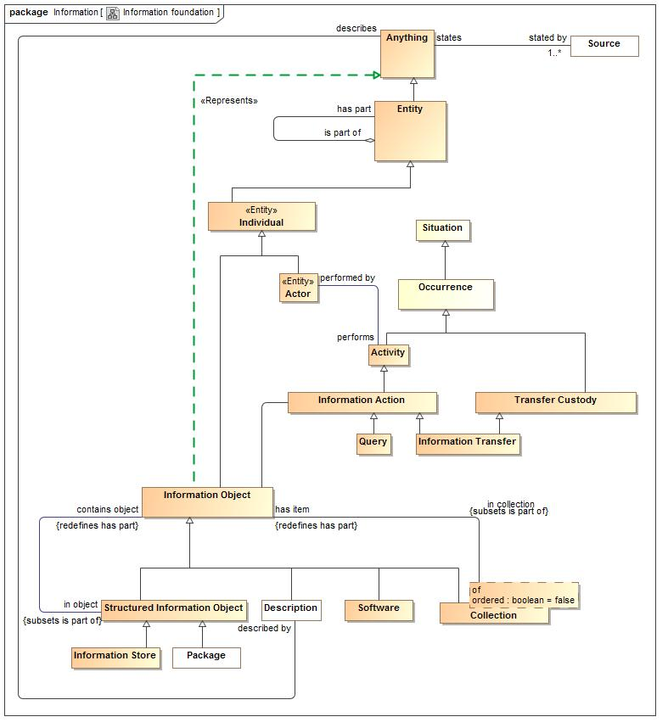

1. Information foundation

### Class Collection

Any group or collection of information.

#### Direct Supertypes

Information Object

**package** Conceptual Modeling and Mapping Library::Generic Concepts::Information

**extends** Information Object

#### Associations

1641579075.jpg has item:Information Object *Redefines*: has part:Entity

One element of a collection, a member of the collection.

#### Inherited Features

***From*** Information Object:

‘in object’:Structured Information Object

‘in collection’:Collection

***From*** Individual:

‘has observation’:Observation

***From*** Entity:

‘used by’:Occurrence

‘is part of’:Entity

‘has part’:Entity

‘has state’:State

‘created by’:Occurrence

‘is related to’:Entity

‘impacted by’:Situation

‘identified by’:Identifier

‘has name’:Name

‘prefered identifier’:Identifier

‘watched by’:Indicator Watchlist

‘observed by’:Observation

‘made available by’:Alter Capability

***From*** Anything:

‘categorized by’:Category

‘plays role’:Role

‘bound by’:Binding

‘in contex of’:Context

‘described by’:Description

‘stated by’:Source

### Class Description

A description of something.

#### Direct Supertypes

Information Object

**package** Conceptual Modeling and Mapping Library::Generic Concepts::Information

**extends** Information Object

#### Associations

885772868.jpg describes:Anything

The concept described by a description.

#### Inherited Features

***From*** Information Object:

‘in object’:Structured Information Object

‘in collection’:Collection

***From*** Individual:

‘has observation’:Observation

***From*** Entity:

‘used by’:Occurrence

‘is part of’:Entity

‘has part’:Entity

‘has state’:State

‘created by’:Occurrence

‘is related to’:Entity

‘impacted by’:Situation

‘identified by’:Identifier

‘has name’:Name

‘prefered identifier’:Identifier

‘watched by’:Indicator Watchlist

‘observed by’:Observation

‘made available by’:Alter Capability

***From*** Anything:

‘categorized by’:Category

‘plays role’:Role

‘bound by’:Binding

‘in contex of’:Context

‘described by’:Description

‘stated by’:Source

### Class Information Action

An action that impacts information objects

#### Direct Supertypes

Activity

**package** Conceptual Modeling and Mapping Library::Generic Concepts::Information

**extends** Activity

#### Associations

941507242.jpg :Information Object

#### Inherited Features

***From*** Activity:

‘performed by’:Actor

***From*** Occurrence:

‘uses’:Entity

‘creates’:Entity

‘step in’:Occurrence

‘step’:Occurrence

‘when’:Situation

***From*** Situation:

‘starts on’:Time Point

‘ends on’:Time Point

‘has binding’:Binding

‘has consequence’:Consequence

‘impacts’:Entity

‘matches’:Template

‘confidence’:Confidence Metric

‘happens before’:Situation

‘happens after’:Situation

‘selects’:Indicator

‘do’:Occurrence

‘course of action’:Process

***From*** Entity:

‘used by’:Occurrence

‘is part of’:Entity

‘has part’:Entity

‘has state’:State

‘created by’:Occurrence

‘is related to’:Entity

‘impacted by’:Situation

‘identified by’:Identifier

‘has name’:Name

‘prefered identifier’:Identifier

‘watched by’:Indicator Watchlist

‘observed by’:Observation

‘made available by’:Alter Capability

***From*** Anything:

‘categorized by’:Category

‘plays role’:Role

‘bound by’:Binding

‘in contex of’:Context

‘described by’:Description

‘stated by’:Source

***From*** Context:

‘generalizes’:Context

‘specializes’:Context

‘contextualizes’:Anything

### Class Information Object

A representation of information/ data/ facts/ assertions/ statements about anything.

#### Direct Supertypes

Individual

**package** Conceptual Modeling and Mapping Library::Generic Concepts::Information

**extends** Individual

#### Associations

665322990.jpg in object:Structured Information Object *Subsets*: is part of:Entity

Where an information is used within another information object.

1641579075.jpg in collection:Collection *Subsets*: is part of:Entity

Collections which contain an information object.

941507242.jpg :Information Action

#### Inherited Features

***From*** Individual:

‘has observation’:Observation

***From*** Entity:

‘used by’:Occurrence

‘is part of’:Entity

‘has part’:Entity

‘has state’:State

‘created by’:Occurrence

‘is related to’:Entity

‘impacted by’:Situation

‘identified by’:Identifier

‘has name’:Name

‘prefered identifier’:Identifier

‘watched by’:Indicator Watchlist

‘observed by’:Observation

‘made available by’:Alter Capability

***From*** Anything:

‘categorized by’:Category

‘plays role’:Role

‘bound by’:Binding

‘in contex of’:Context

‘described by’:Description

‘stated by’:Source

### Class Information Store

A place to put information.

#### Direct Supertypes

Structured Information Object

**package** Conceptual Modeling and Mapping Library::Generic Concepts::Information

**extends** Structured Information Object

#### Inherited Features

***From*** Structured Information Object:

‘contains object’:Information Object

***From*** Information Object:

‘in object’:Structured Information Object

‘in collection’:Collection

***From*** Individual:

‘has observation’:Observation

***From*** Entity:

‘used by’:Occurrence

‘is part of’:Entity

‘has part’:Entity

‘has state’:State

‘created by’:Occurrence

‘is related to’:Entity

‘impacted by’:Situation

‘identified by’:Identifier

‘has name’:Name

‘prefered identifier’:Identifier

‘watched by’:Indicator Watchlist

‘observed by’:Observation

‘made available by’:Alter Capability

***From*** Anything:

‘categorized by’:Category

‘plays role’:Role

‘bound by’:Binding

‘in contex of’:Context

‘described by’:Description

‘stated by’:Source

### Class Information Transfer

The transfer of information from one store to another.

#### Direct Supertypes

Information Action, Transfer Custody

**package** Conceptual Modeling and Mapping Library::Generic Concepts::Information

**extends** Transfer Custody, Information Action

#### Inherited Features

***From*** Transfer Custody:

‘transfer from’:Custody

‘transfer to’:Custody

‘transfers’:Managed Entity

***From*** Occurrence:

‘uses’:Entity

‘creates’:Entity

‘step in’:Occurrence

‘step’:Occurrence

‘when’:Situation

***From*** Situation:

‘starts on’:Time Point

‘ends on’:Time Point

‘has binding’:Binding

‘has consequence’:Consequence

‘impacts’:Entity

‘matches’:Template

‘confidence’:Confidence Metric

‘happens before’:Situation

‘happens after’:Situation

‘selects’:Indicator

‘do’:Occurrence

‘course of action’:Process

***From*** Entity:

‘used by’:Occurrence

‘is part of’:Entity

‘has part’:Entity

‘has state’:State

‘created by’:Occurrence

‘is related to’:Entity

‘impacted by’:Situation

‘identified by’:Identifier

‘has name’:Name

‘prefered identifier’:Identifier

‘watched by’:Indicator Watchlist

‘observed by’:Observation

‘made available by’:Alter Capability

***From*** Anything:

‘categorized by’:Category

‘plays role’:Role

‘bound by’:Binding

‘in contex of’:Context

‘described by’:Description

‘stated by’:Source

***From*** Context:

‘generalizes’:Context

‘specializes’:Context

‘contextualizes’:Anything

***From*** Activity:

‘performed by’:Actor

### Class Package

A group of information objects.

#### Direct Supertypes

Structured Information Object

**package** Conceptual Modeling and Mapping Library::Generic Concepts::Information

**extends** Structured Information Object

#### Inherited Features

***From*** Structured Information Object:

‘contains object’:Information Object

***From*** Information Object:

‘in object’:Structured Information Object

‘in collection’:Collection

***From*** Individual:

‘has observation’:Observation

***From*** Entity:

‘used by’:Occurrence

‘is part of’:Entity

‘has part’:Entity

‘has state’:State

‘created by’:Occurrence

‘is related to’:Entity

‘impacted by’:Situation

‘identified by’:Identifier

‘has name’:Name

‘prefered identifier’:Identifier

‘watched by’:Indicator Watchlist

‘observed by’:Observation

‘made available by’:Alter Capability

***From*** Anything:

‘categorized by’:Category

‘plays role’:Role

‘bound by’:Binding

‘in contex of’:Context

‘described by’:Description

‘stated by’:Source

### Class Query

An activity that returns a subset of a collection.

#### Direct Supertypes

Information Action

**package** Conceptual Modeling and Mapping Library::Generic Concepts::Information

**extends** Information Action

#### Inherited Features

***From*** Activity:

‘performed by’:Actor

***From*** Occurrence:

‘uses’:Entity

‘creates’:Entity

‘step in’:Occurrence

‘step’:Occurrence

‘when’:Situation

***From*** Situation:

‘starts on’:Time Point

‘ends on’:Time Point

‘has binding’:Binding

‘has consequence’:Consequence

‘impacts’:Entity

‘matches’:Template

‘confidence’:Confidence Metric

‘happens before’:Situation

‘happens after’:Situation

‘selects’:Indicator

‘do’:Occurrence

‘course of action’:Process

***From*** Entity:

‘used by’:Occurrence

‘is part of’:Entity

‘has part’:Entity

‘has state’:State

‘created by’:Occurrence

‘is related to’:Entity

‘impacted by’:Situation

‘identified by’:Identifier

‘has name’:Name

‘prefered identifier’:Identifier

‘watched by’:Indicator Watchlist

‘observed by’:Observation

‘made available by’:Alter Capability

***From*** Anything:

‘categorized by’:Category

‘plays role’:Role

‘bound by’:Binding

‘in contex of’:Context

‘described by’:Description

‘stated by’:Source

***From*** Context:

‘generalizes’:Context

‘specializes’:Context

‘contextualizes’:Anything

### Class Software

The programs and other operating information used by a computer.

#### Direct Supertypes

Information Object

**package** Conceptual Modeling and Mapping Library::Generic Concepts::Information

**extends** Information Object

#### Inherited Features

***From*** Information Object:

‘in object’:Structured Information Object

‘in collection’:Collection

***From*** Individual:

‘has observation’:Observation

***From*** Entity:

‘used by’:Occurrence

‘is part of’:Entity

‘has part’:Entity

‘has state’:State

‘created by’:Occurrence

‘is related to’:Entity

‘impacted by’:Situation

‘identified by’:Identifier

‘has name’:Name

‘prefered identifier’:Identifier

‘watched by’:Indicator Watchlist

‘observed by’:Observation

‘made available by’:Alter Capability

***From*** Anything:

‘categorized by’:Category

‘plays role’:Role

‘bound by’:Binding

‘in contex of’:Context

‘described by’:Description

‘stated by’:Source

### Class Source

Metadata defining the source of all statements about anything.

**package** Conceptual Modeling and Mapping Library::Generic Concepts::Information

#### Associations

1401719257.jpg states:Anything

Statements made by an information source. States is metadata, a statement about the assertion, not about the concept it represents.

### Class Structured Information Object

An information bject that has sub-elements. E.g. a "record".

#### Direct Supertypes

Information Object

**package** Conceptual Modeling and Mapping Library::Generic Concepts::Information

**extends** Information Object

#### Associations

665322990.jpg contains object:Information Object *Redefines*: has part:Entity

AN information object contained in another.

#### Inherited Features

***From*** Information Object:

‘in object’:Structured Information Object

‘in collection’:Collection

***From*** Individual:

‘has observation’:Observation

***From*** Entity:

‘used by’:Occurrence

‘is part of’:Entity

‘has part’:Entity

‘has state’:State

‘created by’:Occurrence

‘is related to’:Entity

‘impacted by’:Situation

‘identified by’:Identifier

‘has name’:Name

‘prefered identifier’:Identifier

‘watched by’:Indicator Watchlist

‘observed by’:Observation

‘made available by’:Alter Capability

***From*** Anything:

‘categorized by’:Category

‘plays role’:Role

‘bound by’:Binding

‘in contex of’:Context

‘described by’:Description

‘stated by’:Source

## Conceptual Modeling and Mapping Library::Generic Concepts::Intent

*Intent* captures how the *objectives* of *stakeholders* relate to the real-world *consequences* of *situations* that have or may happen. A *consequence* results in a *benefit* or *harm* to these *objectives* - generally related to a specific entity of value to the stakeholder.

As any situation may have multiple consequences, both benefits and harms, the net desirability of any situation to a stakeholder is calculated in the *Stakeholder Desirability Relation* by combining all of the related consequences.

### Diagram: Intent

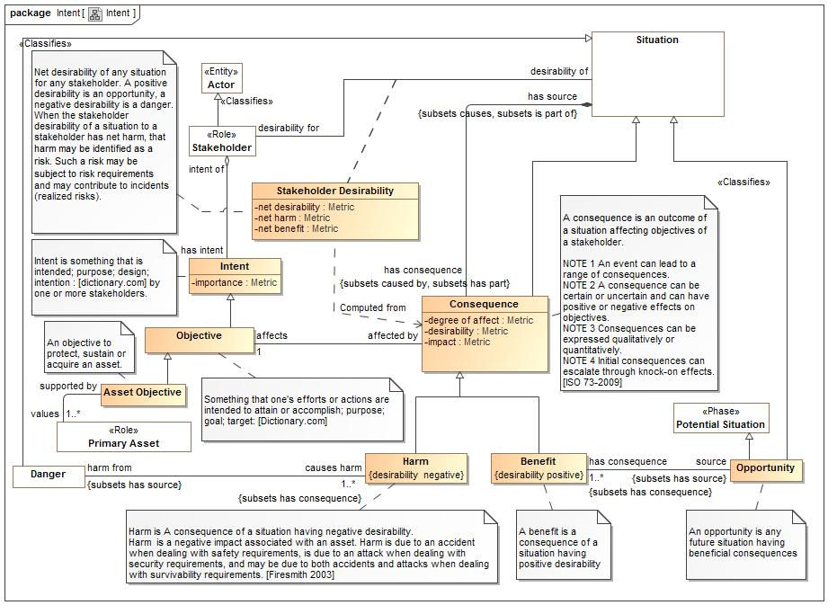

1. Intent

### Class Asset Objective

An objective to protect, sustain or acquire an asset.

#### Direct Supertypes

Objective

**package** Conceptual Modeling and Mapping Library::Generic Concepts::Intent

**extends** Objective

#### Associations

783600193.jpg values:Primary Asset [1..*]

An asset for which there is an objective to create, sustain or prootect the asset.

#### Inherited Features

***From*** Objective:

‘affected by’:Consequence

‘plan for objective’:Plan

***From*** Intent:

‘intent of’:Stakeholder

‘importance’:Metric

### Class Benefit

A benefit is a consequence of a situation having positive desirability

#### Direct Supertypes

Consequence

**package** Conceptual Modeling and Mapping Library::Generic Concepts::Intent

**extends** Consequence

#### Inherited Features

***From*** Consequence:

‘degree of affect’:Metric

‘desirability’:Metric

‘impact’:Metric

‘affects’:Objective

‘has source’:Situation

‘impacts’:Resource

***From*** Situation:

‘starts on’:Time Point

‘ends on’:Time Point

‘has binding’:Binding

‘has consequence’:Consequence

‘impacts’:Entity

‘matches’:Template

‘confidence’:Confidence Metric

‘happens before’:Situation

‘happens after’:Situation

‘selects’:Indicator

‘do’:Occurrence

‘course of action’:Process

***From*** Entity:

‘used by’:Occurrence

‘is part of’:Entity

‘has part’:Entity

‘has state’:State

‘created by’:Occurrence

‘is related to’:Entity

‘impacted by’:Situation

‘identified by’:Identifier

‘has name’:Name

‘prefered identifier’:Identifier

‘watched by’:Indicator Watchlist

‘observed by’:Observation

‘made available by’:Alter Capability

***From*** Anything:

‘categorized by’:Category

‘plays role’:Role

‘bound by’:Binding

‘in contex of’:Context

‘described by’:Description

‘stated by’:Source

***From*** Context:

‘generalizes’:Context

‘specializes’:Context

‘contextualizes’:Anything

### Class Consequence

A consequence is an outcome of a situation affecting objectives of a stakeholder.  
  
NOTE 1 An event can lead to a range of consequences.  
NOTE 2 A consequence can be certain or uncertain and can have positive or negative effects on objectives.  
NOTE 3 Consequences can be expressed qualitatively or quantitatively.  
NOTE 4 Initial consequences can escalate through knock-on effects.  
[ISO 73-2009]

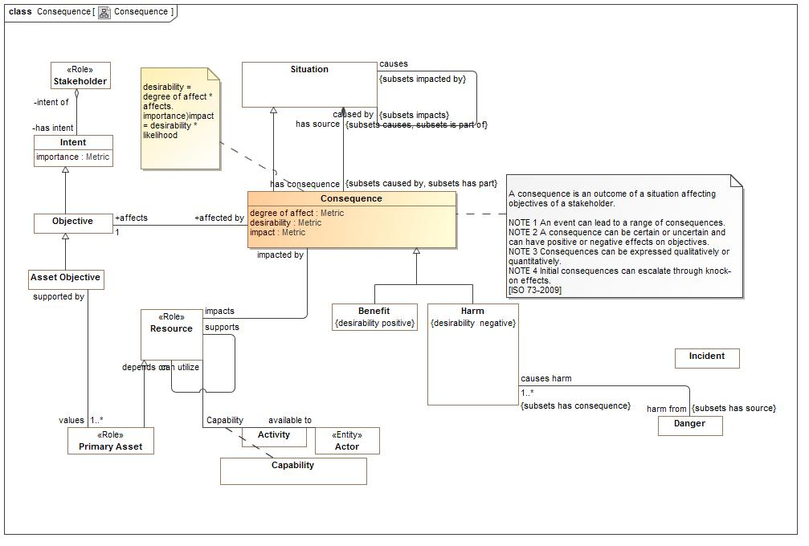

1. Consequence

#### Direct Supertypes

Situation

**package** Conceptual Modeling and Mapping Library::Generic Concepts::Intent

**extends** Situation

#### Attributes

-1634190026.jpg degree of affect : Metric

A metric for how much the consequence affects the objective - how much harm or benefit.

1008303598.jpg desirability : Metric

The desirability of the consequence as importance times degree of affect. May be positive or negative.

-1256606991.jpg impact : Metric

Impact = desirability * likelihood

#### Associations

1386725838.jpg affects:Objective [1]

to act on; produce an effect or change in:

-1829751593.jpg has source:Situation *Subsets*: causes:Situation is part of:Entity

Cause of a consequence.

2059040988.jpg impacts:Resource

Resource a consequence may affect.

#### Inherited Features

***From*** Situation:

‘starts on’:Time Point

‘ends on’:Time Point

‘has binding’:Binding

‘has consequence’:Consequence

‘impacts’:Entity

‘matches’:Template

‘confidence’:Confidence Metric

‘happens before’:Situation

‘happens after’:Situation

‘selects’:Indicator

‘do’:Occurrence

‘course of action’:Process

***From*** Entity:

‘used by’:Occurrence

‘is part of’:Entity

‘has part’:Entity

‘has state’:State

‘created by’:Occurrence

‘is related to’:Entity

‘impacted by’:Situation

‘identified by’:Identifier

‘has name’:Name

‘prefered identifier’:Identifier

‘watched by’:Indicator Watchlist

‘observed by’:Observation

‘made available by’:Alter Capability

***From*** Anything:

‘categorized by’:Category

‘plays role’:Role

‘bound by’:Binding

‘in contex of’:Context

‘described by’:Description

‘stated by’:Source

***From*** Context:

‘generalizes’:Context

‘specializes’:Context

‘contextualizes’:Anything

### Class Harm

Harm is A consequence of a situation having negative desirability.   
Harm is a negative impact associated with an asset. Harm is due to an accident when dealing with safety requirements, is due to an attack when dealing with security requirements, and may be due to both accidents and attacks when dealing with survivability requirements. [Firesmith 2003]

#### Direct Supertypes

Consequence

**package** Conceptual Modeling and Mapping Library::Generic Concepts::Intent

**extends** Consequence

#### Inherited Features

***From*** Consequence:

‘degree of affect’:Metric

‘desirability’:Metric

‘impact’:Metric

‘affects’:Objective

‘has source’:Situation

‘impacts’:Resource

***From*** Situation:

‘starts on’:Time Point

‘ends on’:Time Point

‘has binding’:Binding

‘has consequence’:Consequence

‘impacts’:Entity

‘matches’:Template

‘confidence’:Confidence Metric

‘happens before’:Situation

‘happens after’:Situation

‘selects’:Indicator

‘do’:Occurrence

‘course of action’:Process

***From*** Entity:

‘used by’:Occurrence

‘is part of’:Entity

‘has part’:Entity

‘has state’:State

‘created by’:Occurrence

‘is related to’:Entity

‘impacted by’:Situation

‘identified by’:Identifier

‘has name’:Name

‘prefered identifier’:Identifier

‘watched by’:Indicator Watchlist

‘observed by’:Observation

‘made available by’:Alter Capability

***From*** Anything:

‘categorized by’:Category

‘plays role’:Role

‘bound by’:Binding

‘in contex of’:Context

‘described by’:Description

‘stated by’:Source

***From*** Context:

‘generalizes’:Context

‘specializes’:Context

‘contextualizes’:Anything

### Class Intent

Intent is something that is intended; purpose; design; intention : [dictionary.com] by one or more stakeholders.

**package** Conceptual Modeling and Mapping Library::Generic Concepts::Intent

#### Attributes

1572025937.jpg importance : Metric

Importance of an intent to a stakeholder.

#### Associations

-707726383.jpg intent of:Stakeholder

The stakeholder having an intent.

### Class Objective

Something that one's efforts or actions are intended to attain or accomplish; purpose; goal; target: [Dictionary.com]

#### Direct Supertypes

Intent

**package** Conceptual Modeling and Mapping Library::Generic Concepts::Intent

**extends** Intent

#### Associations

1386725838.jpg affected by:Consequence

to act on; produce an effect or change in:

508196693.jpg plan for objective:Plan

A plan to obtain an objective.

#### Inherited Features

***From*** Intent:

‘intent of’:Stakeholder

‘importance’:Metric

### Class Opportunity

An opportunity is any future situation having beneficial consequences

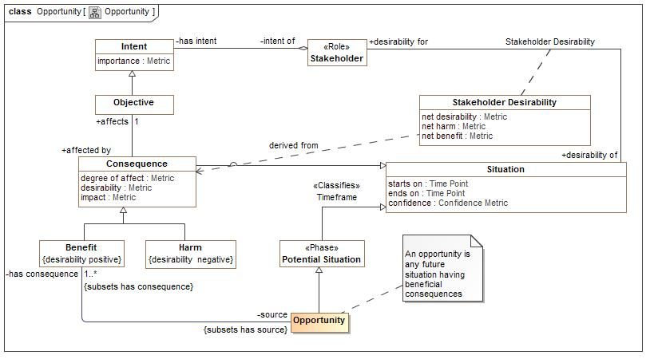

1. Opportunity

#### Direct Supertypes

Potential Situation, Situation

**package** Conceptual Modeling and Mapping Library::Generic Concepts::Intent

**extends** Situation, Potential Situation

#### Inherited Features

***From*** Situation:

‘starts on’:Time Point

‘ends on’:Time Point

‘has binding’:Binding

‘has consequence’:Consequence

‘impacts’:Entity

‘matches’:Template

‘confidence’:Confidence Metric

‘happens before’:Situation

‘happens after’:Situation

‘selects’:Indicator

‘do’:Occurrence

‘course of action’:Process

***From*** Entity:

‘used by’:Occurrence

‘is part of’:Entity

‘has part’:Entity

‘has state’:State

‘created by’:Occurrence

‘is related to’:Entity

‘impacted by’:Situation

‘identified by’:Identifier

‘has name’:Name

‘prefered identifier’:Identifier

‘watched by’:Indicator Watchlist

‘observed by’:Observation

‘made available by’:Alter Capability

***From*** Anything:

‘categorized by’:Category

‘plays role’:Role

‘bound by’:Binding

‘in contex of’:Context

‘described by’:Description

‘stated by’:Source

***From*** Context:

‘generalizes’:Context

‘specializes’:Context

‘contextualizes’:Anything

***From*** Potential Situation:

‘likelihood’:Probability Metric

‘indicated by’:Indicator

***From*** Template:

‘categorizes’:Situation

***From*** Category:

‘categorizes’:Anything

### Class Stakeholder

A person or organization having vested interest in something.

#### Direct Supertypes

Actor

**package** Conceptual Modeling and Mapping Library::Generic Concepts::Intent

**extends** Actor

#### Associations

-707726383.jpg has intent:Intent

Intent of a stakeholder.

2031394894.jpg responsible for:Resource

Resource that a stakeholder manages.

-1067369733.jpg ownes risk:Risk

The stakeholder that manages a risk.

-612095893.jpg assumes risk from:Risk Treatment Option

#### Inherited Features

***From*** Actor:

‘performs’:Activity

‘operates at’:Physical Location

‘contact via’:Contact Information

‘enabled by’:Alter Capability

***From*** Individual:

‘has observation’:Observation

***From*** Entity:

‘used by’:Occurrence

‘is part of’:Entity

‘has part’:Entity

‘has state’:State

‘created by’:Occurrence

‘is related to’:Entity

‘impacted by’:Situation

‘identified by’:Identifier

‘has name’:Name

‘prefered identifier’:Identifier

‘watched by’:Indicator Watchlist

‘observed by’:Observation

‘made available by’:Alter Capability

***From*** Anything:

‘categorized by’:Category

‘plays role’:Role

‘bound by’:Binding

‘in contex of’:Context

‘described by’:Description

‘stated by’:Source

### Association Class Stakeholder Desirability

Net desirability of any situation for any stakeholder. A positive desirability is an opportunity, a negative desirability is a danger.  
When the stakeholder desirability of a situation to a stakeholder has net harm, that harm may be identified as a risk. Such a risk may be subject to risk requirements and may contribute to incidents (realized risks).

**package** Conceptual Modeling and Mapping Library::Generic Concepts::Intent

##### Association Ends

-1601126344.jpg desirability of : Situation

What is desidered.

-1601126344.jpg desirability for : Stakeholder

The stakeholder with a desire.

#### Attributes

1042747320.jpg net desirability : Metric

The aggregation of the impact of all consequences of a situation for a stakeholder. (net benefit - net risk)

1291634017.jpg net harm : Metric

The aggregation of the impact of all detriments (negative consequences) of a situation for a stakeholder.

1030406532.jpg net benefit : Metric

The aggregation of the impact of all Benefits (positive consequences) of a situation for a stakeholder.

#### Associations

389476031.jpg risk of consequences:Risk

Risk that are related to the desirability of a situation to a stakeholder.

## Conceptual Modeling and Mapping Library::Generic Concepts::Location

Concepts about locations and places.

### Diagram: Location

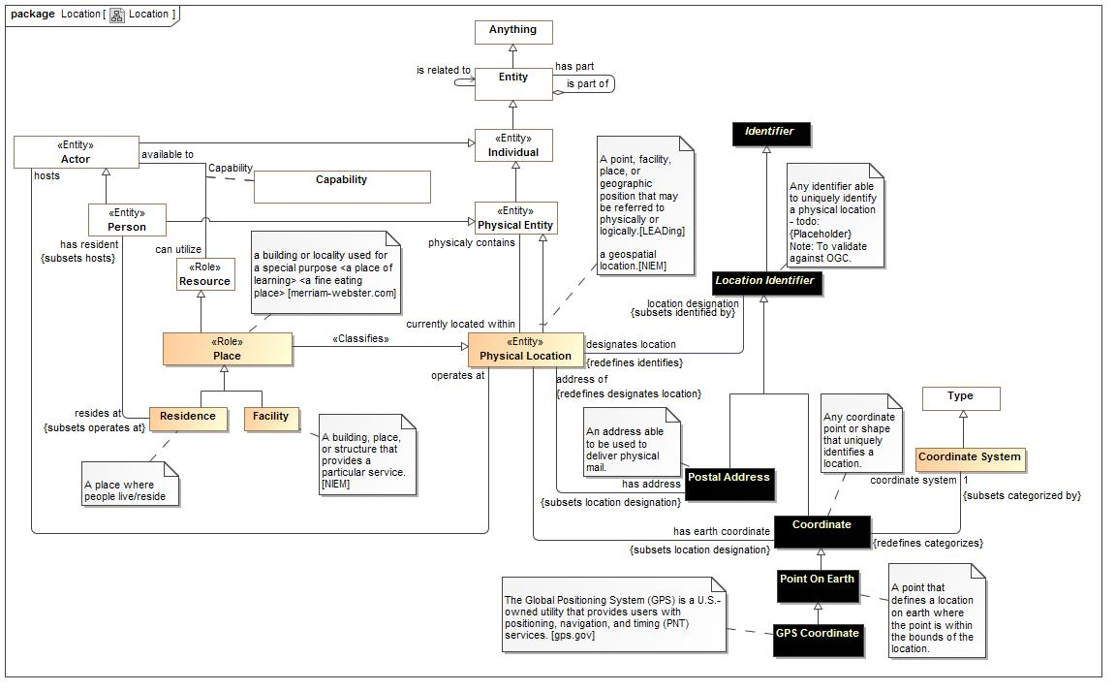

1. Location

### Class Coordinate

Any coordinate point or shape that uniquely identifies a location.

#### Direct Supertypes

Location Identifier

**package** Conceptual Modeling and Mapping Library::Generic Concepts::Location

**extends** Location Identifier

#### Associations

-1320996423.jpg :Physical Location

-1635907773.jpg coordinate system:Coordinate System [1] *Subsets*: categorized by:Category

The coordinate system used for a coordinate.

#### Inherited Features

***From*** Location Identifier:

‘designates location’:Physical Location

***From*** Identifier:

‘identifies’:Entity

***From*** Anything:

‘categorized by’:Category

‘plays role’:Role

‘bound by’:Binding

‘in contex of’:Context

‘described by’:Description

‘stated by’:Source

### Class Coordinate System

A reference system for a coordinate. E.g. WGS-84

#### Direct Supertypes

Type

**package** Conceptual Modeling and Mapping Library::Generic Concepts::Location

**extends** Type

#### Associations

-1635907773.jpg :Coordinate *Redefines*: categorizes:Anything

#### Inherited Features

***From*** Category:

‘categorizes’:Anything

***From*** Entity:

‘used by’:Occurrence

‘is part of’:Entity

‘has part’:Entity

‘has state’:State

‘created by’:Occurrence

‘is related to’:Entity

‘impacted by’:Situation

‘identified by’:Identifier

‘has name’:Name

‘prefered identifier’:Identifier

‘watched by’:Indicator Watchlist

‘observed by’:Observation

‘made available by’:Alter Capability

***From*** Anything:

‘categorized by’:Category

‘plays role’:Role

‘bound by’:Binding

‘in contex of’:Context

‘described by’:Description

‘stated by’:Source

***From*** Context:

‘generalizes’:Context

‘specializes’:Context

‘contextualizes’:Anything

### Class Facility

A building, place, or structure that provides a particular service. [NIEM]

#### Direct Supertypes

Place

**package** Conceptual Modeling and Mapping Library::Generic Concepts::Location

**extends** Place

#### Inherited Features

***From*** Physical Location:

‘physicaly contains’:Physical Entity

‘hosts’:Actor

‘location designation’:Location Identifier

‘has address’:Postal Address

‘has earth coordinate’:Coordinate

***From*** Physical Entity:

‘currently located within’:Physical Location

***From*** Individual:

‘has observation’:Observation

***From*** Entity:

‘used by’:Occurrence

‘is part of’:Entity

‘has part’:Entity

‘has state’:State

‘created by’:Occurrence

‘is related to’:Entity

‘impacted by’:Situation

‘identified by’:Identifier

‘has name’:Name

‘prefered identifier’:Identifier

‘watched by’:Indicator Watchlist

‘observed by’:Observation

‘made available by’:Alter Capability

***From*** Anything:

‘categorized by’:Category

‘plays role’:Role

‘bound by’:Binding

‘in contex of’:Context

‘described by’:Description

‘stated by’:Source

***From*** Resource:

‘has weakness’:Weakness

‘responsibility of’:Stakeholder

‘supports’:Resource

‘impacted by’:Consequence

‘required by’:Process

‘has vunerability’:Vulnerability

‘depends on’:Resource

‘subject to’:Authority

### Class GPS Coordinate

The Global Positioning System (GPS) is a U.S.-owned utility that provides users with positioning, navigation, and timing (PNT) services. [gps.gov]

#### Direct Supertypes

Point On Earth

**package** Conceptual Modeling and Mapping Library::Generic Concepts::Location

**extends** Point On Earth

#### Inherited Features

***From*** Coordinate:

‘coordinate system’:Coordinate System

***From*** Location Identifier:

‘designates location’:Physical Location

***From*** Identifier:

‘identifies’:Entity

***From*** Anything:

‘categorized by’:Category

‘plays role’:Role

‘bound by’:Binding

‘in contex of’:Context

‘described by’:Description

‘stated by’:Source

### Class Location Identifier

Any identifier able to uniquely identify a physical location - todo: {Placeholder} Note: To validate against OGC.

#### Direct Supertypes

Identifier

**package** Conceptual Modeling and Mapping Library::Generic Concepts::Location

**extends** Identifier

#### Associations

-328167001.jpg designates location:Physical Location *Redefines*: identifies:Entity

The location identified

#### Inherited Features

***From*** Identifier:

‘identifies’:Entity

***From*** Anything:

‘categorized by’:Category

‘plays role’:Role

‘bound by’:Binding

‘in contex of’:Context

‘described by’:Description

‘stated by’:Source

### Class Physical Location

A point, facility, place, or geographic position that may be referred to physically or logically.[LEADing]  
  
a geospatial location.[NIEM]

#### Direct Supertypes

Physical Entity

**package** Conceptual Modeling and Mapping Library::Generic Concepts::Location

**extends** Physical Entity

#### Associations

1834571903.jpg physicaly contains:Physical Entity

What something is inside of

1382130166.jpg hosts:Actor

Actors who perform acts at a location

-328167001.jpg location designation:Location Identifier *Subsets*: identified by:Identifier

A way to identify a physical location.

-130330051.jpg has address:Postal Address *Subsets*: location designation:Location Identifier

A postal address of a physical location.

-1320996423.jpg has earth coordinate:Coordinate *Subsets*: location designation:Location Identifier

A coordinate that identifies a a location.

#### Inherited Features

***From*** Physical Entity:

‘currently located within’:Physical Location

***From*** Individual:

‘has observation’:Observation

***From*** Entity:

‘used by’:Occurrence

‘is part of’:Entity

‘has part’:Entity

‘has state’:State

‘created by’:Occurrence

‘is related to’:Entity

‘impacted by’:Situation

‘identified by’:Identifier

‘has name’:Name

‘prefered identifier’:Identifier

‘watched by’:Indicator Watchlist

‘observed by’:Observation

‘made available by’:Alter Capability

***From*** Anything:

‘categorized by’:Category

‘plays role’:Role

‘bound by’:Binding

‘in contex of’:Context

‘described by’:Description

‘stated by’:Source

### Class Place

a building or locality used for a special purpose <a place of learning> <a fine eating place> [merriam-webster.com]

#### Direct Supertypes

Physical Location, Resource

**package** Conceptual Modeling and Mapping Library::Generic Concepts::Location

**extends** Physical Location, Resource

#### Inherited Features

***From*** Physical Location:

‘physicaly contains’:Physical Entity

‘hosts’:Actor

‘location designation’:Location Identifier

‘has address’:Postal Address

‘has earth coordinate’:Coordinate

***From*** Physical Entity:

‘currently located within’:Physical Location

***From*** Individual:

‘has observation’:Observation

***From*** Entity:

‘used by’:Occurrence

‘is part of’:Entity

‘has part’:Entity

‘has state’:State

‘created by’:Occurrence

‘is related to’:Entity

‘impacted by’:Situation

‘identified by’:Identifier

‘has name’:Name

‘prefered identifier’:Identifier

‘watched by’:Indicator Watchlist

‘observed by’:Observation

‘made available by’:Alter Capability

***From*** Anything:

‘categorized by’:Category

‘plays role’:Role

‘bound by’:Binding

‘in contex of’:Context

‘described by’:Description

‘stated by’:Source

***From*** Resource:

‘has weakness’:Weakness

‘responsibility of’:Stakeholder

‘supports’:Resource

‘impacted by’:Consequence

‘required by’:Process

‘has vunerability’:Vulnerability

‘depends on’:Resource

‘subject to’:Authority

### Class Point On Earth

A point that defines a location on earth where the point is within the bounds of the location.

#### Direct Supertypes

Coordinate

**package** Conceptual Modeling and Mapping Library::Generic Concepts::Location

**extends** Coordinate

#### Inherited Features

***From*** Coordinate:

‘coordinate system’:Coordinate System

***From*** Location Identifier:

‘designates location’:Physical Location

***From*** Identifier:

‘identifies’:Entity

***From*** Anything:

‘categorized by’:Category

‘plays role’:Role

‘bound by’:Binding

‘in contex of’:Context

‘described by’:Description

‘stated by’:Source

### Class Postal Address

An address able to be used to deliver physical mail.

#### Direct Supertypes

Location Identifier

**package** Conceptual Modeling and Mapping Library::Generic Concepts::Location

**extends** Location Identifier

#### Associations

-130330051.jpg address of:Physical Location *Redefines*: designates location:Physical Location

Location identified by an address.

#### Inherited Features

***From*** Location Identifier:

‘designates location’:Physical Location

***From*** Identifier:

‘identifies’:Entity

***From*** Anything:

‘categorized by’:Category

‘plays role’:Role

‘bound by’:Binding

‘in contex of’:Context

‘described by’:Description

‘stated by’:Source

### Class Residence

A place where people live/reside

#### Direct Supertypes

Place

**package** Conceptual Modeling and Mapping Library::Generic Concepts::Location

**extends** Place

#### Associations

-1981030601.jpg has resident:Person *Subsets*: hosts:Actor

People living at a residence.

#### Inherited Features

***From*** Physical Location:

‘physicaly contains’:Physical Entity

‘hosts’:Actor

‘location designation’:Location Identifier

‘has address’:Postal Address

‘has earth coordinate’:Coordinate

***From*** Physical Entity:

‘currently located within’:Physical Location

***From*** Individual:

‘has observation’:Observation

***From*** Entity:

‘used by’:Occurrence

‘is part of’:Entity

‘has part’:Entity

‘has state’:State

‘created by’:Occurrence

‘is related to’:Entity

‘impacted by’:Situation

‘identified by’:Identifier

‘has name’:Name

‘prefered identifier’:Identifier

‘watched by’:Indicator Watchlist

‘observed by’:Observation

‘made available by’:Alter Capability

***From*** Anything:

‘categorized by’:Category

‘plays role’:Role

‘bound by’:Binding

‘in contex of’:Context

‘described by’:Description

‘stated by’:Source

***From*** Resource:

‘has weakness’:Weakness

‘responsibility of’:Stakeholder

‘supports’:Resource

‘impacted by’:Consequence

‘required by’:Process

‘has vunerability’:Vulnerability

‘depends on’:Resource

‘subject to’:Authority

## Conceptual Modeling and Mapping Library::Generic Concepts::Observation

Concepts about observations

### Diagram: Observation

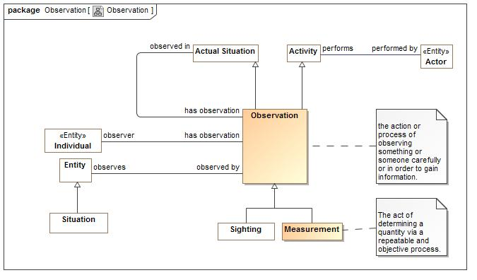

1. Observation

### Class Measurement

The act of determining a quantity via a repeatable and objective process.

#### Direct Supertypes

Observation

**package** Conceptual Modeling and Mapping Library::Generic Concepts::Observation

**extends** Observation

#### Inherited Features

***From*** Observation:

‘observes’:Entity

‘observer’:Individual

‘observed in’:Actual Situation

***From*** Activity:

‘performed by’:Actor

***From*** Occurrence:

‘uses’:Entity

‘creates’:Entity

‘step in’:Occurrence

‘step’:Occurrence

‘when’:Situation

***From*** Situation:

‘starts on’:Time Point

‘ends on’:Time Point

‘has binding’:Binding

‘has consequence’:Consequence

‘impacts’:Entity

‘matches’:Template

‘confidence’:Confidence Metric

‘happens before’:Situation

‘happens after’:Situation

‘selects’:Indicator

‘do’:Occurrence

‘course of action’:Process

***From*** Entity:

‘used by’:Occurrence

‘is part of’:Entity

‘has part’:Entity

‘has state’:State

‘created by’:Occurrence

‘is related to’:Entity

‘impacted by’:Situation

‘identified by’:Identifier

‘has name’:Name

‘prefered identifier’:Identifier

‘watched by’:Indicator Watchlist

‘observed by’:Observation

‘made available by’:Alter Capability

***From*** Anything:

‘categorized by’:Category

‘plays role’:Role

‘bound by’:Binding

‘in contex of’:Context

‘described by’:Description

‘stated by’:Source

***From*** Context:

‘generalizes’:Context

‘specializes’:Context

‘contextualizes’:Anything

***From*** Actual Situation:

‘has sighting’:Sighting

‘has observation’:Observation

***From*** Individual:

‘has observation’:Observation

### Class Observation

the action or process of observing something or someone carefully or in order to gain information.

#### Direct Supertypes

Activity, Actual Situation

**package** Conceptual Modeling and Mapping Library::Generic Concepts::Observation

**extends** Activity, Actual Situation

#### Associations

-1813298664.jpg observes:Entity

The observed entity (individual or situation)

-1321993893.jpg observer:Individual

The observer

-107506044.jpg observed in:Actual Situation

The context in which the observation occurred.

#### Inherited Features

***From*** Activity:

‘performed by’:Actor

***From*** Occurrence:

‘uses’:Entity

‘creates’:Entity

‘step in’:Occurrence

‘step’:Occurrence

‘when’:Situation

***From*** Situation:

‘starts on’:Time Point

‘ends on’:Time Point

‘has binding’:Binding

‘has consequence’:Consequence

‘impacts’:Entity

‘matches’:Template

‘confidence’:Confidence Metric

‘happens before’:Situation

‘happens after’:Situation

‘selects’:Indicator

‘do’:Occurrence

‘course of action’:Process

***From*** Entity:

‘used by’:Occurrence

‘is part of’:Entity

‘has part’:Entity

‘has state’:State

‘created by’:Occurrence

‘is related to’:Entity

‘impacted by’:Situation

‘identified by’:Identifier

‘has name’:Name

‘prefered identifier’:Identifier

‘watched by’:Indicator Watchlist

‘observed by’:Observation

‘made available by’:Alter Capability

***From*** Anything:

‘categorized by’:Category

‘plays role’:Role

‘bound by’:Binding

‘in contex of’:Context

‘described by’:Description

‘stated by’:Source

***From*** Context:

‘generalizes’:Context

‘specializes’:Context

‘contextualizes’:Anything

***From*** Actual Situation:

‘has sighting’:Sighting

‘has observation’:Observation

***From*** Individual:

‘has observation’:Observation

## Conceptual Modeling and Mapping Library::Generic Concepts::Person

The person module defines foundation concepts of people such as their location and name. More specific person attributes may augment this specification.

### Diagram: Person

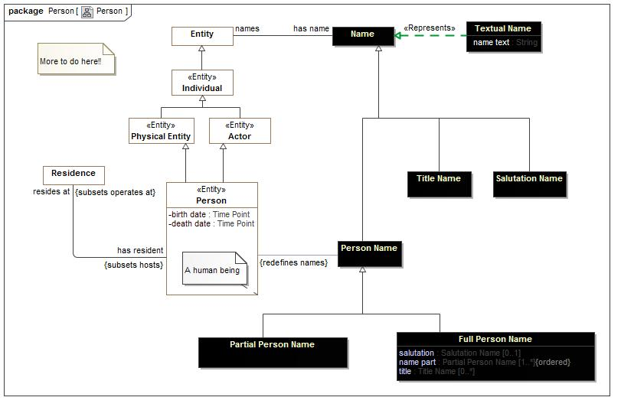

1. Person

### Class Full Person Name

A full name of a person, even if it is represented in a single string.

#### Direct Supertypes

Person Name

**package** Conceptual Modeling and Mapping Library::Generic Concepts::Person

**extends** Person Name

#### Attributes

-596523826.jpg salutation : Salutation Name [0..1]

The prefix of a full name. E.g. Mr.

382916720.jpg name part : Partial Person Name [1..*]

Parts of a name, e.g. surname, given name.

-612425392.jpg title : Title Name [0..*]

Titles, such as Dr.

#### Inherited Features

***From*** Name:

‘names’:Entity

***From*** Identifier:

‘identifies’:Entity

***From*** Anything:

‘categorized by’:Category

‘plays role’:Role

‘bound by’:Binding

‘in contex of’:Context

‘described by’:Description

‘stated by’:Source

### Class Partial Person Name

A single word or phrase used to identify a person, perhaps as part of a full name.

#### Direct Supertypes

Person Name

**package** Conceptual Modeling and Mapping Library::Generic Concepts::Person

**extends** Person Name

#### Inherited Features

***From*** Name:

‘names’:Entity

***From*** Identifier:

‘identifies’:Entity

***From*** Anything:

‘categorized by’:Category

‘plays role’:Role

‘bound by’:Binding

‘in contex of’:Context

‘described by’:Description

‘stated by’:Source

### Class Person

A human being

#### Direct Supertypes

Actor, Physical Entity

**package** Conceptual Modeling and Mapping Library::Generic Concepts::Person

**extends** Physical Entity, Actor

#### Attributes

442708437.jpg birth date : Time Point

1520767396.jpg death date : Time Point

Date the person died, if they did that is.

#### Associations

-1981030601.jpg resides at:Residence *Subsets*: operates at:Physical Location

A residence of a person.

1304730935.jpg :Person Name

#### Inherited Features

***From*** Physical Entity:

‘currently located within’:Physical Location

***From*** Individual:

‘has observation’:Observation

***From*** Entity:

‘used by’:Occurrence

‘is part of’:Entity

‘has part’:Entity

‘has state’:State

‘created by’:Occurrence

‘is related to’:Entity

‘impacted by’:Situation

‘identified by’:Identifier

‘has name’:Name

‘prefered identifier’:Identifier

‘watched by’:Indicator Watchlist

‘observed by’:Observation

‘made available by’:Alter Capability

***From*** Anything:

‘categorized by’:Category

‘plays role’:Role

‘bound by’:Binding

‘in contex of’:Context

‘described by’:Description

‘stated by’:Source

***From*** Actor:

‘performs’:Activity

‘operates at’:Physical Location

‘contact via’:Contact Information

‘enabled by’:Alter Capability

### Class Person Name

Any name identifying a person.

#### Direct Supertypes

Name

**package** Conceptual Modeling and Mapping Library::Generic Concepts::Person

**extends** Name

#### Associations

1304730935.jpg :Person *Redefines*: names:Entity

#### Inherited Features

***From*** Name:

‘names’:Entity

***From*** Identifier:

‘identifies’:Entity

***From*** Anything:

‘categorized by’:Category

‘plays role’:Role

‘bound by’:Binding

‘in contex of’:Context

‘described by’:Description

‘stated by’:Source

### Class Salutation Name

The name of a salutation for a person, Such as. Mr., Mrs.

#### Direct Supertypes

Name

**package** Conceptual Modeling and Mapping Library::Generic Concepts::Person

**extends** Name

#### Inherited Features

***From*** Name:

‘names’:Entity

***From*** Identifier:

‘identifies’:Entity

***From*** Anything:

‘categorized by’:Category

‘plays role’:Role

‘bound by’:Binding

‘in contex of’:Context

‘described by’:Description

‘stated by’:Source

### Class Title Name

The name of a title, such as Dr.

#### Direct Supertypes

Name

**package** Conceptual Modeling and Mapping Library::Generic Concepts::Person

**extends** Name

#### Inherited Features

***From*** Name:

‘names’:Entity

***From*** Identifier:

‘identifies’:Entity

***From*** Anything:

‘categorized by’:Category

‘plays role’:Role

‘bound by’:Binding

‘in contex of’:Context

‘described by’:Description

‘stated by’:Source

## Conceptual Modeling and Mapping Library::Generic Concepts::Requirements

Concepts about requirements.

### Diagram: Requirements

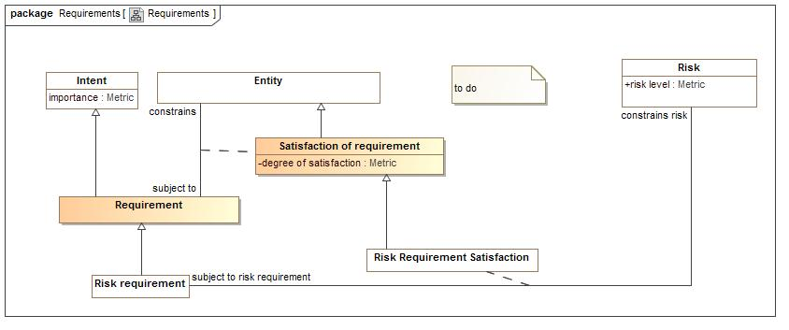

1. Requirements

### Class Requirement

a thing that is compulsory; a necessary condition.  
a statement that identifies a necessary attribute, capability, characteristic, or quality of a system for it to have value and utility to a customer, organization, internal user, or other stakeholder

#### Direct Supertypes

Intent

**package** Conceptual Modeling and Mapping Library::Generic Concepts::Requirements

**extends** Intent

#### Inherited Features

***From*** Intent:

‘intent of’:Stakeholder

‘importance’:Metric

### Association Class Satisfaction of requirement

A requirement something is subject to

#### Direct Supertypes

Entity

**package** Conceptual Modeling and Mapping Library::Generic Concepts::Requirements

**extends** Entity

##### Association Ends

895338587.jpg constrains : Entity *Redefines*: names:Entity

anything constrained by a requirement

895338587.jpg subject to : Requirement *Redefines*: names:Entity

A requirement that is being satisfied.

#### Attributes

-1044816214.jpg degree of satisfaction : Metric

A metric for how much a reqwuirement is satisfied.

#### Inherited Features

***From*** Entity:

‘used by’:Occurrence

‘is part of’:Entity

‘has part’:Entity

‘has state’:State

‘created by’:Occurrence

‘is related to’:Entity

‘impacted by’:Situation

‘identified by’:Identifier

‘has name’:Name

‘prefered identifier’:Identifier

‘watched by’:Indicator Watchlist

‘observed by’:Observation

‘made available by’:Alter Capability

***From*** Anything:

‘categorized by’:Category

‘plays role’:Role

‘bound by’:Binding

‘in contex of’:Context

‘described by’:Description

‘stated by’:Source

## Conceptual Modeling and Mapping Library::Generic Concepts::Resources

A resource is a role of any entity such that it can play a role in a process, impact the objectives of stakeholders and be the basis of a capability of an actor.

As a role Resource is intended to "mix in" with an entity type such as "Person" or "Process" such that the use of that entity may be understood.

Resources that are a Primary Asset are those that are the direct subject of a stakeholders objectives.

### Diagram: Resource

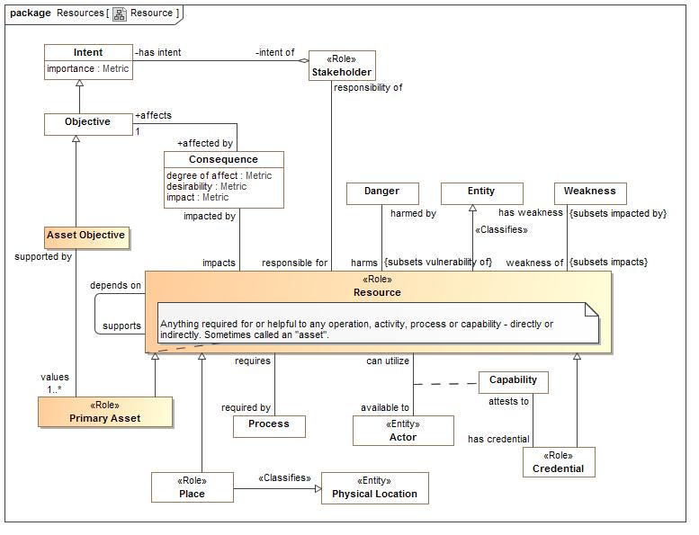

1. Resource

### Class Primary Asset

A system, organization, thing, or person that is the direct concern of a stakeholder

#### Direct Supertypes

Resource

**package** Conceptual Modeling and Mapping Library::Generic Concepts::Resources

**extends** Resource

#### Associations

783600193.jpg supported by:Asset Objective

An objective that supports the creation, sustainment or safety of a resource or asset.

-17417802.jpg has risk:Risk *Subsets*: harmed by:Danger

Risks to a resource of interest.

#### Inherited Features

***From*** Resource:

‘has weakness’:Weakness

‘responsibility of’:Stakeholder

‘supports’:Resource

‘impacted by’:Consequence

‘required by’:Process

‘has vunerability’:Vulnerability

‘depends on’:Resource

‘subject to’:Authority

***From*** Entity:

‘used by’:Occurrence

‘is part of’:Entity

‘has part’:Entity

‘has state’:State

‘created by’:Occurrence

‘is related to’:Entity

‘impacted by’:Situation

‘identified by’:Identifier

‘has name’:Name

‘prefered identifier’:Identifier

‘watched by’:Indicator Watchlist

‘observed by’:Observation

‘made available by’:Alter Capability

***From*** Anything:

‘categorized by’:Category

‘plays role’:Role

‘bound by’:Binding

‘in contex of’:Context

‘described by’:Description

‘stated by’:Source

### Class Resource

Anything required for or helpful to any operation, activity, process or capability - directly or indirectly. Sometimes called an "asset".

#### Direct Supertypes

Entity

**package** Conceptual Modeling and Mapping Library::Generic Concepts::Resources

**extends** Entity

#### Associations

-526131549.jpg has weakness:Weakness *Subsets*: impacted by:Situation

Potential hazards or vulnerabilities of a resource

2031394894.jpg responsibility of:Stakeholder

Stakeholder that manages a resource.

721131134.jpg supports:Stakeholder

Other resources this resource supports in any way

2059040988.jpg impacted by:Consequence

Situations that impact a resource.

-139049095.jpg required by:Process *Subsets*: used by:Occurrence

A process that is required by a resource.

-2047782013.jpg has vunerability:Vulnerability *Subsets*: has weakness:Weakness

Vunerabilities of a resource, whays it may be compromized.

721131134.jpg depends on:Vulnerability *Subsets*: has weakness:Weakness

Any resource that is required to support another asset

467609802.jpg subject to:Authority *Subsets*: impacted by:Situation

The authority that has some control over a resource.

#### Inherited Features

***From*** Entity:

‘used by’:Occurrence

‘is part of’:Entity

‘has part’:Entity

‘has state’:State

‘created by’:Occurrence

‘is related to’:Entity

‘impacted by’:Situation

‘identified by’:Identifier

‘has name’:Name

‘prefered identifier’:Identifier

‘watched by’:Indicator Watchlist

‘observed by’:Observation

‘made available by’:Alter Capability

***From*** Anything:

‘categorized by’:Category

‘plays role’:Role

‘bound by’:Binding

‘in contex of’:Context

‘described by’:Description

‘stated by’:Source

### Class Tool

The role something used to facilitate a process or activity by an actor performing the process or activity. Tools are not actors, the actor corollary would be unwitting participant.

#### Direct Supertypes

Individual, Resource

**package** Conceptual Modeling and Mapping Library::Generic Concepts::Resources

**extends** Individual, Resource

#### Inherited Features

***From*** Individual:

‘has observation’:Observation

***From*** Entity:

‘used by’:Occurrence

‘is part of’:Entity

‘has part’:Entity

‘has state’:State

‘created by’:Occurrence

‘is related to’:Entity

‘impacted by’:Situation

‘identified by’:Identifier

‘has name’:Name

‘prefered identifier’:Identifier

‘watched by’:Indicator Watchlist

‘observed by’:Observation

‘made available by’:Alter Capability

***From*** Anything:

‘categorized by’:Category

‘plays role’:Role

‘bound by’:Binding

‘in contex of’:Context

‘described by’:Description

‘stated by’:Source

***From*** Resource:

‘has weakness’:Weakness

‘responsibility of’:Stakeholder

‘supports’:Resource

‘impacted by’:Consequence

‘required by’:Process

‘has vunerability’:Vulnerability

‘depends on’:Resource

‘subject to’:Authority

### Class Unwitting Participant

An actor facilitating an activity or process without their prior knowledge or consent.

#### Direct Supertypes

Actor, Resource

**package** Conceptual Modeling and Mapping Library::Generic Concepts::Resources

**extends** Actor, Resource

#### Inherited Features

***From*** Actor:

‘performs’:Activity

‘operates at’:Physical Location

‘contact via’:Contact Information

‘enabled by’:Alter Capability

***From*** Individual:

‘has observation’:Observation

***From*** Entity:

‘used by’:Occurrence

‘is part of’:Entity

‘has part’:Entity

‘has state’:State

‘created by’:Occurrence

‘is related to’:Entity

‘impacted by’:Situation

‘identified by’:Identifier

‘has name’:Name

‘prefered identifier’:Identifier

‘watched by’:Indicator Watchlist

‘observed by’:Observation

‘made available by’:Alter Capability

***From*** Anything:

‘categorized by’:Category

‘plays role’:Role

‘bound by’:Binding

‘in contex of’:Context

‘described by’:Description

‘stated by’:Source

***From*** Resource:

‘has weakness’:Weakness

‘responsibility of’:Stakeholder

‘supports’:Resource

‘impacted by’:Consequence

‘required by’:Process

‘has vunerability’:Vulnerability

‘depends on’:Resource

‘subject to’:Authority

## Conceptual Modeling and Mapping Library::Mapping Profile

The mapping profile defines the way to model the mapping between data sources via a conceptual model. This profile is being submitted as part of the SIMF process.

### Diagram: Mapping profile

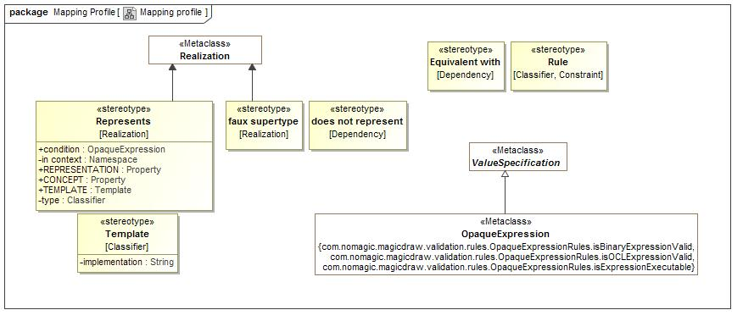

1. Mapping profile

## Conceptual Modeling and Mapping Library::Risk and Threat Concepts

The risk and threat modules use and specialize more generic concepts to build the risk and threat information sharing and analytics framework.

All risks and threats involve a danger that is a real or possible *situation* with *consequences* that do harm and impact the *objectives* of *stakeholders*. The same situation may, of course, not be considered a risk or threat to other stakeholders - some may consider such a situation an objective.

This foundational information is then expanded with metrics and interrelationships such that threats and risks can be fully understood and dealt with.

Fundamental risk/threat specific concepts include:

* Danger
* Risk
* Incident
* Indicator
* Vulnerability

Recognizing that these concepts use and build on more generic concepts that are not risk/threat specific such as "person", "organization" and "Intent".

All dangers derived from the general concept of a "situation" which is fundamental to this specification.

### Diagram: Threat and risk overview

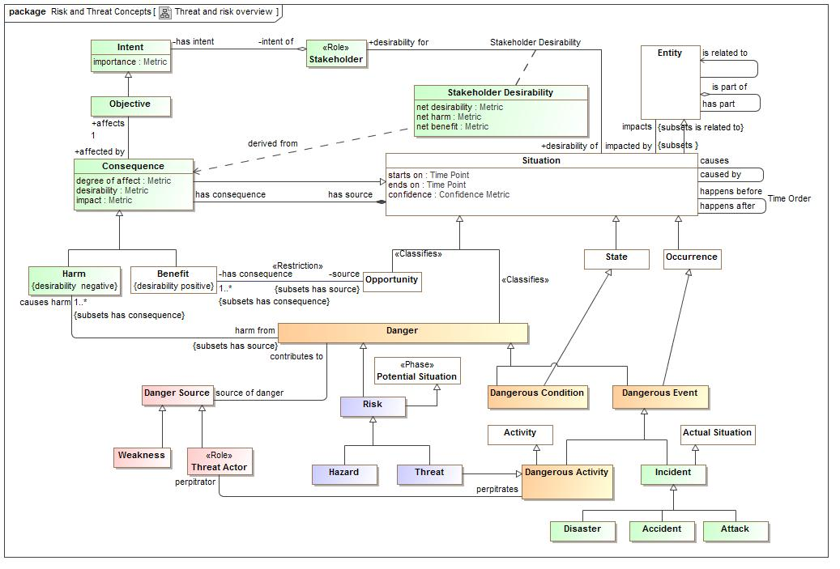

1. Threat and risk overview

## Conceptual Modeling and Mapping Library::Risk and Threat Concepts::Danger

Danger is a fundamentally concept that unifies the threat-risk framework. Danger classifies a situation as one that causes harm to stakeholders. Danger is further specialized across three dimmensions:

* Events Vs. Conditions - Events "happen" where as conditions are a steady state for some period.
* Actual Vs. Potential
* Intentional Vs. Natural or systematic. Intentional dangers involve a "threat actor" where as unintentional only involve weaknesses in resources.

The above are used to define more specific risk & threat concepts, such as:

* Incidents which are actual dangerous situations
* Disasters and Accidents which are unintentional actual situation (no threat actor)
* Attacks which are actual situations perpitrated by a threat actor
* Risks which are potential dangerous situations, thus having some level of uncertanty
* Threats which are intentional risks from a threat actor
* Hazards which are rnatural or systematic risks

Resources also play an importnt role in the risk/threat framework in that resoruces are harmed by dangers but risks are also key for attackers to exploit vunerabilities and for defenders to realize mitigations.

### Diagram: Danger

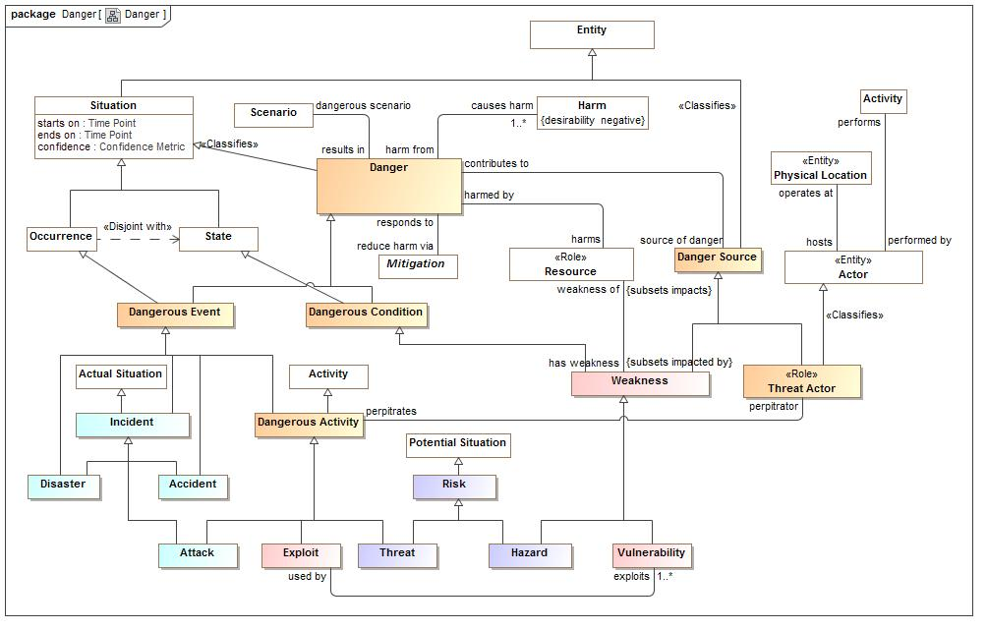

1. Danger

### Class Danger

A danger is any situation or event that has, is or may cause harm that negatively impacts the objectives of stakeholders

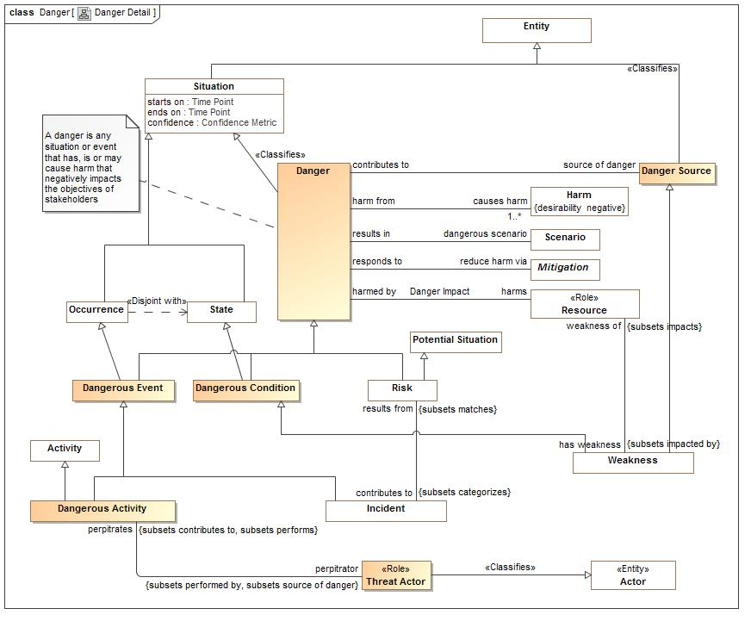

1. Danger Detail

#### Direct Supertypes

Situation

**package** Conceptual Modeling and Mapping Library::Risk and Threat Concepts::Danger

**extends** Situation

#### Attributes

1126982306.jpg severity : Metric

A metric for the total harl caused by a danger.

#### Associations

-1319770645.jpg reduce harm via:Mitigation

An actual or potential response to a danger to minimize the impact of the danger.

312529784.jpg dangerous scenario:Scenario *Subsets*: categorizes:Situation

A scenario that typifies a danger.

291308139.jpg source of danger:Probability Metric

Anything that can contribute to a danger

#### Inherited Features

***From*** Situation:

‘starts on’:Time Point

‘ends on’:Time Point

‘has binding’:Binding

‘has consequence’:Consequence

‘impacts’:Entity

‘matches’:Template

‘confidence’:Confidence Metric

‘happens before’:Situation

‘happens after’:Situation

‘selects’:Indicator

‘do’:Occurrence

‘course of action’:Process

***From*** Entity:

‘used by’:Occurrence

‘is part of’:Entity

‘has part’:Entity

‘has state’:State

‘created by’:Occurrence

‘is related to’:Entity

‘impacted by’:Situation

‘identified by’:Identifier

‘has name’:Name

‘prefered identifier’:Identifier

‘watched by’:Indicator Watchlist

‘observed by’:Observation

‘made available by’:Alter Capability

***From*** Anything:

‘categorized by’:Category

‘plays role’:Role

‘bound by’:Binding

‘in contex of’:Context

‘described by’:Description

‘stated by’:Source

***From*** Context:

‘generalizes’:Context

‘specializes’:Context

‘contextualizes’:Anything

### Association Danger Impact

An impact of a danger on a resource.

**package** Conceptual Modeling and Mapping Library::Risk and Threat Concepts::Danger

#### Association Ends

-831922671.jpg harms : Resource

Anything damaged by a danger.

-831922671.jpg harmed by : Danger

Danger that damages anything.

-831922671.jpg likelihood : Probability Metric

Possibility that the containing element represents reality.

### Class Danger Source

The source of any danger - natural, systematic or intentional

#### Direct Supertypes

Entity

**package** Conceptual Modeling and Mapping Library::Risk and Threat Concepts::Danger

**extends** Entity

#### Associations

291308139.jpg contributes to:Probability Metric

Danger some source of danger contributes to. e.g. an open well contributes to the danger of a child falling in

#### Inherited Features

***From*** Entity:

‘used by’:Occurrence

‘is part of’:Entity

‘has part’:Entity

‘has state’:State

‘created by’:Occurrence

‘is related to’:Entity

‘impacted by’:Situation

‘identified by’:Identifier

‘has name’:Name

‘prefered identifier’:Identifier

‘watched by’:Indicator Watchlist

‘observed by’:Observation

‘made available by’:Alter Capability

***From*** Anything:

‘categorized by’:Category

‘plays role’:Role

‘bound by’:Binding

‘in contex of’:Context

‘described by’:Description

‘stated by’:Source

### Class Dangerous Activity

A danger that is the intent of a threat actor performing an activity which causes harm.

#### Direct Supertypes

Activity, Dangerous Event

**package** Conceptual Modeling and Mapping Library::Risk and Threat Concepts::Danger

**extends** Dangerous Event, Activity

#### Associations

-333746247.jpg perpitrator:Threat Actor *Subsets*: performed by:Actor source of danger:Danger Source

The threat actor performing an activity to cause or contribute to a denergous situation in a real or pssible world.

#### Inherited Features

***From*** Danger:

‘severity’:Metric

‘reduce harm via’:Mitigation

‘dangerous scenario’:Scenario

‘source of danger’:Danger Source

***From*** Situation:

‘starts on’:Time Point

‘ends on’:Time Point

‘has binding’:Binding

‘has consequence’:Consequence

‘impacts’:Entity

‘matches’:Template

‘confidence’:Confidence Metric

‘happens before’:Situation

‘happens after’:Situation

‘selects’:Indicator

‘do’:Occurrence

‘course of action’:Process

***From*** Entity:

‘used by’:Occurrence

‘is part of’:Entity

‘has part’:Entity

‘has state’:State

‘created by’:Occurrence

‘is related to’:Entity

‘impacted by’:Situation

‘identified by’:Identifier

‘has name’:Name

‘prefered identifier’:Identifier

‘watched by’:Indicator Watchlist

‘observed by’:Observation

‘made available by’:Alter Capability

***From*** Anything:

‘categorized by’:Category

‘plays role’:Role

‘bound by’:Binding

‘in contex of’:Context

‘described by’:Description

‘stated by’:Source

***From*** Context:

‘generalizes’:Context

‘specializes’:Context

‘contextualizes’:Anything

***From*** Occurrence:

‘uses’:Entity

‘creates’:Entity

‘step in’:Occurrence

‘step’:Occurrence

‘when’:Situation

***From*** Activity:

‘performed by’:Actor

### Class Dangerous Condition

A dangerous condition is a static situation (not something happening) that directly or indirectly does or may have detrimental consequences impacting the objectives of stakeholders.

#### Direct Supertypes

Danger, State

**package** Conceptual Modeling and Mapping Library::Risk and Threat Concepts::Danger

**extends** Danger, State

#### Inherited Features

***From*** Danger:

‘severity’:Metric

‘reduce harm via’:Mitigation

‘dangerous scenario’:Scenario

‘source of danger’:Danger Source

***From*** Situation:

‘starts on’:Time Point

‘ends on’:Time Point

‘has binding’:Binding

‘has consequence’:Consequence

‘impacts’:Entity

‘matches’:Template

‘confidence’:Confidence Metric

‘happens before’:Situation

‘happens after’:Situation

‘selects’:Indicator

‘do’:Occurrence

‘course of action’:Process

***From*** Entity:

‘used by’:Occurrence

‘is part of’:Entity

‘has part’:Entity

‘has state’:State

‘created by’:Occurrence

‘is related to’:Entity

‘impacted by’:Situation

‘identified by’:Identifier

‘has name’:Name

‘prefered identifier’:Identifier

‘watched by’:Indicator Watchlist

‘observed by’:Observation

‘made available by’:Alter Capability

***From*** Anything:

‘categorized by’:Category

‘plays role’:Role

‘bound by’:Binding

‘in contex of’:Context

‘described by’:Description

‘stated by’:Source

***From*** Context:

‘generalizes’:Context

‘specializes’:Context

‘contextualizes’:Anything

***From*** State:

‘state of’:Entity

### Class Dangerous Event

A dangerous event is a occurrence (something happening) that directly or indirectly does or may have detrimental consequences.

#### Direct Supertypes

Danger, Occurrence

**package** Conceptual Modeling and Mapping Library::Risk and Threat Concepts::Danger

**extends** Danger, Occurrence

#### Inherited Features

***From*** Danger:

‘severity’:Metric

‘reduce harm via’:Mitigation

‘dangerous scenario’:Scenario

‘source of danger’:Danger Source

***From*** Situation:

‘starts on’:Time Point

‘ends on’:Time Point

‘has binding’:Binding

‘has consequence’:Consequence

‘impacts’:Entity

‘matches’:Template

‘confidence’:Confidence Metric

‘happens before’:Situation

‘happens after’:Situation

‘selects’:Indicator

‘do’:Occurrence

‘course of action’:Process

***From*** Entity:

‘used by’:Occurrence

‘is part of’:Entity

‘has part’:Entity

‘has state’:State

‘created by’:Occurrence

‘is related to’:Entity

‘impacted by’:Situation

‘identified by’:Identifier

‘has name’:Name

‘prefered identifier’:Identifier

‘watched by’:Indicator Watchlist

‘observed by’:Observation

‘made available by’:Alter Capability

***From*** Anything:

‘categorized by’:Category

‘plays role’:Role

‘bound by’:Binding

‘in contex of’:Context

‘described by’:Description

‘stated by’:Source

***From*** Context:

‘generalizes’:Context

‘specializes’:Context

‘contextualizes’:Anything

***From*** Occurrence:

‘uses’:Entity

‘creates’:Entity

‘step in’:Occurrence

‘step’:Occurrence

‘when’:Situation

### Class Threat Actor

An actor responsible for an intentional threat or attack.

#### Direct Supertypes

Actor, Danger Source

**package** Conceptual Modeling and Mapping Library::Risk and Threat Concepts::Danger

**extends** Danger Source, Actor

#### Associations

-333746247.jpg perpitrates:Dangerous Activity *Subsets*: contributes to:Danger performs:Activity

The activity performed by a threat actor to cause or contribute to a denergous situation in a real or pssible world.

#### Inherited Features

***From*** Danger Source:

‘contributes to’:Danger

***From*** Entity:

‘used by’:Occurrence

‘is part of’:Entity

‘has part’:Entity

‘has state’:State

‘created by’:Occurrence

‘is related to’:Entity

‘impacted by’:Situation

‘identified by’:Identifier

‘has name’:Name

‘prefered identifier’:Identifier

‘watched by’:Indicator Watchlist

‘observed by’:Observation

‘made available by’:Alter Capability

***From*** Anything:

‘categorized by’:Category

‘plays role’:Role

‘bound by’:Binding

‘in contex of’:Context

‘described by’:Description

‘stated by’:Source

***From*** Actor:

‘performs’:Activity

‘operates at’:Physical Location

‘contact via’:Contact Information

‘enabled by’:Alter Capability

***From*** Individual:

‘has observation’:Observation

## Conceptual Modeling and Mapping Library::Risk and Threat Concepts::Incident

Concepts relating to incidents - negative events that actually happen.

### Diagram: Incident

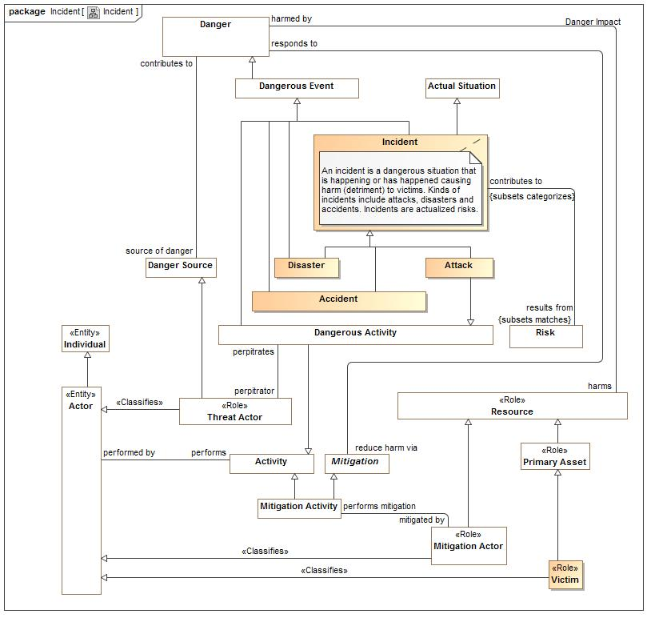

1. Incident

### Class Accident

Accident (also known as mishap) is an unplanned and unintended (but not necessarily unexpected) event or series of related events resulting in harm to an asset [ESA 97, IEEE 94, Leveson 95, NASA 97, UK 96].

#### Direct Supertypes

Dangerous Event, Incident

**package** Conceptual Modeling and Mapping Library::Risk and Threat Concepts::Incident

**extends** Dangerous Event, Incident

#### Inherited Features

***From*** Danger:

‘severity’:Metric

‘reduce harm via’:Mitigation

‘dangerous scenario’:Scenario

‘source of danger’:Danger Source

***From*** Situation:

‘starts on’:Time Point

‘ends on’:Time Point

‘has binding’:Binding

‘has consequence’:Consequence

‘impacts’:Entity

‘matches’:Template

‘confidence’:Confidence Metric

‘happens before’:Situation

‘happens after’:Situation

‘selects’:Indicator

‘do’:Occurrence

‘course of action’:Process

***From*** Entity:

‘used by’:Occurrence

‘is part of’:Entity

‘has part’:Entity

‘has state’:State

‘created by’:Occurrence

‘is related to’:Entity

‘impacted by’:Situation

‘identified by’:Identifier

‘has name’:Name

‘prefered identifier’:Identifier

‘watched by’:Indicator Watchlist

‘observed by’:Observation

‘made available by’:Alter Capability

***From*** Anything:

‘categorized by’:Category

‘plays role’:Role

‘bound by’:Binding

‘in contex of’:Context

‘described by’:Description

‘stated by’:Source

***From*** Context:

‘generalizes’:Context

‘specializes’:Context

‘contextualizes’:Anything

***From*** Occurrence:

‘uses’:Entity

‘creates’:Entity

‘step in’:Occurrence

‘step’:Occurrence

‘when’:Situation

***From*** Incident:

‘results from’:Risk

***From*** Actual Situation:

‘has sighting’:Sighting

‘has observation’:Observation

***From*** Individual:

‘has observation’:Observation

### Class Attack

An attack is the sequence of activities that a threat actor may follow when setting upon a target and thus causing harm.  
  
an aggressive and violent action against a person or place [LEADing]

#### Direct Supertypes

Dangerous Activity, Incident

**package** Conceptual Modeling and Mapping Library::Risk and Threat Concepts::Incident

**extends** Dangerous Activity, Incident

#### Inherited Features

***From*** Dangerous Activity:

‘perpitrator’:Threat Actor

***From*** Danger:

‘severity’:Metric

‘reduce harm via’:Mitigation

‘dangerous scenario’:Scenario

‘source of danger’:Danger Source

***From*** Situation:

‘starts on’:Time Point

‘ends on’:Time Point

‘has binding’:Binding

‘has consequence’:Consequence

‘impacts’:Entity

‘matches’:Template

‘confidence’:Confidence Metric

‘happens before’:Situation

‘happens after’:Situation

‘selects’:Indicator

‘do’:Occurrence

‘course of action’:Process

***From*** Entity:

‘used by’:Occurrence

‘is part of’:Entity

‘has part’:Entity

‘has state’:State

‘created by’:Occurrence

‘is related to’:Entity

‘impacted by’:Situation

‘identified by’:Identifier

‘has name’:Name

‘prefered identifier’:Identifier

‘watched by’:Indicator Watchlist

‘observed by’:Observation

‘made available by’:Alter Capability

***From*** Anything:

‘categorized by’:Category

‘plays role’:Role

‘bound by’:Binding

‘in contex of’:Context

‘described by’:Description

‘stated by’:Source

***From*** Context:

‘generalizes’:Context

‘specializes’:Context

‘contextualizes’:Anything

***From*** Occurrence:

‘uses’:Entity

‘creates’:Entity

‘step in’:Occurrence

‘step’:Occurrence

‘when’:Situation

***From*** Activity:

‘performed by’:Actor

***From*** Incident:

‘results from’:Risk

***From*** Actual Situation:

‘has sighting’:Sighting

‘has observation’:Observation

***From*** Individual:

‘has observation’:Observation

### Class Disaster

A sudden event that causes great damage or loss of life. [LEADing]

#### Direct Supertypes

Dangerous Event, Incident

**package** Conceptual Modeling and Mapping Library::Risk and Threat Concepts::Incident

**extends** Dangerous Event, Incident

#### Inherited Features

***From*** Danger:

‘severity’:Metric

‘reduce harm via’:Mitigation

‘dangerous scenario’:Scenario

‘source of danger’:Danger Source

***From*** Situation:

‘starts on’:Time Point

‘ends on’:Time Point

‘has binding’:Binding

‘has consequence’:Consequence

‘impacts’:Entity

‘matches’:Template

‘confidence’:Confidence Metric

‘happens before’:Situation

‘happens after’:Situation

‘selects’:Indicator

‘do’:Occurrence

‘course of action’:Process

***From*** Entity:

‘used by’:Occurrence

‘is part of’:Entity

‘has part’:Entity

‘has state’:State

‘created by’:Occurrence

‘is related to’:Entity

‘impacted by’:Situation

‘identified by’:Identifier

‘has name’:Name

‘prefered identifier’:Identifier

‘watched by’:Indicator Watchlist

‘observed by’:Observation

‘made available by’:Alter Capability

***From*** Anything:

‘categorized by’:Category

‘plays role’:Role

‘bound by’:Binding

‘in contex of’:Context

‘described by’:Description

‘stated by’:Source

***From*** Context:

‘generalizes’:Context

‘specializes’:Context

‘contextualizes’:Anything

***From*** Occurrence:

‘uses’:Entity

‘creates’:Entity

‘step in’:Occurrence

‘step’:Occurrence

‘when’:Situation

***From*** Incident:

‘results from’:Risk

***From*** Actual Situation:

‘has sighting’:Sighting

‘has observation’:Observation

***From*** Individual:

‘has observation’:Observation

### Class Incident

An incident is a dangerous situation that is happening or has happened causing harm (detriment) to victims. Kinds of incidents include attacks, disasters and accidents. Incidents are actualized risks.

#### Direct Supertypes

Actual Situation, Dangerous Event

**package** Conceptual Modeling and Mapping Library::Risk and Threat Concepts::Incident

**extends** Dangerous Event, Actual Situation

#### Associations

2004790005.jpg results from:Risk *Subsets*: matches:Template

Incidents that result from a risk

#### Inherited Features

***From*** Danger:

‘severity’:Metric

‘reduce harm via’:Mitigation

‘dangerous scenario’:Scenario

‘source of danger’:Danger Source

***From*** Situation:

‘starts on’:Time Point

‘ends on’:Time Point

‘has binding’:Binding

‘has consequence’:Consequence

‘impacts’:Entity

‘matches’:Template

‘confidence’:Confidence Metric

‘happens before’:Situation

‘happens after’:Situation

‘selects’:Indicator

‘do’:Occurrence

‘course of action’:Process

***From*** Entity:

‘used by’:Occurrence

‘is part of’:Entity

‘has part’:Entity

‘has state’:State

‘created by’:Occurrence

‘is related to’:Entity

‘impacted by’:Situation

‘identified by’:Identifier

‘has name’:Name

‘prefered identifier’:Identifier

‘watched by’:Indicator Watchlist

‘observed by’:Observation

‘made available by’:Alter Capability

***From*** Anything:

‘categorized by’:Category

‘plays role’:Role

‘bound by’:Binding

‘in contex of’:Context

‘described by’:Description

‘stated by’:Source

***From*** Context:

‘generalizes’:Context

‘specializes’:Context

‘contextualizes’:Anything

***From*** Occurrence:

‘uses’:Entity

‘creates’:Entity

‘step in’:Occurrence

‘step’:Occurrence

‘when’:Situation

***From*** Actual Situation:

‘has sighting’:Sighting

‘has observation’:Observation

***From*** Individual:

‘has observation’:Observation

### Class Victim

The role of any actor harmed by an incident.

#### Direct Supertypes

Actor, Primary Asset

**package** Conceptual Modeling and Mapping Library::Risk and Threat Concepts::Incident

**extends** Actor, Primary Asset

#### Inherited Features

***From*** Actor:

‘performs’:Activity

‘operates at’:Physical Location

‘contact via’:Contact Information

‘enabled by’:Alter Capability

***From*** Individual:

‘has observation’:Observation

***From*** Entity:

‘used by’:Occurrence

‘is part of’:Entity

‘has part’:Entity

‘has state’:State

‘created by’:Occurrence

‘is related to’:Entity

‘impacted by’:Situation

‘identified by’:Identifier

‘has name’:Name

‘prefered identifier’:Identifier

‘watched by’:Indicator Watchlist

‘observed by’:Observation

‘made available by’:Alter Capability

***From*** Anything:

‘categorized by’:Category

‘plays role’:Role

‘bound by’:Binding

‘in contex of’:Context

‘described by’:Description

‘stated by’:Source

***From*** Primary Asset:

‘supported by’:Asset Objective

‘has risk’:Risk

***From*** Resource:

‘has weakness’:Weakness

‘responsibility of’:Stakeholder

‘supports’:Resource

‘impacted by’:Consequence

‘required by’:Process

‘has vunerability’:Vulnerability

‘depends on’:Resource

‘subject to’:Authority

## Conceptual Modeling and Mapping Library::Risk and Threat Concepts::Indicator

*Indicators* are patterns of *situations* or lists of entities to watch out for that **indicate** a **situation** that may happen. An indicator may be selected by a situation, which contextualizes when it applies. When a situation matching an indicator is *observed* there is a *sighting* of that indicator which is then *evidence* for an *actual situation*, such as an *incident*. e.g. watch for these terrorists in airports...

A *sighting* is an *observation* of some *entity* or *situation* *observed* another *actual situation*. E.g. the terrorist ABadguy was seen at BWI on this 12/11/2014 by a police officer Sam Shoe.

Indicators are not certain and may have a likelihood attached to the potential situations for which they are evidence.

Once an sighting flags an indicator, a *course of action* rule may be fired based on the indicated situation.

Specializations of indicator include indicator patterns (an arbitrary pattern of anything) and watch lists. Indicators may also be grouped.

### Diagram: Indicator

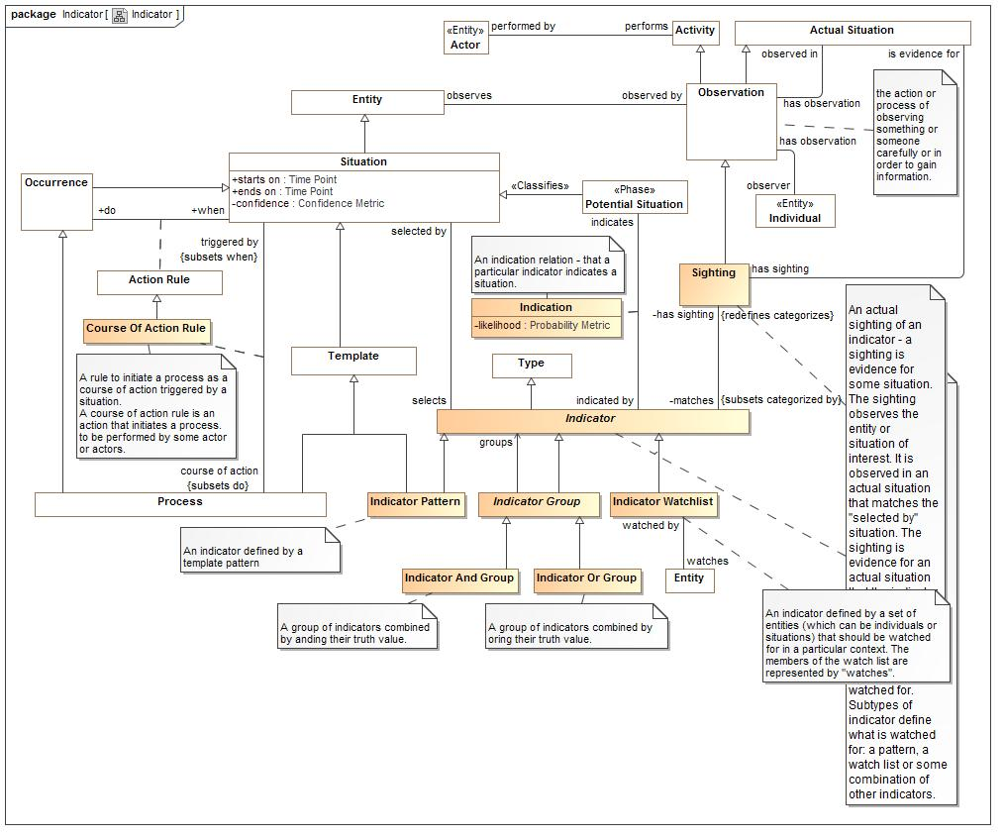

1. Indicator

### Association Class Indication

An indication relation - that a particular indicator indicates a situation.

**package** Conceptual Modeling and Mapping Library::Risk and Threat Concepts::Indicator

##### Association Ends

2057692105.jpg indicates : Potential Situation *Subsets*: matches:Template

The situation or situation or situation pattern indicated by an indicator.

2057692105.jpg indicated by : Indicator *Subsets*: matches:Template

Indicators of a situation

#### Attributes

-1438860915.jpg likelihood : Probability Metric

The probability that the indication actually indicates the situation.

### Class Indicator

An **indicator** is the type of a *sighting* which defines the conditions (*selected by*) under which sightings are relevant and the situations it *indicates*, sightings suggests further study or action based on a **course of action rule**. Indicators may be used to identify situations or entities that should be watched for.

Subtypes of indicator define what is watched for: a pattern, a watch list or some combination of other indicators.

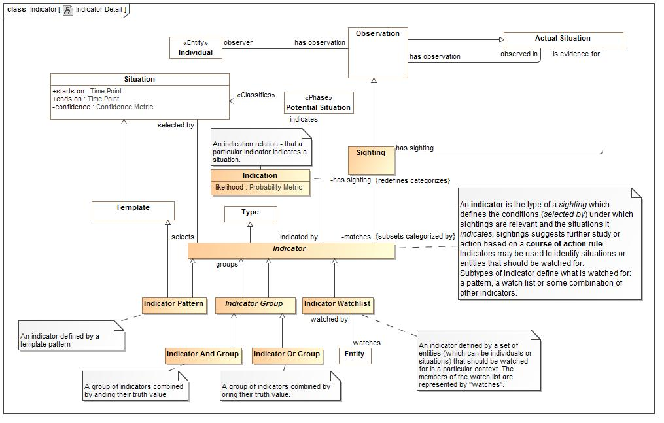

1. Indicator Detail

#### Direct Supertypes

Type

**package** Conceptual Modeling and Mapping Library::Risk and Threat Concepts::Indicator

**extends** Type

#### Associations

-1115658578.jpg has sighting:Sighting *Redefines*: categorizes:Anything

Sightings of an indicator

414591249.jpg selected by:Situation

Situation which scopes (contextualizes) the validity of an indicator.

2057692105.jpg indicates:Potential Situation

The situation or situation or situation pattern indicated by an indicator.

#### Inherited Features

***From*** Category:

‘categorizes’:Anything

***From*** Entity:

‘used by’:Occurrence

‘is part of’:Entity

‘has part’:Entity

‘has state’:State

‘created by’:Occurrence

‘is related to’:Entity

‘impacted by’:Situation

‘identified by’:Identifier

‘has name’:Name

‘prefered identifier’:Identifier

‘watched by’:Indicator Watchlist

‘observed by’:Observation

‘made available by’:Alter Capability

***From*** Anything:

‘categorized by’:Category

‘plays role’:Role

‘bound by’:Binding

‘in contex of’:Context

‘described by’:Description

‘stated by’:Source

***From*** Context:

‘generalizes’:Context

‘specializes’:Context

‘contextualizes’:Anything

### Class Indicator And Group

A group of indicators combined by anding their truth value.

#### Direct Supertypes

Indicator Group

**package** Conceptual Modeling and Mapping Library::Risk and Threat Concepts::Indicator

**extends** Indicator Group

#### Inherited Features

***From*** Indicator Group:

‘groups’:Indicator

***From*** Indicator:

‘has sighting’:Sighting

‘selected by’:Situation

‘indicates’:Potential Situation

***From*** Category:

‘categorizes’:Anything

***From*** Entity:

‘used by’:Occurrence

‘is part of’:Entity

‘has part’:Entity

‘has state’:State

‘created by’:Occurrence

‘is related to’:Entity

‘impacted by’:Situation

‘identified by’:Identifier

‘has name’:Name

‘prefered identifier’:Identifier

‘watched by’:Indicator Watchlist

‘observed by’:Observation

‘made available by’:Alter Capability

***From*** Anything:

‘categorized by’:Category

‘plays role’:Role

‘bound by’:Binding

‘in contex of’:Context

‘described by’:Description

‘stated by’:Source

***From*** Context:

‘generalizes’:Context

‘specializes’:Context

‘contextualizes’:Anything

### Class Indicator Group

An indicator expression that groups other indicators.

#### Direct Supertypes

Indicator

**package** Conceptual Modeling and Mapping Library::Risk and Threat Concepts::Indicator

**extends** Indicator

#### Associations

1725383223.jpg groups:Indicator

The set of indicators grouped for an "and" or a "or"

#### Inherited Features

***From*** Indicator:

‘has sighting’:Sighting

‘selected by’:Situation

‘indicates’:Potential Situation

***From*** Category:

‘categorizes’:Anything

***From*** Entity:

‘used by’:Occurrence

‘is part of’:Entity

‘has part’:Entity

‘has state’:State

‘created by’:Occurrence

‘is related to’:Entity

‘impacted by’:Situation

‘identified by’:Identifier

‘has name’:Name

‘prefered identifier’:Identifier

‘watched by’:Indicator Watchlist

‘observed by’:Observation

‘made available by’:Alter Capability

***From*** Anything:

‘categorized by’:Category

‘plays role’:Role

‘bound by’:Binding

‘in contex of’:Context

‘described by’:Description

‘stated by’:Source

***From*** Context:

‘generalizes’:Context

‘specializes’:Context

‘contextualizes’:Anything

### Class Indicator Or Group

A group of indicators combined by oring their truth value.

#### Direct Supertypes

Indicator Group

**package** Conceptual Modeling and Mapping Library::Risk and Threat Concepts::Indicator

**extends** Indicator Group

#### Inherited Features

***From*** Indicator Group:

‘groups’:Indicator

***From*** Indicator:

‘has sighting’:Sighting

‘selected by’:Situation

‘indicates’:Potential Situation

***From*** Category:

‘categorizes’:Anything

***From*** Entity:

‘used by’:Occurrence

‘is part of’:Entity

‘has part’:Entity

‘has state’:State

‘created by’:Occurrence

‘is related to’:Entity

‘impacted by’:Situation

‘identified by’:Identifier

‘has name’:Name

‘prefered identifier’:Identifier

‘watched by’:Indicator Watchlist

‘observed by’:Observation

‘made available by’:Alter Capability

***From*** Anything:

‘categorized by’:Category

‘plays role’:Role

‘bound by’:Binding

‘in contex of’:Context

‘described by’:Description

‘stated by’:Source

***From*** Context:

‘generalizes’:Context

‘specializes’:Context

‘contextualizes’:Anything

### Class Indicator Pattern

An indicator defined by a template pattern

#### Direct Supertypes

Indicator, Template

**package** Conceptual Modeling and Mapping Library::Risk and Threat Concepts::Indicator

**extends** Template, Indicator

#### Inherited Features

***From*** Template:

‘categorizes’:Situation

***From*** Situation:

‘starts on’:Time Point

‘ends on’:Time Point

‘has binding’:Binding

‘has consequence’:Consequence

‘impacts’:Entity

‘matches’:Template

‘confidence’:Confidence Metric

‘happens before’:Situation

‘happens after’:Situation

‘selects’:Indicator

‘do’:Occurrence

‘course of action’:Process

***From*** Entity:

‘used by’:Occurrence

‘is part of’:Entity

‘has part’:Entity

‘has state’:State

‘created by’:Occurrence

‘is related to’:Entity

‘impacted by’:Situation

‘identified by’:Identifier

‘has name’:Name

‘prefered identifier’:Identifier

‘watched by’:Indicator Watchlist

‘observed by’:Observation

‘made available by’:Alter Capability

***From*** Anything:

‘categorized by’:Category

‘plays role’:Role

‘bound by’:Binding

‘in contex of’:Context

‘described by’:Description

‘stated by’:Source

***From*** Context:

‘generalizes’:Context

‘specializes’:Context

‘contextualizes’:Anything

***From*** Category:

‘categorizes’:Anything

***From*** Indicator:

‘has sighting’:Sighting

‘selected by’:Situation

‘indicates’:Potential Situation

### Class Indicator Watchlist

An indicator defined by a set of entities (which can be individuals or situations) that should be watched for in a particular context. The members of the watch list are represented by "watches".

#### Direct Supertypes

Indicator

**package** Conceptual Modeling and Mapping Library::Risk and Threat Concepts::Indicator

**extends** Indicator

#### Associations

-324390161.jpg watches:Entity

The entities (individuals, systems, situations etc.) watched by a watchlist.

#### Inherited Features

***From*** Indicator:

‘has sighting’:Sighting

‘selected by’:Situation

‘indicates’:Potential Situation

***From*** Category:

‘categorizes’:Anything

***From*** Entity:

‘used by’:Occurrence

‘is part of’:Entity

‘has part’:Entity

‘has state’:State

‘created by’:Occurrence

‘is related to’:Entity

‘impacted by’:Situation

‘identified by’:Identifier

‘has name’:Name

‘prefered identifier’:Identifier

‘watched by’:Indicator Watchlist

‘observed by’:Observation

‘made available by’:Alter Capability

***From*** Anything:

‘categorized by’:Category

‘plays role’:Role

‘bound by’:Binding

‘in contex of’:Context

‘described by’:Description

‘stated by’:Source

***From*** Context:

‘generalizes’:Context

‘specializes’:Context

‘contextualizes’:Anything

### Class Sighting

An actual sighting of an indicator - a sighting is evidence for some situation. The sighting observes the entity or situation of interest. It is observed in an actual situation that matches the "selected by" situation. The sighting is evidence for an actual situation that the indicator indicates.

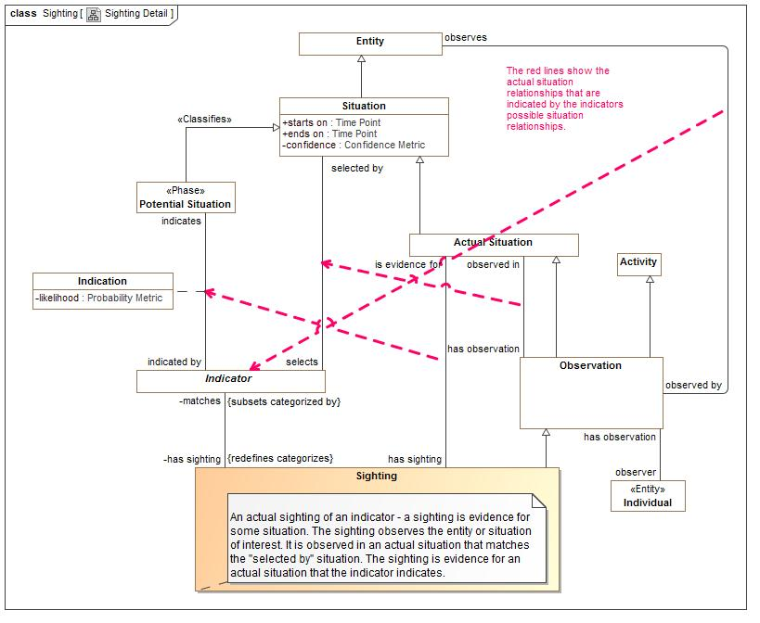

1. Sighting Detail

#### Direct Supertypes

Observation

**package** Conceptual Modeling and Mapping Library::Risk and Threat Concepts::Indicator

**extends** Observation

#### Associations

-1115658578.jpg matches:Indicator *Subsets*: categorized by:Category

Indicators a sighting matches

1842775683.jpg is evidence for:Actual Situation

Situation that is indicated by a sighting.

#### Inherited Features

***From*** Observation:

‘observes’:Entity

‘observer’:Individual

‘observed in’:Actual Situation

***From*** Activity:

‘performed by’:Actor

***From*** Occurrence:

‘uses’:Entity

‘creates’:Entity

‘step in’:Occurrence

‘step’:Occurrence

‘when’:Situation

***From*** Situation:

‘starts on’:Time Point

‘ends on’:Time Point

‘has binding’:Binding

‘has consequence’:Consequence

‘impacts’:Entity

‘matches’:Template

‘confidence’:Confidence Metric

‘happens before’:Situation

‘happens after’:Situation

‘selects’:Indicator

‘do’:Occurrence

‘course of action’:Process

***From*** Entity:

‘used by’:Occurrence

‘is part of’:Entity

‘has part’:Entity

‘has state’:State

‘created by’:Occurrence

‘is related to’:Entity

‘impacted by’:Situation

‘identified by’:Identifier

‘has name’:Name

‘prefered identifier’:Identifier

‘watched by’:Indicator Watchlist

‘observed by’:Observation

‘made available by’:Alter Capability

***From*** Anything:

‘categorized by’:Category

‘plays role’:Role

‘bound by’:Binding

‘in contex of’:Context

‘described by’:Description

‘stated by’:Source

***From*** Context:

‘generalizes’:Context

‘specializes’:Context

‘contextualizes’:Anything

***From*** Actual Situation:

‘has sighting’:Sighting

‘has observation’:Observation

***From*** Individual:

‘has observation’:Observation

## Conceptual Modeling and Mapping Library::Risk and Threat Concepts::Risk

*Risks* are identified **potential dangers**, *situations* with inherent uncertainty having a negative impact (*harm*) on objectives, people or resources. A risk typically identifies the risk to a *primary asset* - a *resource* of direct interest to stakeholders. Kinds of risks include *threats* and *hazards* which are intentional and unintentional, respectively. All relations relevant to any *danger* may be utilized to understand a risk.

*Desirability metrics,* computed based on all the *consequences* of a *situation* on the *objectives* of a *stakeholder*, provide the basis for the calculation of the risk level and the evaluation of what risk may be accepted and what may be avoided or mitigated.

Risk may be subject to *risk requirements* and may have a history of where that risk *contributed* to *incidents*. A risk may have *mitigations* to *reduce harm* as well as mitigations to *reduce the likelihood* of the risk. Such mitigations include *plans* and *activities*.

Risk planing includes the identification of risk treatment options. As a risk is a "possible future", each *risk treatment option* is an alternative possible future based on taking certain actions. These actions include:

* Avoiding the risk
* Transfer of risk to another stakeholder
* Reducing the likelihood
* Reducing the impact
* Accepting the risk

### Diagram: Risk

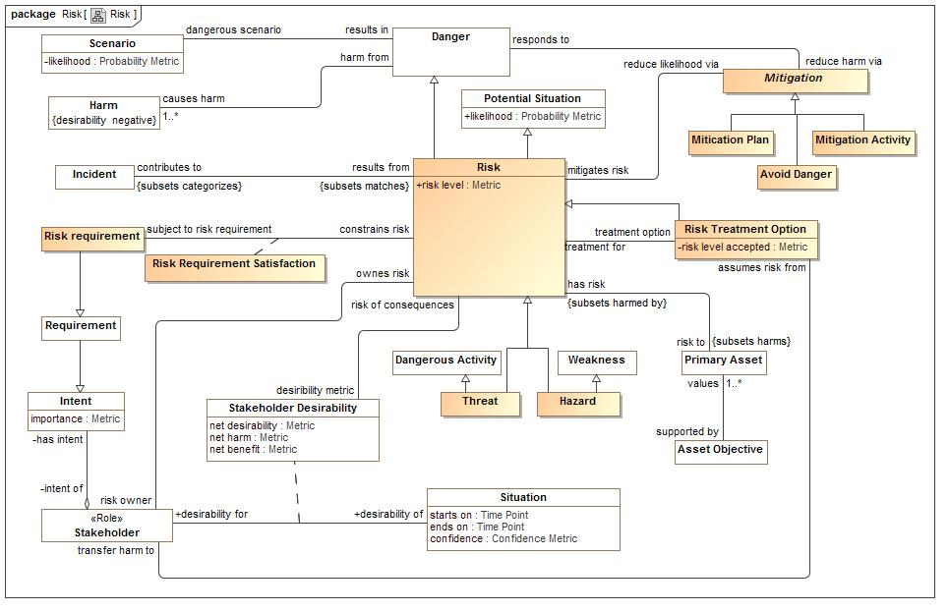

1. Risk

### Class Avoid Danger

A likelihood reduction strategy whereby a stakeholder decides not to engage in a risky activity.

#### Direct Supertypes

Mitigation

**package** Conceptual Modeling and Mapping Library::Risk and Threat Concepts::Risk

**extends** Mitigation

#### Inherited Features

***From*** Mitigation:

‘mitigates risk’:Risk

‘responds to’:Danger

‘degree of prevention’:Metric

### Class Hazard

A hazard is a condition that may lead to undesired consequences. Hazards lack intent and do not require the involvement of a threat actor.

#### Direct Supertypes

Risk, Weakness

**package** Conceptual Modeling and Mapping Library::Risk and Threat Concepts::Risk

**extends** Weakness, Risk

#### Inherited Features

***From*** Weakness:

‘weakness of’:Resource

***From*** Danger Source:

‘contributes to’:Danger

***From*** Entity:

‘used by’:Occurrence

‘is part of’:Entity

‘has part’:Entity

‘has state’:State

‘created by’:Occurrence

‘is related to’:Entity

‘impacted by’:Situation

‘identified by’:Identifier

‘has name’:Name

‘prefered identifier’:Identifier

‘watched by’:Indicator Watchlist

‘observed by’:Observation

‘made available by’:Alter Capability

***From*** Anything:

‘categorized by’:Category

‘plays role’:Role

‘bound by’:Binding

‘in contex of’:Context

‘described by’:Description

‘stated by’:Source

***From*** Danger:

‘severity’:Metric

‘reduce harm via’:Mitigation

‘dangerous scenario’:Scenario

‘source of danger’:Danger Source

***From*** Situation:

‘starts on’:Time Point

‘ends on’:Time Point

‘has binding’:Binding

‘has consequence’:Consequence

‘impacts’:Entity

‘matches’:Template

‘confidence’:Confidence Metric

‘happens before’:Situation

‘happens after’:Situation

‘selects’:Indicator

‘do’:Occurrence

‘course of action’:Process

***From*** Context:

‘generalizes’:Context

‘specializes’:Context

‘contextualizes’:Anything

***From*** State:

‘state of’:Entity

***From*** Risk:

‘desiribility metric’:Stakeholder Desirability

‘risk level’:Metric

‘contributes to’:Incident

‘treatment option’:Risk Treatment Option

‘risk to’:Primary Asset

‘risk owner’:Stakeholder

‘reduce likelihood via’:Mitigation

***From*** Potential Situation:

‘likelihood’:Probability Metric

‘indicated by’:Indicator

***From*** Template:

‘categorizes’:Situation

***From*** Category:

‘categorizes’:Anything

### Class Mitication Plan

A plan to lessen the probability or impact of a risk.

#### Direct Supertypes

Mitigation, Plan

**package** Conceptual Modeling and Mapping Library::Risk and Threat Concepts::Risk

**extends** Mitigation, Plan

#### Inherited Features

***From*** Mitigation:

‘mitigates risk’:Risk

‘responds to’:Danger

‘degree of prevention’:Metric

***From*** Plan:

‘supports objective’:Objective

***From*** Process:

‘requires’:Resource

‘triggered by’:Situation

***From*** Occurrence:

‘uses’:Entity

‘creates’:Entity

‘step in’:Occurrence

‘step’:Occurrence

‘when’:Situation

***From*** Situation:

‘starts on’:Time Point

‘ends on’:Time Point

‘has binding’:Binding

‘has consequence’:Consequence

‘impacts’:Entity

‘matches’:Template

‘confidence’:Confidence Metric

‘happens before’:Situation

‘happens after’:Situation

‘selects’:Indicator

‘do’:Occurrence

‘course of action’:Process

***From*** Entity:

‘used by’:Occurrence

‘is part of’:Entity

‘has part’:Entity

‘has state’:State

‘created by’:Occurrence

‘is related to’:Entity

‘impacted by’:Situation

‘identified by’:Identifier

‘has name’:Name

‘prefered identifier’:Identifier

‘watched by’:Indicator Watchlist

‘observed by’:Observation

‘made available by’:Alter Capability

***From*** Anything:

‘categorized by’:Category

‘plays role’:Role

‘bound by’:Binding

‘in contex of’:Context

‘described by’:Description

‘stated by’:Source

***From*** Context:

‘generalizes’:Context

‘specializes’:Context

‘contextualizes’:Anything

***From*** Template:

‘categorizes’:Situation

***From*** Category:

‘categorizes’:Anything

***From*** Activity:

‘performed by’:Actor

### Class Mitigation

Anything which minimizes or eliminates the possibility or impact of a danger or risk.

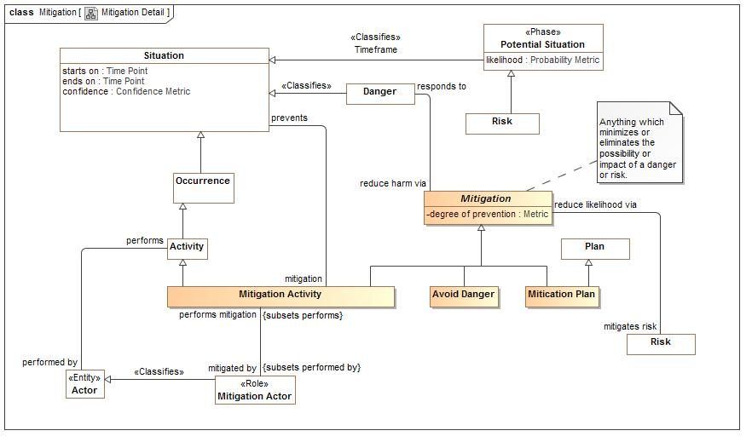

1. Mitigation Detail

**package** Conceptual Modeling and Mapping Library::Risk and Threat Concepts::Risk

#### Attributes

534497747.jpg degree of prevention : Metric

A metric for how much a mitigation mitigates a dangerous situation.

#### Associations

1949928154.jpg mitigates risk:Risk

Risks mitigated by a mitigation.

-1319770645.jpg responds to:Danger

Danger that a mitication responds to.

### Class Mitigation Activity

An act of mitigating, or lessening the force or intensity of something unpleasant, as wrath, pain, grief, or extreme circumstances [dictionary.com]

#### Direct Supertypes

Activity, Mitigation

**package** Conceptual Modeling and Mapping Library::Risk and Threat Concepts::Risk

**extends** Activity, Mitigation

#### Associations

1538757110.jpg mitigated by:Mitigation Actor *Subsets*: performed by:Actor

The actor(s) that may peform a mitigation.

-1388018520.jpg prevents:Situation

What a mitication activity prevents or is intended to prevent.

#### Inherited Features

***From*** Activity:

‘performed by’:Actor

***From*** Occurrence:

‘uses’:Entity

‘creates’:Entity

‘step in’:Occurrence

‘step’:Occurrence

‘when’:Situation

***From*** Situation:

‘starts on’:Time Point

‘ends on’:Time Point

‘has binding’:Binding

‘has consequence’:Consequence

‘impacts’:Entity

‘matches’:Template

‘confidence’:Confidence Metric

‘happens before’:Situation

‘happens after’:Situation

‘selects’:Indicator

‘do’:Occurrence

‘course of action’:Process

***From*** Entity:

‘used by’:Occurrence

‘is part of’:Entity

‘has part’:Entity

‘has state’:State

‘created by’:Occurrence

‘is related to’:Entity

‘impacted by’:Situation

‘identified by’:Identifier

‘has name’:Name

‘prefered identifier’:Identifier

‘watched by’:Indicator Watchlist

‘observed by’:Observation

‘made available by’:Alter Capability

***From*** Anything:

‘categorized by’:Category

‘plays role’:Role

‘bound by’:Binding

‘in contex of’:Context

‘described by’:Description

‘stated by’:Source

***From*** Context:

‘generalizes’:Context

‘specializes’:Context

‘contextualizes’:Anything

***From*** Mitigation:

‘mitigates risk’:Risk

‘responds to’:Danger

‘degree of prevention’:Metric

### Class Mitigation Actor

One who performs a mitigation

#### Direct Supertypes

Actor, Resource

**package** Conceptual Modeling and Mapping Library::Risk and Threat Concepts::Risk

**extends** Actor, Resource

#### Associations

1538757110.jpg performs mitigation:Mitigation Activity *Subsets*: performs:Activity

The mitication an actor performs.

#### Inherited Features

***From*** Actor:

‘performs’:Activity

‘operates at’:Physical Location

‘contact via’:Contact Information

‘enabled by’:Alter Capability

***From*** Individual:

‘has observation’:Observation

***From*** Entity:

‘used by’:Occurrence

‘is part of’:Entity

‘has part’:Entity

‘has state’:State

‘created by’:Occurrence

‘is related to’:Entity

‘impacted by’:Situation

‘identified by’:Identifier

‘has name’:Name

‘prefered identifier’:Identifier

‘watched by’:Indicator Watchlist

‘observed by’:Observation

‘made available by’:Alter Capability

***From*** Anything:

‘categorized by’:Category

‘plays role’:Role

‘bound by’:Binding

‘in contex of’:Context

‘described by’:Description

‘stated by’:Source

***From*** Resource:

‘has weakness’:Weakness

‘responsibility of’:Stakeholder

‘supports’:Resource

‘impacted by’:Consequence

‘required by’:Process

‘has vunerability’:Vulnerability

‘depends on’:Resource

‘subject to’:Authority

### Class Risk

Risks are identified potential situations with inherent uncertainty having a negative impact (harm) on objectives, people or resources. Risk measures the expected level of harm (net negative desirability) to a primary asset with respect to the objectives of stakeholders.  
  
Risk refers to uncertainty in terms of vulnerability and are about the severity and impact of the consequences (or outcomes), with respect to something that is valued. It is therefore the combined impact of any conditions, events or factors that can affect the potential for keeping or achieving desired objectives. [LEADing]

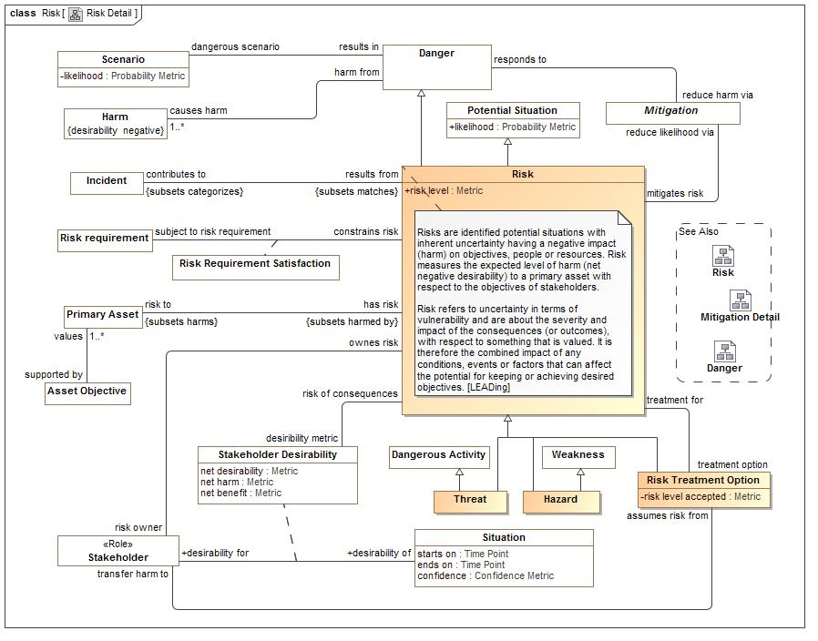

1. Risk Detail

#### Direct Supertypes

Danger, Potential Situation

**package** Conceptual Modeling and Mapping Library::Risk and Threat Concepts::Risk

**extends** Potential Situation, Danger

#### Attributes

-1191367753.jpg risk level : Metric

Net harm times net likelihood

#### Associations

389476031.jpg desiribility metric:Stakeholder Desirability

How much something is desired by a stakeholder.

2004790005.jpg contributes to:Incident *Subsets*: categorizes:Situation

Risks that have contributed incidents

1568753261.jpg treatment option:Risk Treatment Option

An option for handling a risk.

-17417802.jpg risk to:Primary Asset *Subsets*: harms:Resource

Asset that would be in danger should a risk happen.

-1067369733.jpg risk owner:Stakeholder

Stakeholder that manages a risk.

1949928154.jpg reduce likelihood via:Mitigation

A potential safeguard against a risk to minimize the possibility of the danger occurring.

#### Inherited Features

***From*** Potential Situation:

‘likelihood’:Probability Metric

‘indicated by’:Indicator

***From*** Situation:

‘starts on’:Time Point

‘ends on’:Time Point

‘has binding’:Binding

‘has consequence’:Consequence

‘impacts’:Entity

‘matches’:Template

‘confidence’:Confidence Metric

‘happens before’:Situation

‘happens after’:Situation

‘selects’:Indicator

‘do’:Occurrence

‘course of action’:Process

***From*** Entity:

‘used by’:Occurrence

‘is part of’:Entity

‘has part’:Entity

‘has state’:State

‘created by’:Occurrence

‘is related to’:Entity

‘impacted by’:Situation

‘identified by’:Identifier

‘has name’:Name

‘prefered identifier’:Identifier

‘watched by’:Indicator Watchlist

‘observed by’:Observation

‘made available by’:Alter Capability

***From*** Anything:

‘categorized by’:Category

‘plays role’:Role

‘bound by’:Binding

‘in contex of’:Context

‘described by’:Description

‘stated by’:Source

***From*** Context:

‘generalizes’:Context

‘specializes’:Context

‘contextualizes’:Anything

***From*** Template:

‘categorizes’:Situation

***From*** Category:

‘categorizes’:Anything

***From*** Danger:

‘severity’:Metric

‘reduce harm via’:Mitigation

‘dangerous scenario’:Scenario

‘source of danger’:Danger Source

### Class Risk requirement

A requirement that constrains a risk or the management of a risk.

#### Direct Supertypes

Requirement

**package** Conceptual Modeling and Mapping Library::Risk and Threat Concepts::Risk

**extends** Requirement

#### Inherited Features

***From*** Intent:

‘intent of’:Stakeholder

‘importance’:Metric

### Association Class Risk Requirement Satisfaction

How a risk requirement is satisfied.

#### Direct Supertypes

Satisfaction of requirement

**package** Conceptual Modeling and Mapping Library::Risk and Threat Concepts::Risk

**extends** Satisfaction of requirement

##### Association Ends

1510583319.jpg subject to risk requirement : Risk requirement

A requirement that is being satisfied.

1510583319.jpg constrains risk : Risk

A constraint on risk.

#### Inherited Features

***From*** Satisfaction of requirement:

‘degree of satisfaction’:Metric

‘constrains’:Entity

‘subject to’:Requirement

***From*** Entity:

‘used by’:Occurrence

‘is part of’:Entity

‘has part’:Entity

‘has state’:State

‘created by’:Occurrence

‘is related to’:Entity

‘impacted by’:Situation

‘identified by’:Identifier

‘has name’:Name

‘prefered identifier’:Identifier

‘watched by’:Indicator Watchlist

‘observed by’:Observation

‘made available by’:Alter Capability

***From*** Anything:

‘categorized by’:Category

‘plays role’:Role

‘bound by’:Binding

‘in contex of’:Context

‘described by’:Description

‘stated by’:Source

### Class Risk Treatment Option

A representation of a Risk modified in some way to represent an option for the management and handling of a risk.

#### Direct Supertypes

Risk

**package** Conceptual Modeling and Mapping Library::Risk and Threat Concepts::Risk

**extends** Risk

#### Attributes

-1386936664.jpg risk level accepted : Metric

#### Associations

1568753261.jpg treatment for:Risk

Risk for which an option is being defined.

-612095893.jpg transfer harm to:Stakeholder

#### Inherited Features

***From*** Risk:

‘desiribility metric’:Stakeholder Desirability

‘risk level’:Metric

‘contributes to’:Incident

‘treatment option’:Risk Treatment Option

‘risk to’:Primary Asset

‘risk owner’:Stakeholder

‘reduce likelihood via’:Mitigation

***From*** Potential Situation:

‘likelihood’:Probability Metric

‘indicated by’:Indicator

***From*** Situation:

‘starts on’:Time Point

‘ends on’:Time Point

‘has binding’:Binding

‘has consequence’:Consequence

‘impacts’:Entity

‘matches’:Template

‘confidence’:Confidence Metric

‘happens before’:Situation

‘happens after’:Situation

‘selects’:Indicator

‘do’:Occurrence

‘course of action’:Process

***From*** Entity:

‘used by’:Occurrence

‘is part of’:Entity

‘has part’:Entity

‘has state’:State

‘created by’:Occurrence

‘is related to’:Entity

‘impacted by’:Situation

‘identified by’:Identifier

‘has name’:Name

‘prefered identifier’:Identifier

‘watched by’:Indicator Watchlist

‘observed by’:Observation

‘made available by’:Alter Capability

***From*** Anything:

‘categorized by’:Category

‘plays role’:Role

‘bound by’:Binding

‘in contex of’:Context

‘described by’:Description

‘stated by’:Source

***From*** Context:

‘generalizes’:Context

‘specializes’:Context

‘contextualizes’:Anything

***From*** Template:

‘categorizes’:Situation

***From*** Category:

‘categorizes’:Anything

***From*** Danger:

‘severity’:Metric

‘reduce harm via’:Mitigation

‘dangerous scenario’:Scenario

‘source of danger’:Danger Source

### Class Threat

Threat is a situation that increases the likelihood of one or more related attacks.  
The threat consists of the existence of one or more potential attackers together with a set of one or more system conditions or states that provide motivation to the attackers. Thus, the threat of theft may result in an actual theft (attack), and threats correspond to attacks that are typically classified by attacker motivation (e.g., theft) as opposed to technique (e.g., spoofing). In some books and articles, the different but highly related terms “attack” and “threat” are sometimes confounded by being used as synonyms [Firesmith 03, Tulloch 03].

#### Direct Supertypes

Dangerous Activity, Risk

**package** Conceptual Modeling and Mapping Library::Risk and Threat Concepts::Risk

**extends** Dangerous Activity, Risk

#### Inherited Features

***From*** Dangerous Activity:

‘perpitrator’:Threat Actor

***From*** Danger:

‘severity’:Metric

‘reduce harm via’:Mitigation

‘dangerous scenario’:Scenario

‘source of danger’:Danger Source

***From*** Situation:

‘starts on’:Time Point

‘ends on’:Time Point

‘has binding’:Binding

‘has consequence’:Consequence

‘impacts’:Entity

‘matches’:Template

‘confidence’:Confidence Metric

‘happens before’:Situation

‘happens after’:Situation

‘selects’:Indicator

‘do’:Occurrence

‘course of action’:Process

***From*** Entity:

‘used by’:Occurrence

‘is part of’:Entity

‘has part’:Entity

‘has state’:State

‘created by’:Occurrence

‘is related to’:Entity

‘impacted by’:Situation

‘identified by’:Identifier

‘has name’:Name

‘prefered identifier’:Identifier

‘watched by’:Indicator Watchlist

‘observed by’:Observation

‘made available by’:Alter Capability

***From*** Anything:

‘categorized by’:Category

‘plays role’:Role

‘bound by’:Binding

‘in contex of’:Context

‘described by’:Description

‘stated by’:Source

***From*** Context:

‘generalizes’:Context

‘specializes’:Context

‘contextualizes’:Anything

***From*** Occurrence:

‘uses’:Entity

‘creates’:Entity

‘step in’:Occurrence

‘step’:Occurrence

‘when’:Situation

***From*** Activity:

‘performed by’:Actor

***From*** Risk:

‘desiribility metric’:Stakeholder Desirability

‘risk level’:Metric

‘contributes to’:Incident

‘treatment option’:Risk Treatment Option

‘risk to’:Primary Asset

‘risk owner’:Stakeholder

‘reduce likelihood via’:Mitigation

***From*** Potential Situation:

‘likelihood’:Probability Metric

‘indicated by’:Indicator

***From*** Template:

‘categorizes’:Situation

***From*** Category:

‘categorizes’:Anything

## Conceptual Modeling and Mapping Library::Risk and Threat Concepts::Vulnerability

Vulnerabilities and weaknesses represent flaws or inherent qualities of some resource that can be the source of danger.

Vulnerabilities are more specific in that a vulnerability may be exploited to cause harm.

### Diagram: Vulnerability Detail

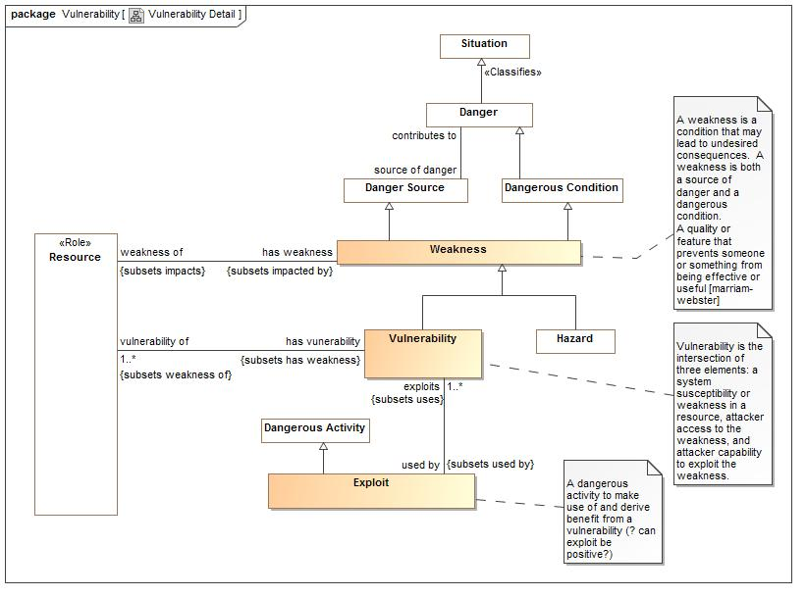

1. Vulnerability Detail

### Class Exploit

A dangerous activity to make use of and derive benefit from a vulnerability (? can exploit be positive?)

#### Direct Supertypes

Dangerous Activity

**package** Conceptual Modeling and Mapping Library::Risk and Threat Concepts::Vulnerability

**extends** Dangerous Activity

#### Associations

2048649128.jpg exploits:Vulnerability [1..*] *Subsets*: uses:Entity

Vunerability exploited.

#### Inherited Features

***From*** Dangerous Activity:

‘perpitrator’:Threat Actor

***From*** Danger:

‘severity’:Metric

‘reduce harm via’:Mitigation

‘dangerous scenario’:Scenario

‘source of danger’:Danger Source

***From*** Situation:

‘starts on’:Time Point

‘ends on’:Time Point

‘has binding’:Binding

‘has consequence’:Consequence

‘impacts’:Entity

‘matches’:Template

‘confidence’:Confidence Metric

‘happens before’:Situation

‘happens after’:Situation

‘selects’:Indicator

‘do’:Occurrence

‘course of action’:Process

***From*** Entity:

‘used by’:Occurrence

‘is part of’:Entity

‘has part’:Entity

‘has state’:State

‘created by’:Occurrence

‘is related to’:Entity

‘impacted by’:Situation

‘identified by’:Identifier

‘has name’:Name

‘prefered identifier’:Identifier

‘watched by’:Indicator Watchlist

‘observed by’:Observation

‘made available by’:Alter Capability

***From*** Anything:

‘categorized by’:Category

‘plays role’:Role

‘bound by’:Binding

‘in contex of’:Context

‘described by’:Description

‘stated by’:Source

***From*** Context:

‘generalizes’:Context

‘specializes’:Context

‘contextualizes’:Anything

***From*** Occurrence:

‘uses’:Entity

‘creates’:Entity

‘step in’:Occurrence

‘step’:Occurrence

‘when’:Situation

***From*** Activity:

‘performed by’:Actor

### Class Vulnerability

Vulnerability is the intersection of three elements: a system susceptibility or weakness in a resource, attacker access to the weakness, and attacker capability to exploit the weakness.

#### Direct Supertypes

Weakness

**package** Conceptual Modeling and Mapping Library::Risk and Threat Concepts::Vulnerability

**extends** Weakness

#### Associations

-2047782013.jpg vulnerability of:Resource [1..*] *Subsets*: weakness of:Resource

Resources a vunerability may affect.

2048649128.jpg used by:Exploit *Subsets*: used by:Occurrence

Exploits used by a vunerability.

#### Inherited Features

***From*** Weakness:

‘weakness of’:Resource

***From*** Danger Source:

‘contributes to’:Danger

***From*** Entity:

‘used by’:Occurrence

‘is part of’:Entity

‘has part’:Entity

‘has state’:State

‘created by’:Occurrence

‘is related to’:Entity

‘impacted by’:Situation

‘identified by’:Identifier

‘has name’:Name

‘prefered identifier’:Identifier

‘watched by’:Indicator Watchlist

‘observed by’:Observation

‘made available by’:Alter Capability

***From*** Anything:

‘categorized by’:Category

‘plays role’:Role

‘bound by’:Binding

‘in contex of’:Context

‘described by’:Description

‘stated by’:Source

***From*** Danger:

‘severity’:Metric

‘reduce harm via’:Mitigation

‘dangerous scenario’:Scenario

‘source of danger’:Danger Source

***From*** Situation:

‘starts on’:Time Point

‘ends on’:Time Point

‘has binding’:Binding

‘has consequence’:Consequence

‘impacts’:Entity

‘matches’:Template

‘confidence’:Confidence Metric

‘happens before’:Situation

‘happens after’:Situation

‘selects’:Indicator

‘do’:Occurrence

‘course of action’:Process

***From*** Context:

‘generalizes’:Context

‘specializes’:Context

‘contextualizes’:Anything

***From*** State:

‘state of’:Entity

### Class Weakness

A weakness is a condition that may lead to undesired consequences. A weakness is both a source of danger and a dangerous condition.  
A quality or feature that prevents someone or something from being effective or useful [marriam-webster]

#### Direct Supertypes

Danger Source, Dangerous Condition

**package** Conceptual Modeling and Mapping Library::Risk and Threat Concepts::Vulnerability

**extends** Danger Source, Dangerous Condition

#### Associations

-526131549.jpg weakness of:Resource *Subsets*: impacts:Entity

A resource that has some hazard or vulnerability

#### Inherited Features

***From*** Danger Source:

‘contributes to’:Danger

***From*** Entity:

‘used by’:Occurrence

‘is part of’:Entity

‘has part’:Entity

‘has state’:State

‘created by’:Occurrence

‘is related to’:Entity

‘impacted by’:Situation

‘identified by’:Identifier

‘has name’:Name

‘prefered identifier’:Identifier

‘watched by’:Indicator Watchlist

‘observed by’:Observation

‘made available by’:Alter Capability

***From*** Anything:

‘categorized by’:Category

‘plays role’:Role

‘bound by’:Binding

‘in contex of’:Context

‘described by’:Description

‘stated by’:Source

***From*** Danger:

‘severity’:Metric

‘reduce harm via’:Mitigation

‘dangerous scenario’:Scenario

‘source of danger’:Danger Source

***From*** Situation:

‘starts on’:Time Point

‘ends on’:Time Point

‘has binding’:Binding

‘has consequence’:Consequence

‘impacts’:Entity

‘matches’:Template

‘confidence’:Confidence Metric

‘happens before’:Situation

‘happens after’:Situation

‘selects’:Indicator

‘do’:Occurrence

‘course of action’:Process

***From*** Context:

‘generalizes’:Context

‘specializes’:Context

‘contextualizes’:Anything

***From*** State:

‘state of’:Entity

# Data Type

## Number

Any number

## ordered

Assertion that elements of a collection are ordered in some way.

# Tree

## Class Hierarchy

## Enumeration Hierarchy